DUMMY POSITIONING

CRS: Evenflo Tribute – Rearward Facing – SB3PT

TRC Test Number: S211103-3 VRTC Test Number: SIDE_398
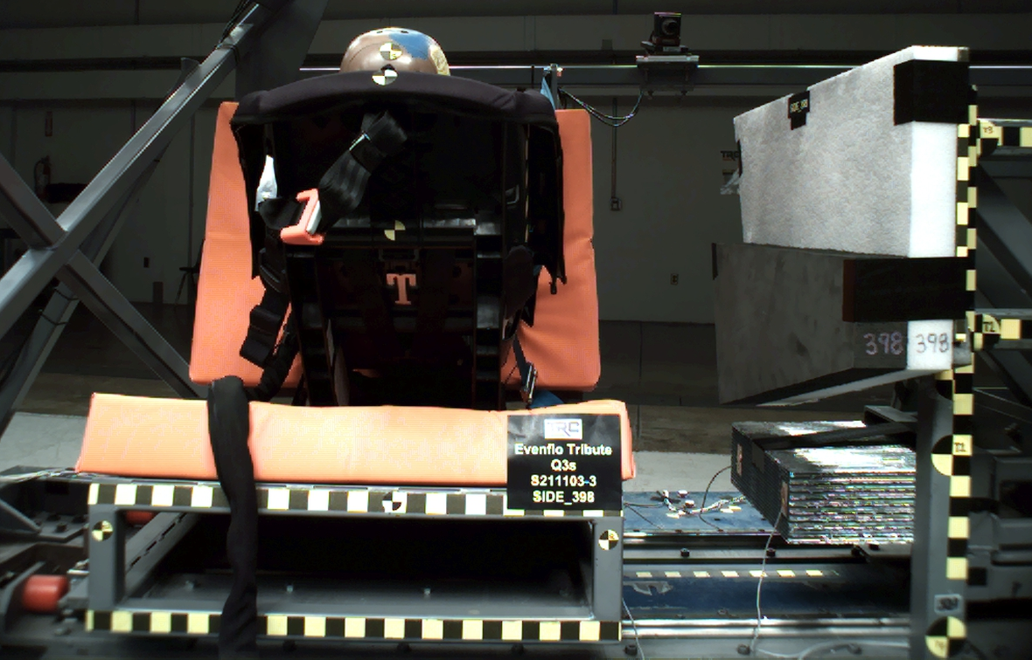

DUMMY POSITIONING FARO MEASUREMENTS
Description | Units | X | Y | Z
Origin Post | mm | -0.06 | -0.22 | 0.02
Front of Sliding Seat | mm | -154.83 | 671.24 | 576.23
Sliding Seat Corner | mm | -162.63 | 371.56 | 561.00
Point S1 | mm | -148.20 | 390.91 | 621.92
Point S2 | mm | -150.29 | 1049.48 | 625.54
Honeycomb Corner | mm | -316.47 | 95.99 | 579.46
Z point | mm | -771.73 | 1068.95 | 685.93
Back of Sliding Seat | mm | -891.54 | 671.67 | 3.86
CRS mid height | mm | -100.70 | 669.57 | 224.10
CRS top of the seat | mm | 32.31 | 670.56 | 56.73
CRS top of base | mm | -663.38 | 670.92 | 314.37
CRS bottom Center | mm | -617.45 | 673.71 | 259.30
Top of Head | mm | -94.17 | 674.34 | -20.99
Front of Face | mm | -216.03 | 671.85 | 25.38
Head CG Right | mm | -136.84 | 606.57 | 53.86
Head CG Left | mm | -133.58 | 741.12 | 53.81
Shoulder | mm | -185.81 | 559.83 | 177.71
Chest Clip | mm | -293.65 | 673.16 | 132.83
Buckle | mm | -450.38 | 670.70 | 244.24
Right Knee Out | mm | -572.12 | 589.32 | 224.28
DUMMY POSITIONING FARO MEASUREMENTS, CONTINUED
Description | Units | X | Y | Z
Right Leg Up | mm | -608.10 | 614.24 | 155.14
Right Leg Down | mm | -677.54 | 611.23 | 102.06
Right Ankle | mm | -735.73 | 582.55 | 89.63
Left Knee Out | mm | -570.25 | 761.80 | 223.09
Left Leg Up | mm | -605.86 | 742.15 | 152.19
Left Leg Down | mm | -675.22 | 743.51 | 101.54
Left Ankle | mm | -741.25 | 768.06 | 89.80
CRS 1 | mm | -104.87 | 507.62 | 108.56
CRS 4 | mm | -292.45 | 498.17 | 303.17
CRS 2 | mm | -387.88 | 511.37 | 367.39
CRS 3 | mm | -540.02 | 533.38 | 359.60

