DUMMY POSITIONING

CRS: Clek Foonf – Rearward Facing – SB3PT

TRC Test Number: S211103-2 VRTC Test Number: SIDE_397
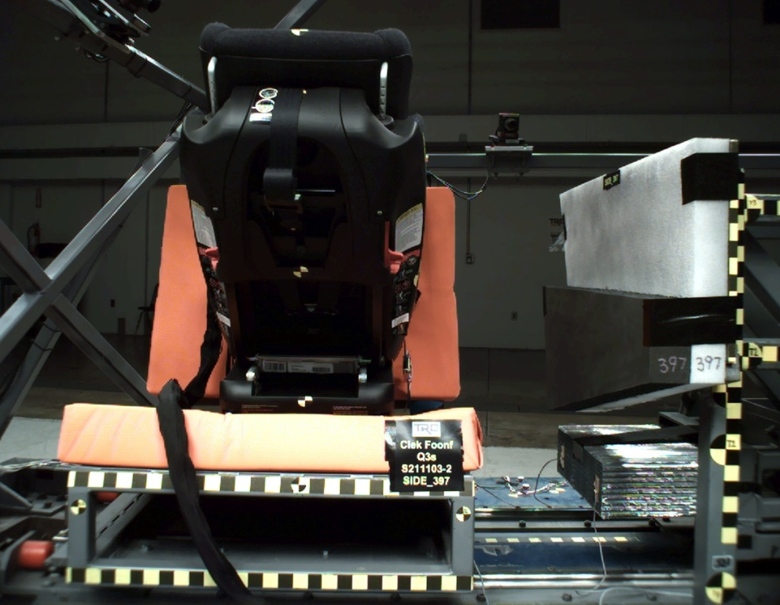

DUMMY POSITIONING FARO MEASUREMENTS
Description | Units | X | Y | Z
Origin Post | mm | -0.33 | 0.04 | 0.05
Front of Sliding Seat | mm | -154.92 | 672.67 | 576.19
Sliding Seat Corner | mm | -162.75 | 373.04 | 561.05
Point S1 | mm | -148.30 | 392.22 | 622.02
Point S2 | mm | -150.39 | 1050.55 | 625.30
Honeycomb Corner | mm | -316.99 | 97.43 | 582.73
Z point | mm | -771.96 | 1070.13 | 685.89
Back of Sliding Seat | mm | -892.29 | 672.07 | 4.47
CRS base center top | mm | -237.15 | 671.91 | 446.03
CRS mid height | mm | -140.60 | 674.38 | 213.34
CRS top of the seat | mm | -4.49 | 672.97 | -53.66
CRS top of headrest | mm | 4.20 | 669.95 | -144.02
CRS bottom Center | mm | -660.27 | 673.28 | 166.15
Top of Head | mm | -146.83 | 673.78 | -179.18
Front of Face | mm | -259.71 | 672.59 | -114.82
Head CG Right | mm | -176.20 | 606.66 | -96.85
Head CG Left | mm | -174.39 | 741.70 | -99.22
Chest Clip | mm | -320.25 | 669.37 | 0.48
Buckle | mm | -469.38 | 672.76 | 168.49
Right Knee Out | mm | -574.41 | 554.98 | 119.60
DUMMY POSITIONING FARO MEASUREMENTS, CONTINUED
Description | Units | X | Y | Z
Right Leg Up | mm | -625.71 | 563.08 | 55.36
Right Leg Down | mm | -701.47 | 542.66 | 18.14
Right Ankle | mm | -755.33 | 504.73 | 20.57
Left Knee Out | mm | -584.62 | 790.06 | 121.39
Left Leg Up | mm | -629.58 | 779.34 | 53.87
Left Leg Down | mm | -704.59 | 792.01 | 13.12
Left Ankle | mm | -768.42 | 825.18 | 13.16
CRS 1 | mm | -138.63 | 471.05 | 0.10
CRS 4 | mm | -313.38 | 465.68 | 212.82
CRS 2 | mm | -416.64 | 463.76 | 262.93
CRS 3 | mm | -558.86 | 456.92 | 207.86

