DUMMY POSITIONING

CRS: Graco 4Ever – Rearward Facing – LA Only

TRC Test Number: S211102-1 VRTC Test Number: SIDE_395
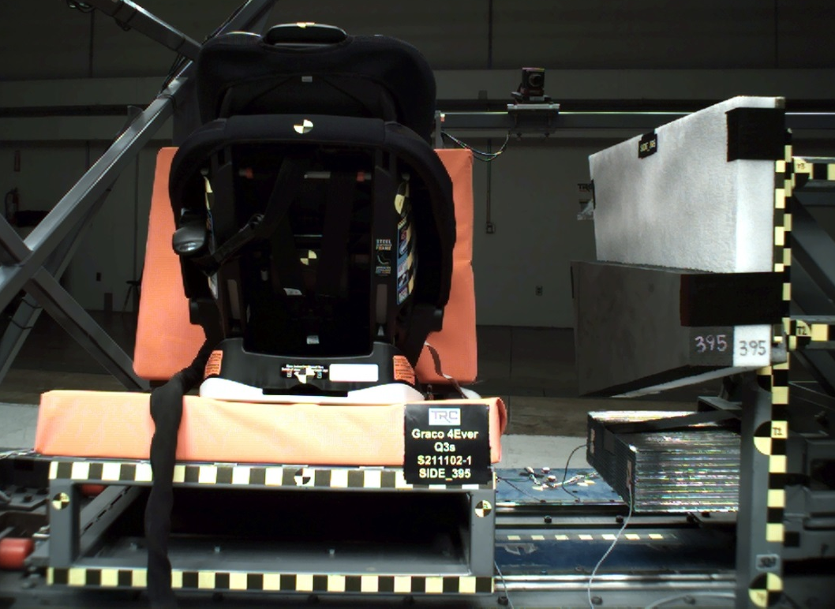

DUMMY POSITIONING FARO MEASUREMENTS
Description | Units | X | Y | Z
Origin Post | mm | -0.09 | -0.17 | 0.09
Front of Sliding Seat | mm | -154.82 | 672.79 | 576.42
Sliding Seat Corner | mm | -162.58 | 373.08 | 561.06
Point S1 | mm | -148.17 | 392.29 | 621.94
Point S2 | mm | -150.34 | 1050.60 | 625.42
Honeycomb Corner | mm | -317.08 | 96.24 | 580.70
Z point | mm | -771.78 | 1070.18 | 686.42
Back of Sliding Seat | mm | -892.19 | 671.82 | 4.52
CRS base center top | mm | -190.21 | 673.81 | 423.52
CRS mid height | mm | -168.25 | 671.07 | 238.09
CRS top of the seat | mm | -32.04 | 669.56 | 55.23
CRS top of headrest | mm | -25.58 | 670.78 | -88.53
CRS bottom Center | mm | -678.85 | 671.08 | 247.65
Top of Head | mm | -173.81 | 674.03 | -78.15
Front of Face | mm | -284.83 | 673.32 | -11.99
Head CG Right | mm | -202.37 | 606.90 | 5.04
Head CG Left | mm | -200.04 | 741.39 | 2.79
Chest Clip | mm | -345.92 | 673.76 | 91.92
Buckle | mm | -482.09 | 670.56 | 222.21
Right Knee Out | mm | -606.45 | 582.13 | 220.52
DUMMY POSITIONING FARO MEASUREMENTS, CONTINUED
Description | Units | X | Y | Z
Right Leg Up | mm | -633.00 | 607.84 | 146.21
Right Leg Down | mm | -694.90 | 607.48 | 85.14
Right Ankle | mm | -752.60 | 580.96 | 64.90
Left Knee Out | mm | -612.49 | 753.40 | 218.13
Left Leg Up | mm | -636.98 | 735.84 | 142.48
Left Leg Down | mm | -697.91 | 739.68 | 81.24
Left Ankle | mm | -762.28 | 767.47 | 61.16
CRS 1 | mm | -90.69 | 525.22 | 144.31
CRS 4 | mm | -254.09 | 533.95 | 367.27
CRS 2 | mm | -415.92 | 436.80 | 307.37
CRS 3 | mm | -564.23 | 462.54 | 291.88

