DUMMY POSITIONING

CRS: Evenflo LiteMax – Rearward Facing – SB3PT

TRC Test Number: S211028-1 VRTC Test Number: SIDE_394
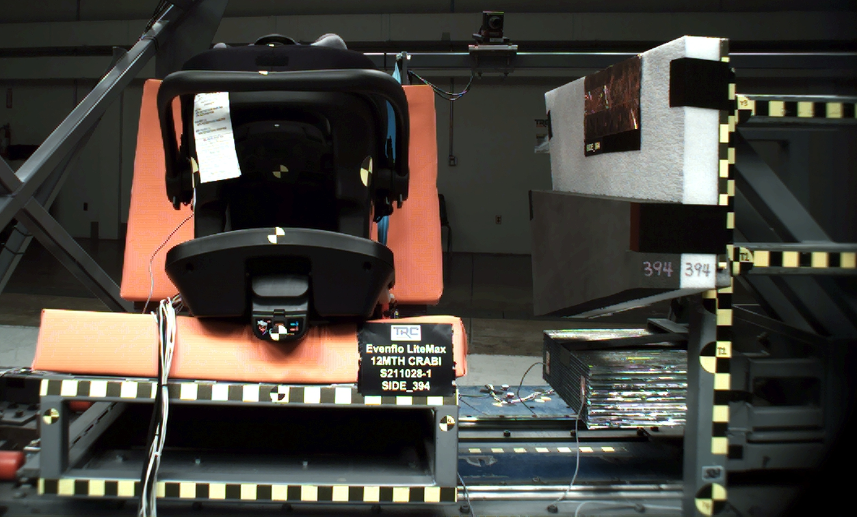

DUMMY POSITIONING FARO MEASUREMENTS
Description | Units | X | Y | Z
Origin Post | mm | -0.02 | -0.25 | 0.07
Front of Sliding Seat | mm | -154.83 | 671.19 | 576.35
Sliding Seat Corner | mm | -162.57 | 371.46 | 561.02
Point S1 | mm | -148.17 | 390.80 | 621.84
Point S2 | mm | -150.34 | 1049.21 | 625.34
Honeycomb Corner | mm | -317.23 | 95.32 | 574.86
Z point | mm | -771.39 | 1068.87 | 686.95
Back of Sliding Seat | mm | -892.17 | 670.44 | 4.32
CRS base center top | Mm | -87.75 | 670.52 | 307.95
CRS base center bottom | mm | -110.98 | 667.36 | 467.50
CRS mid height | mm | -145.28 | 670.39 | 209.06
CRS handle | mm | 14.55 | 676.00 | 70.10
CRS top of the seat | mm | -52.79 | 673.86 | 20.30
CRS top of base | mm | -637.03 | 671.21 | 410.49
CRS handle side | mm | -317.51 | 448.65 | 221.25
CRS bottom Center | mm | -625.46 | 673.48 | 366.81
Top of Head | mm | -193.84 | 673.23 | 2.00
Front of Face | mm | -279.14 | 670.97 | 46.08
Head CG | mm | -217.45 | 609.83 | 70.42
Chest Clip | mm | -302.47 | 672.96 | 156.65
DUMMY POSITIONING FARO MEASUREMENTS, CONTINUED
Description | Units | X | Y | Z
Right Knee | mm | -516.59 | 597.08 | 331.60
Right Ankle | mm | -663.11 | 595.85 | 319.77
Left Knee | mm | -515.73 | 743.88 | 333.30
Left Ankle | mm | -659.28 | 745.92 | 315.27
CRS 1 | mm | -151.54 | 529.41 | 205.34
CRS 4 | mm | -281.13 | 475.13 | 396.38
CRS 2 | mm | -366.81 | 519.18 | 355.59
CRS 3 | mm | -641.03 | 494.35 | 409.22

