DUMMY POSITIONING

CRS: Chicco NextFit – Forward Facing – LATCH

TRC Test Number: S211027-2 VRTC Test Number: SIDE_393
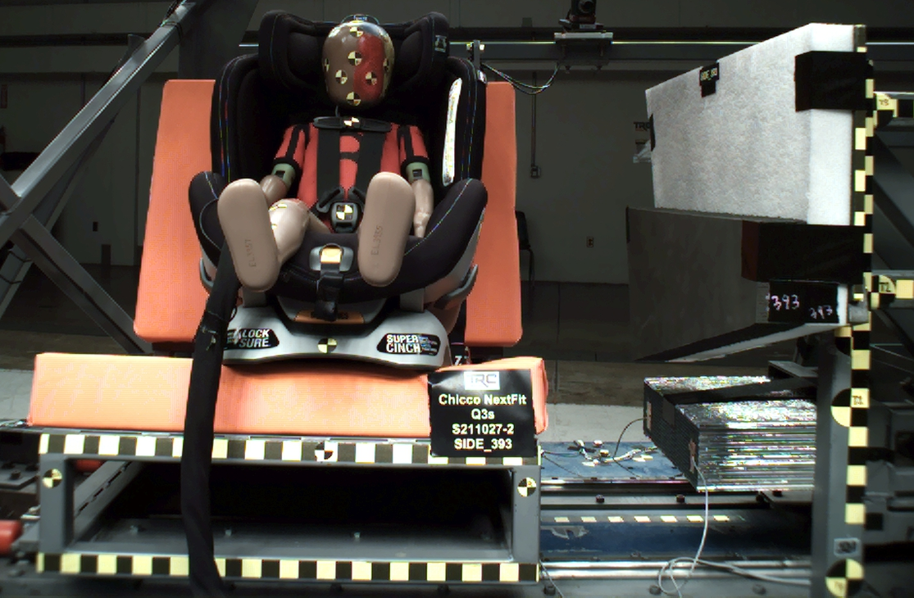

DUMMY POSITIONING FARO MEASUREMENTS
Description | Units | X | Y | Z
Origin Post | mm | -0.25 | -0.13 | 0.14
Front of Sliding Seat | mm | -154.87 | 673.10 | 576.68
Point S1 | mm | -148.35 | 392.62 | 621.96
Point S2 | mm | -150.45 | 1051.02 | 625.30
Sliding Seat Corner | mm | -162.83 | 373.34 | 561.06
Honeycomb Corner | mm | -318.81 | 96.24 | 586.17
Z point | mm | -771.97 | 1070.57 | 686.42
Back of Sliding Seat | mm | -895.38 | 978.14 | 5.92
Front of Base | mm | -167.70 | 672.34 | 430.37
Top of Seat | mm | -795.32 | 670.36 | -46.26
Top of Headrest | mm | -785.46 | 673.73 | -145.79
Top of Head | mm | -642.80 | 668.68 | -106.14
Front of Face | mm | -545.87 | 668.88 | -20.26
Left Head CG | mm | -631.81 | 600.47 | -22.91
Right Head CG | mm | -630.28 | 735.39 | -19.84
Left Shoulder | mm | -594.30 | 555.94 | 117.90
Chest Clip | mm | -512.16 | 669.84 | 95.65
Buckle | mm | -389.68 | 669.54 | 254.76
CRS 1 | mm | -641.27 | 460.42 | 53.54
CRS 4 | mm | -541.13 | 472.21 | 306.21
DUMMY POSITIONING FARO MEASUREMENTS, CONTINUED
Description | Units | X | Y | Z
CRS 2 | mm | -444.61 | 459.84 | 324.66
CRS 3 | mm | -306.58 | 451.41 | 267.28
Left Knee Outer | mm | -258.77 | 571.94 | 259.71
Left Knee Top | mm | -265.49 | 596.21 | 234.26
Left Leg Up | mm | -183.44 | 593.99 | 238.97
Left Leg Down | mm | -98.87 | 594.94 | 258.15
Left Ankle | mm | -47.40 | 572.93 | 301.26
Right Knee Outer | mm | -264.42 | 769.34 | 260.74
Right Knee Top | mm | -267.83 | 744.64 | 231.98
Right Leg Up | mm | -187.32 | 748.39 | 241.99
Right Leg Down | mm | -104.04 | 748.92 | 265.78
Right Ankle | mm | -59.45 | 771.46 | 309.01

