DUMMY POSITIONING

CRS: Cybex Sirona M – Forward Facing – SB3PT&T

TRC Test Number: S211027-1 VRTC Test Number: SIDE_392
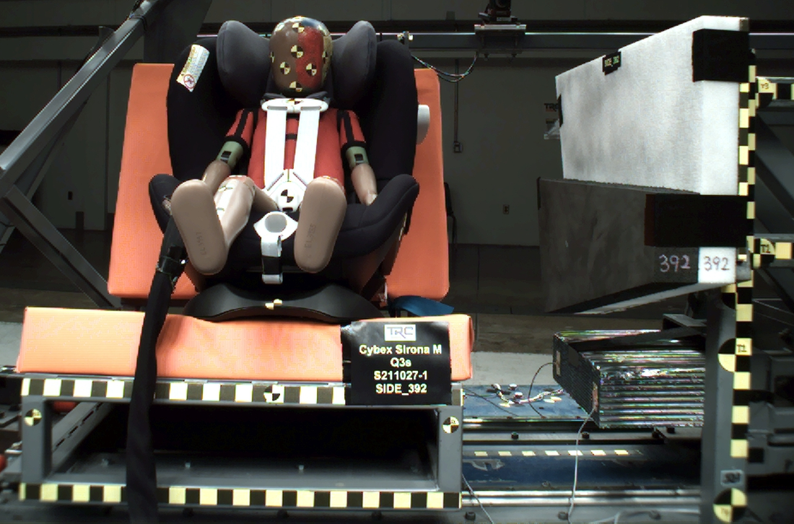

DUMMY POSITIONING FARO MEASUREMENTS
Description | Units | X | Y | Z
Origin Post | mm | -0.17 | -0.19 | 0.10
Front of Sliding Seat | mm | -154.85 | 672.50 | 576.36
Point S1 | mm | -148.19 | 392.21 | 621.93
Point S2 | mm | -150.32 | 1050.48 | 625.24
Sliding Seat Corner | mm | -162.67 | 372.87 | 561.07
Honeycomb Corner | mm | -324.67 | 96.75 | 584.36
Z point | mm | -771.17 | 1070.59 | 686.84
Back of Sliding Seat | mm | -894.67 | 978.03 | 5.76
Front of Base | mm | -165.23 | 673.07 | 435.56
Top of Seat | mm | -795.49 | 670.64 | -30.63
Top of Headrest | mm | -745.14 | 673.36 | -58.41
Top of Head | mm | -630.87 | 669.95 | -99.33
Front of Face | mm | -536.83 | 671.81 | -9.51
Left Head CG | mm | -621.82 | 601.52 | -15.76
Right Head CG | mm | -622.46 | 737.22 | -12.62
Left Shoulder | mm | -594.42 | 554.30 | 125.68
Chest Clip | mm | -502.32 | 671.22 | 92.70
Buckle | mm | -372.33 | 671.52 | 278.15
CRS 1 | mm | -630.09 | 449.87 | 7.72
CRS 4 | mm | -572.39 | 453.95 | 275.29
DUMMY POSITIONING FARO MEASUREMENTS, CONTINUED
Description | Units | X | Y | Z
CRS 2 | mm | -458.23 | 459.16 | 371.95
CRS 3 | mm | -312.57 | 461.76 | 324.84
Left Knee Outer | mm | -255.13 | 567.45 | 266.13
Left Knee Top | mm | -262.16 | 589.97 | 239.01
Left Leg Up | mm | -178.44 | 591.68 | 254.15
Left Leg Down | mm | -97.21 | 598.40 | 283.88
Left Ankle | mm | -52.04 | 580.65 | 334.55
Right Knee Outer | mm | -258.31 | 774.47 | 265.72
Right Knee Top | mm | -261.91 | 749.82 | 238.61
Right Leg Up | mm | -181.19 | 753.99 | 256.20
Right Leg Down | mm | -100.41 | 754.98 | 288.87
Right Ankle | mm | -60.39 | 776.67 | 337.94

