DUMMY POSITIONING

CRS: Safety 1st Grow and Go – Forward Facing – LATCH

TRC Test Number: S211026-2 VRTC Test Number: SIDE_391
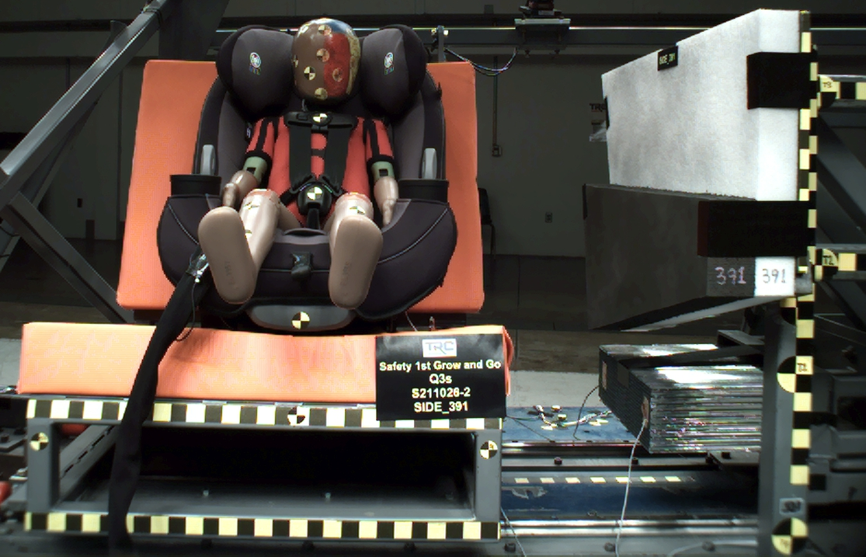

DUMMY POSITIONING FARO MEASUREMENTS
Description | Units | X | Y | Z
Origin Post | mm | -0.07 | -0.15 | 0.10
Front of Sliding Seat | mm | -154.79 | 673.05 | 576.38
Point S1 | mm | -148.22 | 392.52 | 622.16
Point S2 | mm | -150.26 | 1050.97 | 625.52
Sliding Seat Corner | mm | -162.61 | 373.39 | 560.96
Honeycomb Corner | mm | -319.36 | 96.87 | 579.60
Z point | mm | -771.42 | 1071.02 | 686.83
Back of Sliding Seat | mm | -894.19 | 978.51 | 5.49
Front of Base | mm | -182.67 | 671.59 | 442.46
Top of Seat | mm | -822.43 | 673.72 | -33.48
Top of Headrest | mm | -803.09 | 672.59 | -94.43
Top of Head | mm | -630.90 | 670.14 | -82.89
Front of Face | mm | -536.56 | 670.34 | 5.00
Left Head CG | mm | -624.11 | 604.20 | 2.66
Right Head CG | mm | -620.91 | 738.58 | 1.94
Left Shoulder | mm | -589.60 | 559.27 | 147.27
Chest Clip | mm | -502.84 | 672.34 | 122.27
Buckle | mm | -388.41 | 670.75 | 261.04
CRS 1 | mm | -766.87 | 535.20 | 29.85
CRS 4 | mm | -676.32 | 535.67 | 291.59
CRS 2 | mm | -480.03 | 518.16 | 393.95
DUMMY POSITIONING FARO MEASUREMENTS, CONTINUED
Description | Units | X | Y | Z
CRS 3 | mm | -327.38 | 534.13 | 434.74
Left Knee Outer | mm | -275.72 | 569.06 | 282.01
Left Knee Top | mm | -282.24 | 593.39 | 256.37
Left Leg Up | mm | -196.80 | 591.28 | 277.65
Left Leg Down | mm | -118.87 | 593.59 | 313.55
Left Ankle | mm | -77.10 | 572.71 | 368.75
Right Knee Outer | mm | -276.71 | 773.29 | 277.33
Right Knee Top | mm | -281.75 | 748.67 | 251.91
Right Leg Up | mm | -199.36 | 750.45 | 274.34
Right Leg Down | mm | -119.94 | 748.98 | 310.17
Right Ankle | mm | -81.95 | 772.00 | 358.98

