DUMMY POSITIONING

CRS: Baby Trend Hybrid 3-in-1 – Forward Facing – SB3PT&T

TRC Test Number: S211026-1 VRTC Test Number: SIDE_390
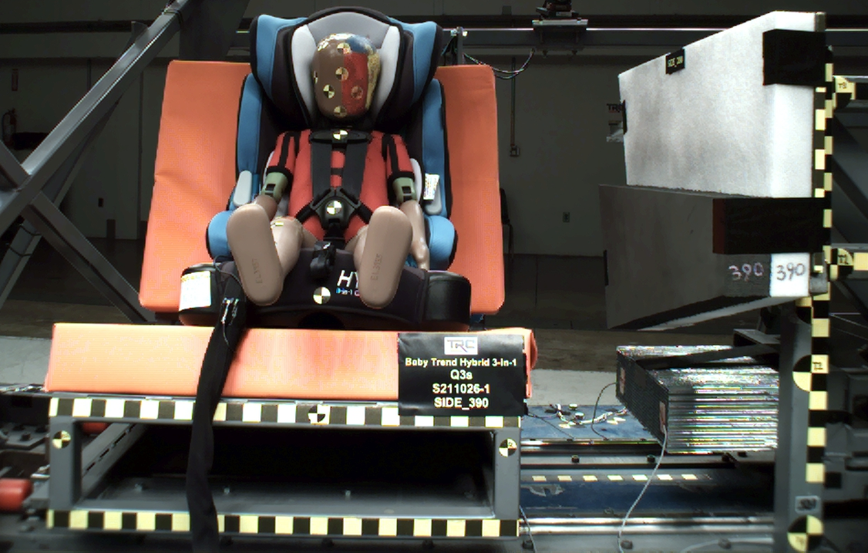

DUMMY POSITIONING FARO MEASUREMENTS
Description | Units | X | Y | Z
Origin Post | mm | -0.23 | -0.23 | 0.10
Front of Sliding Seat | mm | -154.87 | 671.56 | 576.40
Point S1 | mm | -148.30 | 391.26 | 621.47
Point S2 | mm | -150.31 | 1049.64 | 625.25
Sliding Seat Corner | mm | -162.76 | 371.82 | 561.13
Honeycomb Corner | mm | -315.22 | 96.71 | 582.30
Z point | mm | -771.73 | 1069.30 | 686.66
Back of Sliding Seat | mm | -894.78 | 976.94 | 5.68
Front of Base | mm | -223.42 | 672.92 | 414.17
Top of Headrest | mm | -854.17 | 673.09 | -146.07
Top of Head | mm | -632.03 | 669.61 | -57.35
Front of Face | mm | -546.31 | 671.72 | 38.51
Left Head CG | mm | -631.64 | 602.77 | 28.39
Right Head CG | mm | -630.77 | 739.15 | 30.41
Left Shoulder | mm | -610.96 | 558.94 | 173.64
Chest Clip | mm | -522.02 | 670.94 | 153.12
Buckle | mm | -419.04 | 671.79 | 286.79
CRS 1 | mm | -704.20 | 479.71 | 59.66
CRS 4 | mm | -606.14 | 468.37 | 315.92
CRS 2 | mm | -506.64 | 465.24 | 400.81
DUMMY POSITIONING FARO MEASUREMENTS, CONTINUED
Description | Units | X | Y | Z
CRS 3 | mm | -341.19 | 436.61 | 446.36
Left Knee Outer | mm | -298.74 | 566.98 | 332.58
Left Knee Top | mm | -303.69 | 590.49 | 306.80
Left Leg Up | mm | -222.64 | 584.86 | 311.02
Left Leg Down | mm | -137.43 | 583.47 | 328.71
Left Ankle | mm | -85.43 | 560.42 | 373.56
Right Knee Outer | mm | -302.06 | 770.05 | 323.78
Right Knee Top | mm | -306.35 | 747.00 | 297.66
Right Leg Up | mm | -226.25 | 747.74 | 305.75
Right Leg Down | mm | -142.66 | 744.45 | 326.90
Right Ankle | mm | -95.31 | 763.17 | 372.63

