DUMMY POSITIONING

CRS: Nuna Rava – Forward Facing – SB3PT&T

TRC Test Number: S211025-2 VRTC Test Number: SIDE_389
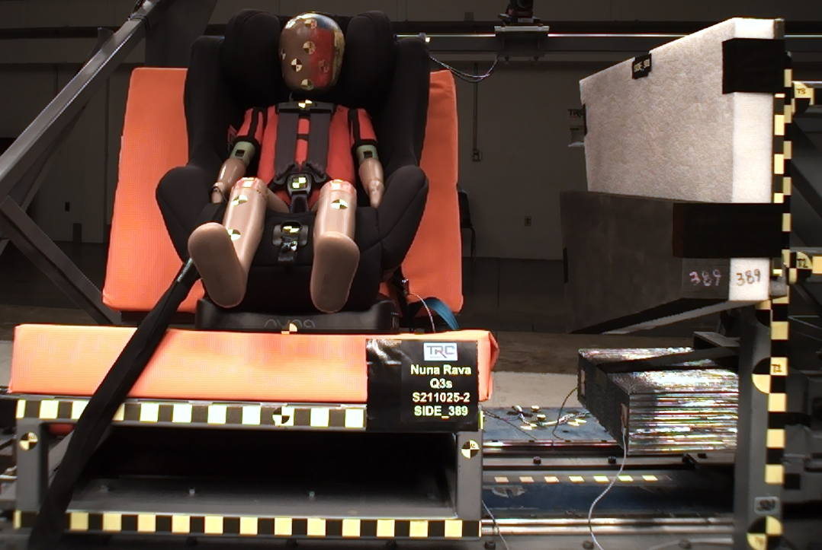

DUMMY POSITIONING FARO MEASUREMENTS
Description | Units | X | Y | Z
Origin Post | mm | -0.18 | -0.19 | 0.10
Front of Sliding Seat | mm | -154.90 | 671.70 | 576.07
Point S1 | mm | -148.14 | 391.30 | 622.12
Point S2 | mm | -150.34 | 1049.57 | 625.60
Sliding Seat Corner | mm | -162.62 | 372.04 | 561.05
Honeycomb Corner | mm | -313.26 | 96.10 | 585.24
Z point | mm | -771.77 | 1069.11 | 686.18
Back of Sliding Seat | mm | -894.31 | 976.86 | 5.38
Front of Base | mm | -256.26 | 670.58 | 469.34
Top of Seat | mm | -826.17 | 668.75 | -55.75
Top of Headrest | mm | -803.11 | 673.07 | -143.43
Top of Head | mm | -671.65 | 669.71 | -114.53
Front of Face | mm | -575.71 | 669.16 | -28.32
Left Head CG | mm | -663.11 | 602.22 | -30.36
Right Head CG | mm | -658.35 | 737.50 | -28.98
Left Shoulder | mm | -628.03 | 554.95 | 111.69
Chest Clip | mm | -541.01 | 672.53 | 82.79
Buckle | mm | -417.07 | 671.10 | 235.69
CRS 1 | mm | -661.47 | 451.52 | 38.90
CRS 4 | mm | -568.68 | 480.94 | 297.88
CRS 2 | mm | -501.73 | 479.21 | 321.76
DUMMY POSITIONING FARO MEASUREMENTS, CONTINUED
Description | Units | X | Y | Z
CRS 3 | mm | -356.54 | 470.61 | 291.30
Left Knee Outer | mm | -291.75 | 568.36 | 253.82
Left Knee Top | mm | -296.63 | 592.99 | 228.56
Left Leg Up | mm | -214.93 | 592.13 | 262.70
Left Leg Down | mm | -143.77 | 596.39 | 311.34
Left Ankle | mm | -110.49 | 575.74 | 372.47
Right Knee Outer | mm | -295.87 | 771.31 | 254.47
Right Knee Top | mm | -297.23 | 746.17 | 226.62
Right Leg Up | mm | -217.62 | 748.79 | 259.66
Right Leg Down | mm | -144.32 | 747.26 | 309.03
Right Ankle | mm | -115.56 | 768.99 | 362.62

