DUMMY POSITIONING

CRS: Graco Nautilus 65 LX – Forward Facing – SB3PT&T

TRC Test Number: S211025-1 VRTC Test Number: SIDE_388
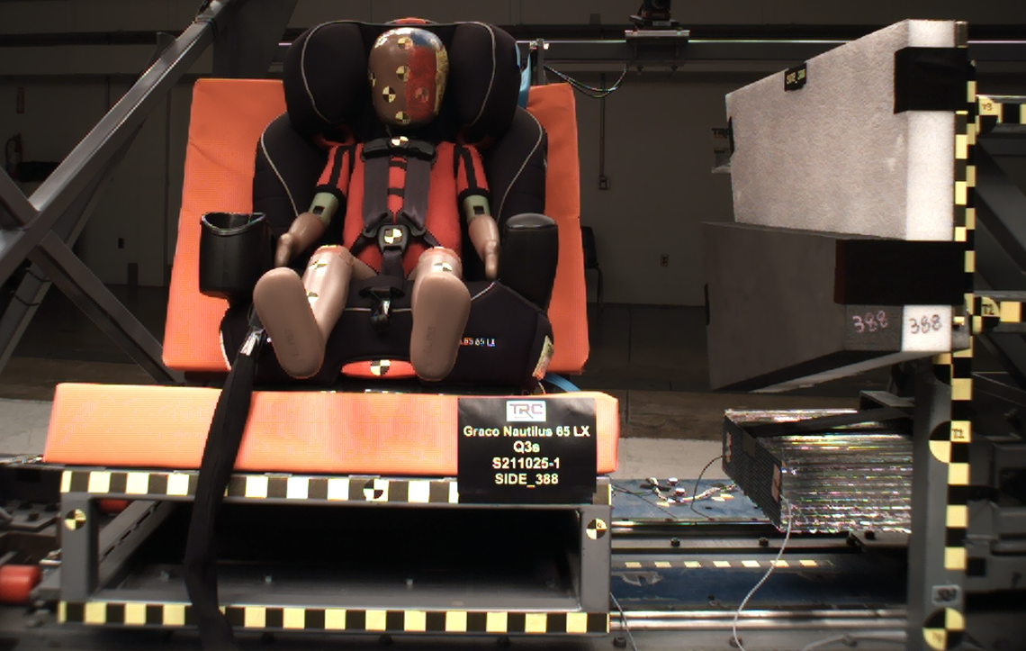

DUMMY POSITIONING FARO MEASUREMENTS
Description | Units | X | Y | Z
Origin Post | mm | -0.06 | -0.40 | 0.09
Front of Sliding Seat | mm | -154.86 | 672.61 | 576.38
Point S1 | mm | -148.23 | 392.27 | 622.51
Point S2 | mm | -150.35 | 1050.50 | 625.19
Sliding Seat Corner | mm | -162.69 | 372.97 | 561.10
Honeycomb Corner | mm | -326.01 | 96.78 | 584.91
Z point | mm | -771.93 | 1070.67 | 685.09
Back of Sliding Seat | mm | -894.38 | 977.61 | 5.00
Front of Base | mm | -218.35 | 672.85 | 430.96
Top of Seat | mm | -780.08 | 672.04 | 10.73
Top of Headrest | mm | -800.14 | 671.02 | -133.90
Top of Head | mm | -619.51 | 669.20 | -85.80
Front of Face | mm | -531.22 | 669.25 | 6.75
Left Head CG | mm | -616.54 | 600.35 | -2.56
Right Head CG | mm | -615.38 | 735.21 | 1.70
Left Shoulder | mm | -592.17 | 552.22 | 143.36
Chest Clip | mm | -508.72 | 671.83 | 116.34
Buckle | mm | -406.45 | 671.66 | 268.05
CRS 1 | mm | -715.02 | 468.07 | 66.76
CRS 4 | mm | -656.59 | 533.34 | 335.05
CRS 2 | mm | -518.67 | 457.32 | 370.81
DUMMY POSITIONING FARO MEASUREMENTS, CONTINUED
Description | Units | X | Y | Z
CRS 3 |  | -378.34 | 434.82 | 322.09
Left Knee Outer | mm | -284.39 | 567.86 | 302.28
Left Knee Top | mm | -289.00 | 592.23 | 276.70
Left Leg Up | mm | -205.97 | 590.99 | 296.90
Left Leg Down | mm | -126.53 | 592.86 | 332.22
Left Ankle | mm | -84.17 | 571.67 | 384.35
Right Knee Outer | mm | -290.08 | 776.13 | 304.23
Right Knee Top | mm | -291.54 | 751.41 | 276.66
Right Leg Up | mm | -211.39 | 754.52 | 297.88
Right Leg Down | mm | -131.49 | 752.64 | 333.86
Right Ankle | mm | -94.23 | 774.28 | 383.57

