DUMMY POSITIONING

CRS: Graco Nautilus 65 – Forward Facing – SB3PT&T

TRC Test Number: S211018-2 VRTC Test Number: SIDE_382
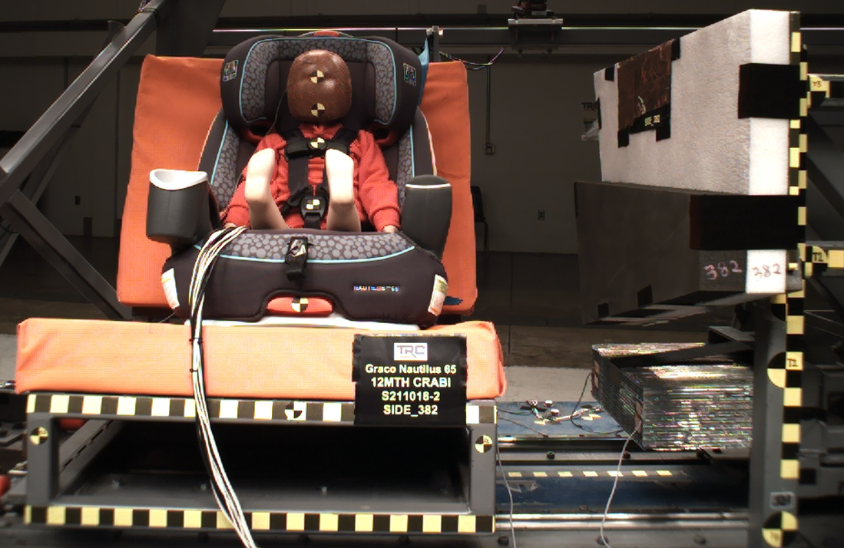

DUMMY POSITIONING FARO MEASUREMENTS
Description | Units | X | Y | Z
Origin Post | mm | 0.08 | -0.32 | -0.22
Front of Sliding Seat | mm | -154.70 | 671.08 | 576.12
Sliding Seat Corner | mm | -162.60 | 371.35 | 560.76
Point S1 | mm | -148.19 | 390.63 | 621.43
Point S2 | mm | -150.15 | 1048.89 | 625.11
Honeycomb Corner | mm | -315.55 | 97.15 | 587.21
Z point | mm | -771.43 | 1069.15 | 685.73
Back of Sliding Seat | mm | -895.20 | 976.67 | 5.67
CRS top of the seat | Mm | -794.91 | 669.44 | 19.53
CRS top of the headrest | mm | -779.74 | 669.21 | -81.89
CRS bottom Center | mm | -215.41 | 670.03 | 427.89
Top of Head | mm | -596.63 | 673.11 | -13.89
Front of Face | mm | -522.01 | 672.10 | 46.23
Head CG | mm | -585.98 | 609.77 | 55.13
Shoulder | mm | -593.46 | 565.28 | 175.87
Chest Clip | mm | -512.28 | 668.08 | 172.32
Buckle | mm | -438.41 | 669.32 | 286.82
Right Knee | mm | -389.61 | 748.30 | 340.25
Right Ankle | mm | -264.68 | 761.71 | 264.68
Left Knee | mm | -381.17 | 586.79 | 338.60
DUMMY POSITIONING FARO MEASUREMENTS, CONTINUED
Description | Units | X | Y | Z
CRS 1 | mm | -712.00 | 537.06 | 168.71
CRS 4 | mm | -615.24 | 538.05 | 424.90
CRS 2 | mm | -524.03 | 460.86 | 373.72
CRS 3 | mm | -378.15 | 433.76 | 347.69

