DUMMY POSITIONING

CRS: Cosco Scenera Next – Forward Facing – SB3PT&T

TRC Test Number: S211018-1 VRTC Test Number: SIDE_381
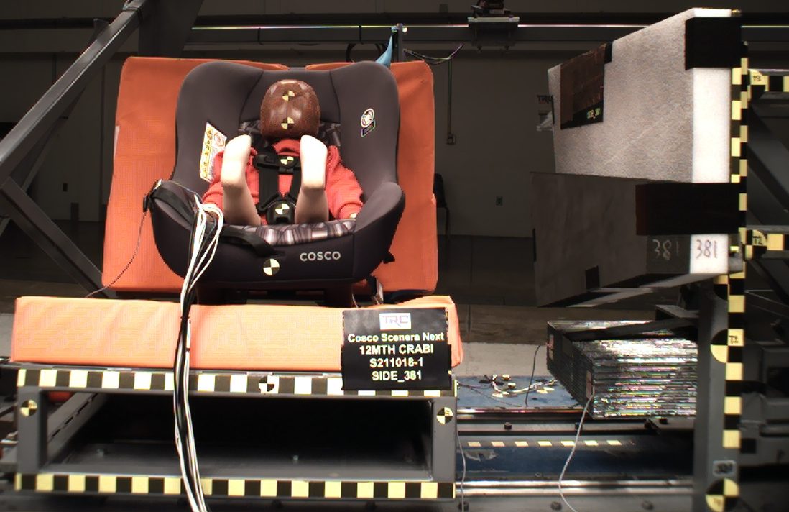

DUMMY POSITIONING FARO MEASUREMENTS
Description | Units | X | Y | Z
Origin Post | mm | 0.11 | -0.16 | 0.05
Front of Sliding Seat | mm | -155.22 | 671.22 | 576.46
Sliding Seat Corner | mm | -162.83 | 371.67 | 561.06
Point S1 | mm | -148.41 | 390.67 | 621.89
Point S2 | mm | -150.91 | 1049.09 | 625.64
Honeycomb Corner | mm | -315.93 | 96.02 | 579.73
Z point | mm | -772.38 | 1068.80 | 688.00
Back of Sliding Seat | mm | -894.27 | 976.73 | 5.10
CRS top of the seat | Mm | -820.21 | 670.28 | 22.04
CRS bottom Center | mm | -184.20 | 670.23 | 396.12
Top of Head | mm | -646.89 | 671.38 | 58.58
Front of Face | mm | -556.25 | 673.26 | 93.33
Head CG | mm | -613.87 | 611.30 | 123.63
Shoulder | mm | -585.57 | 570.05 | 241.11
Chest Clip | mm | -496.50 | 670.05 | 226.06
Buckle | mm | -382.57 | 669.35 | 315.72
Right Knee | mm | -329.47 | 750.95 | 341.53
Right Ankle | mm | -208.04 | 754.59 | 258.15
Left Knee | mm | -330.02 | 590.88 | 338.86
Left Ankle | mm | -211.19 | 587.63 | 260.30
DUMMY POSITIONING FARO MEASUREMENTS, CONTINUED
Description | Units | X | Y | Z
CRS 1 | mm | -699.94 | 538.68 | 127.86
CRS 4 | mm | -632.97 | 539.70 | 393.27
CRS 2 | mm | -423.52 | 504.12 | 394.55
CRS 3 | mm | -274.82 | 538.07 | 412.63

