DUMMY POSITIONING

CRS: Evenflo LITE MAX – Rearward Facing – SB3PT

TRC Test Number: S211013-1 VRTC Test Number: SIDE_379
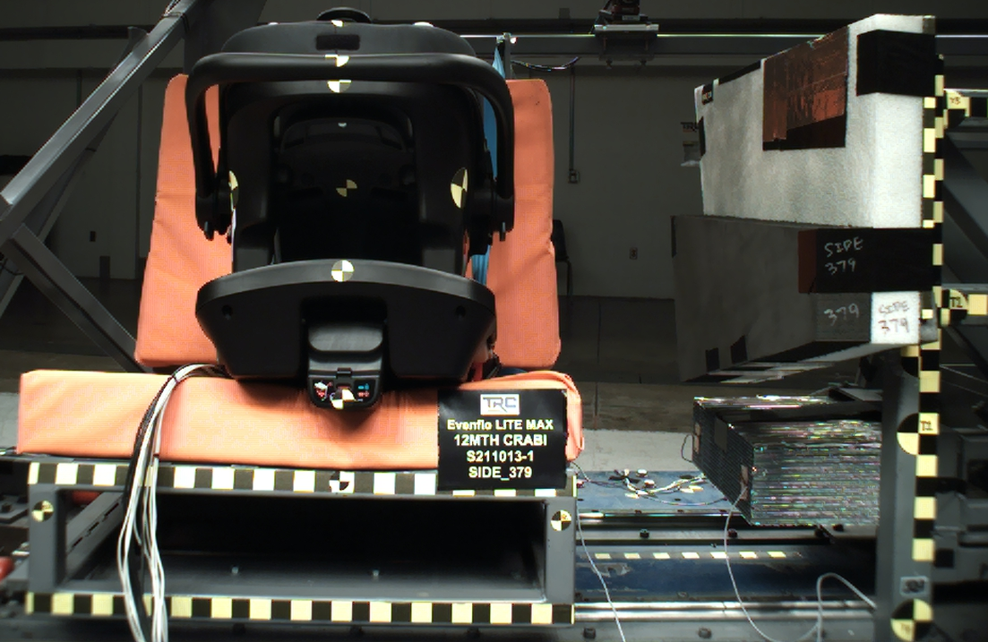

DUMMY POSITIONING FARO MEASUREMENTS
Description | Units | X | Y | Z
Origin Post | mm | -0.15 | -0.30 | 0.04
Front of Sliding Seat | mm | -154.98 | 674.02 | 576.45
Sliding Seat Corner | mm | -162.79 | 374.52 | 561.15
Point S1 | mm | -148.27 | 393.66 | 621.79
Point S2 | mm | -150.33 | 1052.21 | 625.41
Honeycomb Corner | mm | -315.11 | 94.99 | 569.00
Z point | mm | -771.30 | 1072.69 | 685.65
Back of Sliding Seat | mm | -891.69 | 673.71 | 3.78
CRS base center top | Mm | -87.24 | 667.94 | 302.84
CRS base center bottom | mm | -105.33 | 667.25 | 461.80
CRS mid height | mm | -150.06 | 669.71 | 204.94
CRS handle | mm | 15.61 | 668.28 | 65.12
CRS top of the seat | mm | -57.01 | 670.65 | 15.35
CRS top of base | mm | -627.24 | 670.13 | 420.71
CRS handle side | mm | -318.70 | 448.56 | 225.26
CRS bottom Center | mm | -627.48 | 673.40 | 371.79
Top of Head | mm | -199.88 | 671.61 | -1.06
Front of Face | mm | -286.43 | 669.43 | 43.07
Head CG | mm | -225.30 | 607.52 | 66.66
Chest Clip | mm | -309.67 | 675.06 | 156.71
DUMMY POSITIONING FARO MEASUREMENTS, CONTINUED
Description | Units | X | Y | Z
Buckle | mm | -430.08 | 675.35 | 280.09
Right Knee | mm | -512.15 | 594.68 | 343.19
Right Ankle | mm | -659.34 | 585.40 | 321.45
Left Knee | mm | -512.90 | 754.78 | 340.32
Left Ankle | mm | -655.05 | 759.74 | 323.28
CRS 1 | mm | -155.09 | 526.44 | 202.10
CRS 4 | mm | -277.50 | 473.53 | 401.63
CRS 2 | mm | -366.53 | 515.45 | 331.60
CRS 3 | mm | -642.28 | 494.72 | 419.63

