Seat Back Strength Requirements Study

FMVSS 301 Simulations with Rear Seat Passenger
Once the front seat models were developed and integrated with acceptable accuracy in terms of structural integrity and strength (comparing to seat back pull test), seat and occupant kinematics, dynamic characteristics (comparing FMVSS301 high speed rear impact sled test), the next step was to study the seat back strength requirements to avoid rear seat passenger injuries. This study was intended to observe the seat back movement that could potentially cause injuries to rear seat passenger in the rear crash events. As discussed with notable rear crash cases (Section 2.1), the rapid rear seat movement due to impact forces and occupant reaction on the seat back could cause severe injuries to the rear seat occupants such as children or adults due to interaction with the front seat or front seat occupant. Therefore, the necessary seat back strength has to be investigated with the rear seat occupant seated at the impact side of the vehicle, in this case the driver side. The detailed FE front seat models, driver side FE model of the Honda Accord MY 2014 full vehicle and Bio-RID II FE model were used to simulate the rear crash scenario. In this study 2 FEA models (for manual seat and power seat) with rear seat passenger were developed and investigated for the seat back strength.

Manual Seat – FMVSS 301 Simulation with Rear Seat Passenger
The FEA model used for sled test simulation in Section 5.2.1 was set up with a rear seat occupant dummy for FMVSS 301 rear crash. In this case Bio-RID II FE dummy model itself was used as rear seat passenger and positioned on the rear seat behind the driver side seat (manual seat) under investigation. The necessary rear seat head rest was modeled and integrated in the full vehicle representation of FE model. Figure 41 shows the FMVSS 301 FE model with rear seat occupant dummy.

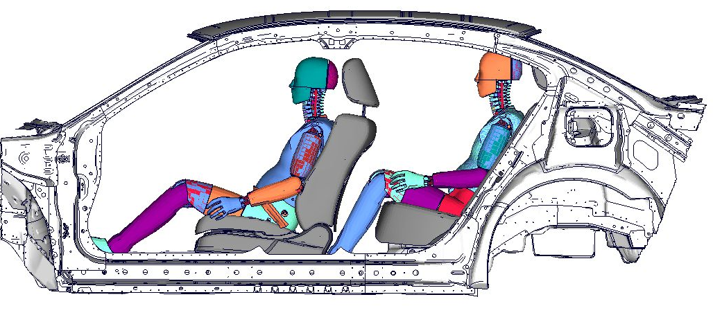
Figure 41: FMVSS 301 FE Model with Rear Seat Occupant Dummy – Manual Seat

LS-DYNA simulation was run for 200 milliseconds. The front seat back rotation and the rear seat occupant interaction with the front seat were observed. The front seat back movements are illustrated in the following Figure 42.

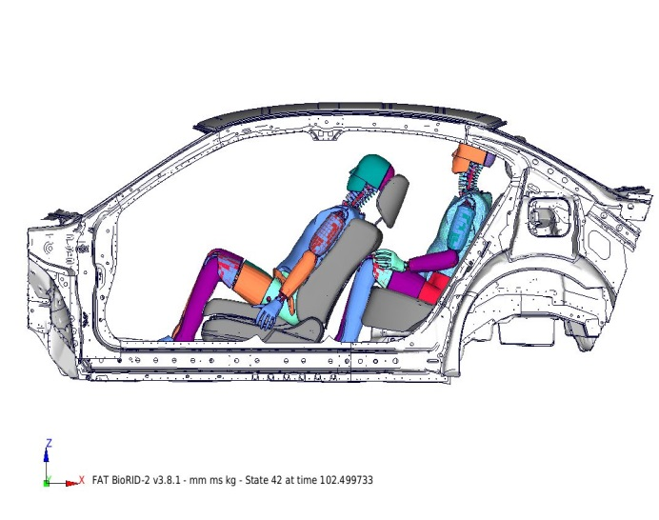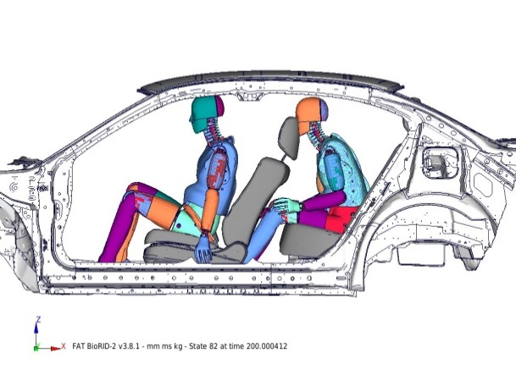
Front seat in contact with rear occupant knee
Front seat in at maximum impact with rear occupant
Figure 42: Front Seat Back and Rear Seat Occupant Interaction – Manual Seat

Power Seat – FMVSS 301 Simulation with Rear Seat Passenger
Similarly, the FEA model used for sled test simulation in Section 5.2.2 was set up with rear seat occupant dummy for FMVSS 301 rear crash. The Bio-RID II FE dummy model was used as rear seat passenger in unbelted condition as shown in Figure 43. LS-DYNA simulation was run for 200 milliseconds. The front seat back rotation and the rear seat occupant interaction with the front seat were observed for power seat. The front seat back movements of the power seat are illustrated in the following Figure 44.

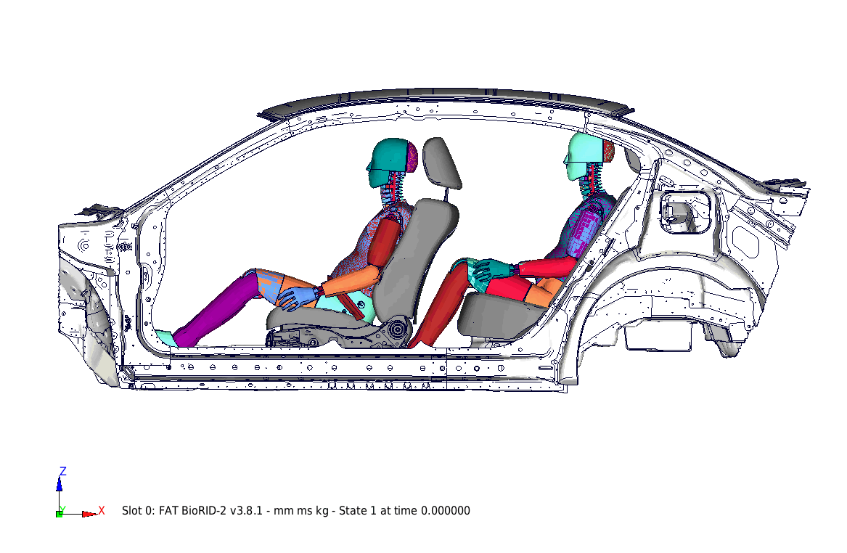
Figure 43: FMVSS 301 FE Model with Rear Seat Occupant Dummy – Power Seat

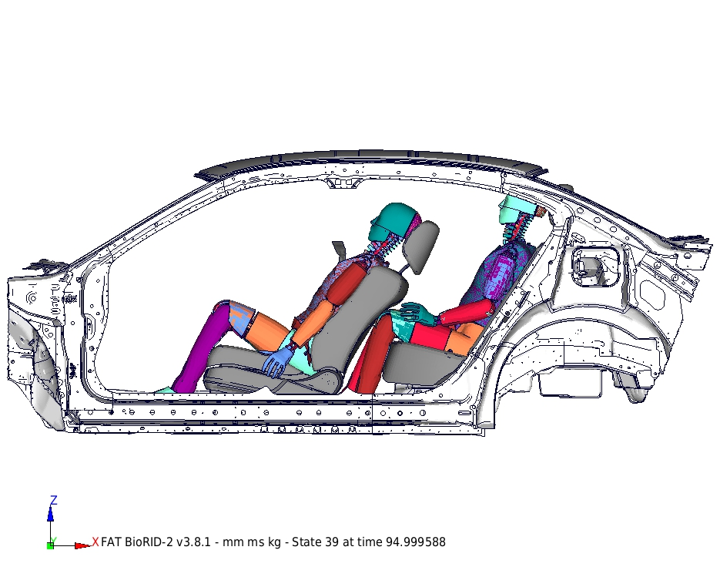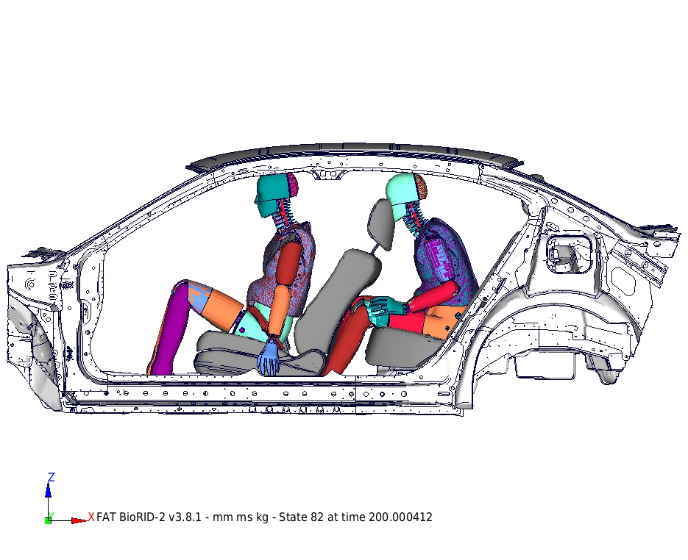
Front seat in contact with rear occupant knee
Front seat in at maximum impact with rear occupant
Figure 44: Front Seat Back and Rear Seat Occupant Interaction – Power Seat

