Conclusion and Recommendations
The primary objective of the project to identify the required seat tests and validate the front seat back strength was met. One quasi-static seat back pull test based on FMVSS 207 with extended loading until seat collapse was proposed. And, the other test to include the high speed rear impact scenario was also proposed. The seat back strength improvement investigation and study for the front seat driver seat was carried out by utilizing CAE techniques in a systematic approach. Starting with identifying the front seats of a good performing vehicle, the study was conducted by following the steps listed below.
- Identified a vehicle which is currently in the market
- Procured the necessary front seats (manual seat and power seat)
- Developed the FEA model of the seats
- Conducted quasi-static seat pull test and validated the FEA seat models by comparing the FEA simulations and tests
- Integrated the FEA seat models into the full vehicle FEA model
- Developed FMVSS 301 high speed rear impact FEA model by including Bio-RID II dummy model on the front seat.
- Conducted FMVSS 301 high speed rear impact Sled test using Bio-RID II dummy and validate the FEA models.
- Developed FMVSS 301 high speed rear impact FEA model by including front and rear seat occupant models
- Investigated the dynamic seat back motion of the front seat against the rear seat occupant.
- Having found significant injuries on the rear seat occupant, seat back strength was improved by necessary countermeasures on the seat bottom frame parts to reduce the injury level.
- Verified the improved seats did not affect the low speed rear impact performance using IIHS vehicle head restraint dynamic test simulations.
- Estimated the cost impact of seat modifications.

Summary of the study and recommended actions are provided in the following sections.

Summary of Project Results
In this project Honda Accord MY2014 was chosen for CAE based study. The reason being for this selection, EDAG had developed fully functional and validated FEA model of Honda Accord MY2014 for the previous projects. The FEA model could be used without a need for developing full vehicle model. The front seats of Honda Accord MY2014, readily available in the market were procured for the purpose of developing much more detailed seat models. Both manually operated and power operated front seats were purchased. Upon review of the seats, it was found that there were significant geometry changes. So, the FEA seat model already available in the full vehicle model was updated to reflect the changes. The Manual seat and Power seat were modeled separately with necessary details including the recliner mechanism. Two physical tests, FMVSS207 based quasi static seat back strength test and dynamic rear impact test were identified for model validation and seat back improvement study purposes respectively. The FEA seat models were validated by correlating the quasi-static seat back pull strength simulations to the physical test. Third party testing organization MGA was sub-contracted to conduct the quasi-static seat back pull tests for both manual and power seats. The seat model simulations results in terms of seat back rotation kinematics, static deflection were correlated to an acceptable 78% conformation and the seat models were considered to be good FEA models.

As per the scope, it was needed to study the occupant interaction with seats in the rear impact scenarios. The seat back strength and dynamic motion of the front seat in terms of front and rear seat occupant injury during rear impact was preliminary measurements to investigate the need for seat back improvement. Therefore, two rear impact scenarios modeling of occupant simulation were considered in the study. First, the front seat occupant interaction on the driver seat in the rear impact event was critical to observe the dynamic motion of the seat back towards the rear seat. Second, the rear seat occupant injuries due to the interaction of the front seat back. FEA models for these two scenarios were developed. In order to validate the modeling of the front seat occupant interaction on the driver seat, the high speed rear impact sled test was conducted for manual and power sets. Generic vehicle pulse based on FMVSS301 high speed rear impact pulse (20 G) was used for the sled speed. Bio-RID II 50th percentile male occupant dummy was calibrated and supplied by NHTSA. The results from the sled tests were used to compare the simulation results. Even though higher degree of correlation was not the scope of the project, good comparison was achieved and the occupant FEA models were considered good for the study. Two parts of the results, seat kinematics and occupant injuries were included for comparison. Seat back motion of manual and power seats with occupant dummies closely matched to that of the sled test respectively. The HIC values of occupant dummy of tests and simulations were compared to be less than 2% difference. The NIJ values were also comparable with a difference of 5%. Considering the objective of the project to determine the need for seat back strength improvement by reducing the dynamic motion of the seat back towards the rear set occupant, a directional outcome was intended rather than focusing on achieving higher degree of occupant model development. However, good correlated seat models were included in the study to reason the outcome to be valid.

The next part of the project involved the study of seat back strength requirement by including the rear seat occupant behind the driver seat. Both manual and power seats were studied separately by developing two separate rear impact occupant models. The occupant dummy chosen for the rear seat was the same Bio-RID II, 50th percentile male dummy in unbelted condition. The worst case scenario of front seat, full down and full rear position was set up as initial condition. The rear impact pulse of 20 G was applied as the sled speed. The front seat kinematics, front seat occupant injury and rear seat occupant injury were observed from the simulations. It was clearly seen that the rear seat rotated about 40° and hit the rear seat occupant knee. The rear seat occupant head hit the front seat back at an acceleration of 30G and HIC value of 51. The knee impact force was observed to be 3.5 kN. The seat back rotation observed from this study was considered high potential to cause injuries to the rear seat occupants of all types such as children and adults. It was evident to reduce the seat back dynamic motion by improving the seat strength.

Countermeasure actions were undertaken by FEA simulation iterations to reduce the seat back movement by setting necessary performance targets for optimization in terms of seat back rotation and occupant characteristics such HIC, NIJ and knee force. Seat parts modifications were made based on gauge and grade (2G) optimization of the highly deformed/displaced parts of seat back and seat bottom. It was noted that, modification of the seat back parts or recliner mechanism showed no improvement. Most of the seat back dynamic rotation was caused by weakness of the seat bottom frame parts and seat mechanism. EDAG countermeasure actions took place on the seat bottom frame parts only and any modification of the seat mechanism was assumed to increase the cost to seat manufacturers. While performing the countermeasures, attention was paid not to add weight more than 10% and not to involve any expensive design change. Out of several countermeasures, gauge increase to 3.0 mm from 1.8 mm and grade change to high strength steel on the seat bottom frames yielded the performance meeting the targets. This added 1.69 kg per seat and $2.73 cost increase per kg weight increase.

In the final stage of project, it was necessary to make sure that the countermeasures did not increase the seat rigidity which will affect the low speed rear impact regulatory requirements. For this purpose, the modified seats performances were verified by FEA simulations of one IIHS low speed rear impact case for vehicle head restraint dynamic test. Additionally, the results of the manual seat simulation were compared with the available test results from IIHS. Thus it was verified that the obtained countermeasures from this study did not affect any of the low speed rear impact regulatory requirements.

Recommendations
It can be noted that the entire study was limited to one type of occupant which was 50th percentile male. Both front seat strength observation in rear impact scenario and front seat back rotation to rear seat occupant involved only Bio-RID II 50th percentile male dummy. The observation of front seat back dynamic rotation causing potential injuries to rear seat occupant and the implemented countermeasures are from the occupant injuries of 50th percentile male. However, the severity of the injury can vary depending on different occupant (children, adult, etc.) and different riding condition such as belted, unbelted, add-on restraint systems for babies and young children such as child seat etc.

From this investigation and CAE based studies discussed in this report, with the evidence of front seats under certain configuration (seat position) causing injuries to the rear seat occupant (unbelted 50th percentile male), it is duly recommended that seat back dynamic rotation should be reduced to less than 35°. Currently it is estimated that the seat back rotation could reach up to 40° and cause head injuries and knee injuries to the 50th percentile male occupant. Apart from using 50th percentile male occupant in the rear seat, the directional outcome of this study, the seat back rotation range of 38.5° is useful to illustrate potentials of serious injuries to different occupant and different seating conditions. Figure 69 to 71 below show different rear seat occupants with more than 38.5°. It should be noted that, a minimum seat back rotation (less than 38.5°) could cause injury to 95th percentile male occupant.

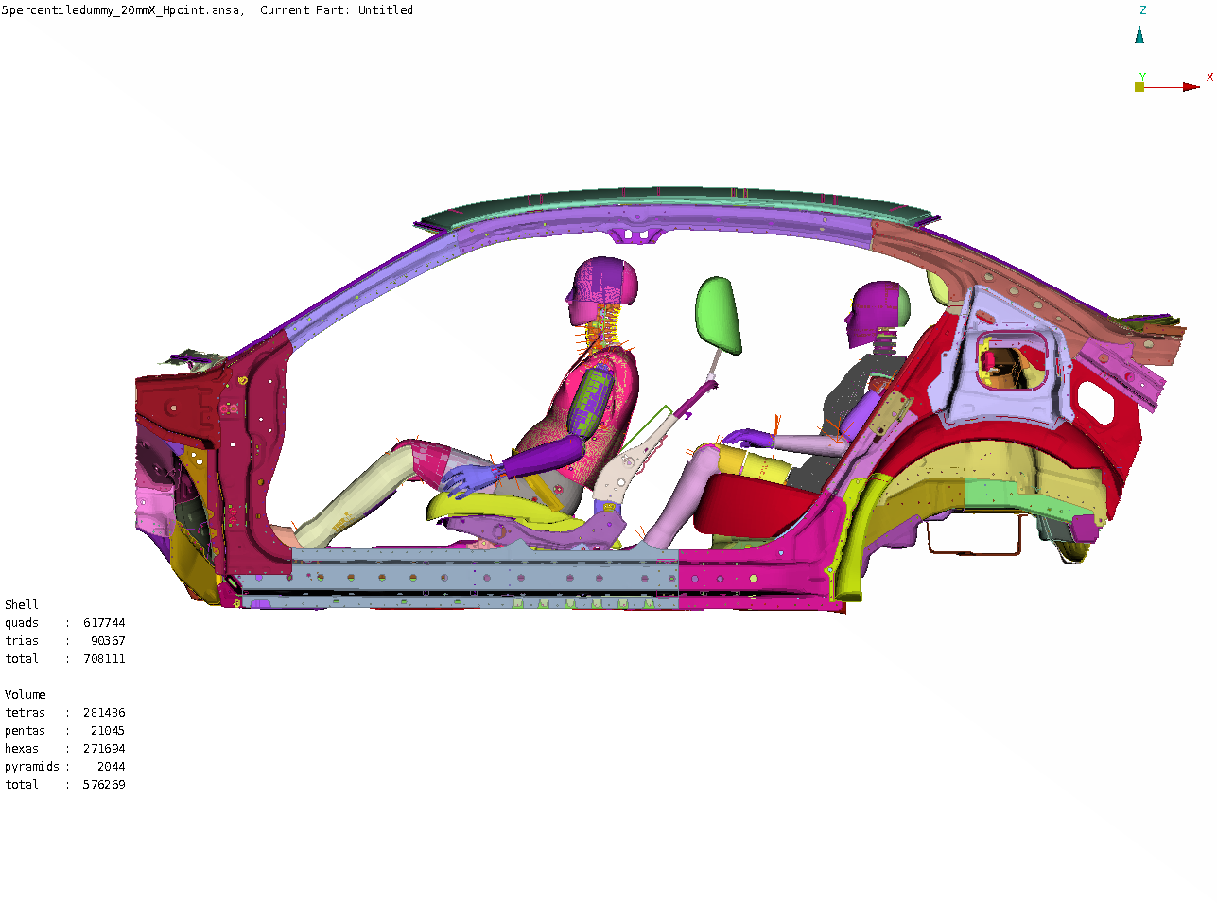
Figure 69: Illustration of Front Seat Interaction on 5th %ile Rear Seat Occupant

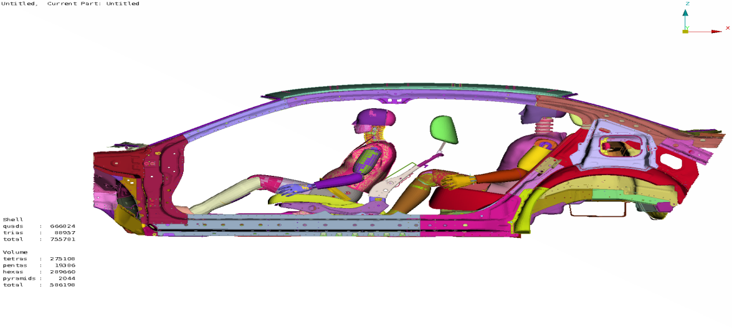
Figure 70: Illustration of Front Seat Interaction on 90th %ile Rear Seat Occupant

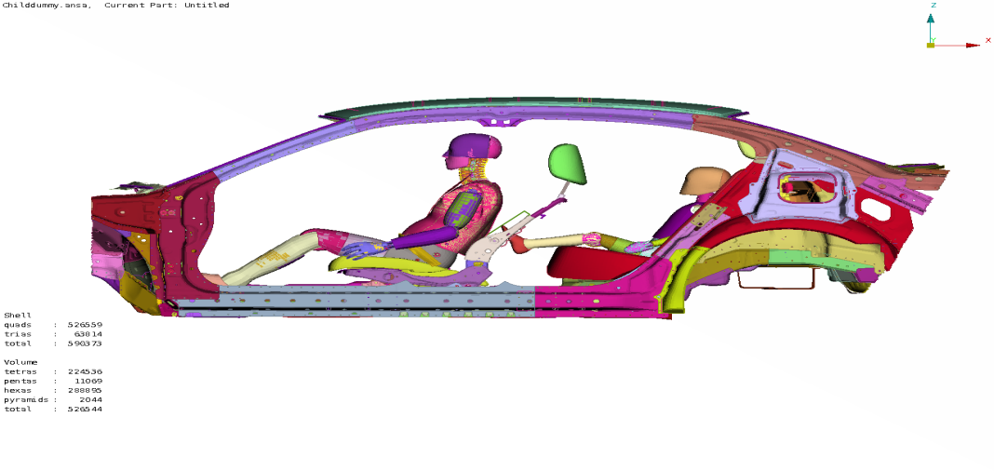
Figure 71: Illustration of Front Seat Interaction on Child Rear Seat Occupant

From the seat back dynamic rotation stand point, the countermeasures discussed here are for the Honda Accord MY2014 vehicle. The countermeasure on the seat back was not effective, but update of the parts on the seat bottom was effective. The advantage is observed, being only modifications on the seat bottom is that seat back kinematics and dynamic deformation characteristics in a high speed frontal crash should be less affected. Further, the countermeasure requirements could vary for different vehicle and different seat structures. By observing the rear seat and occupant kinematics against the front seat back motions, the countermeasure actions can be studied for case by case for each rear seat occupant type. The future work can be extended to 1) verify the seat back characteristics in the high speed frontal impact events, 2) optimize the countermeasures by including occupant types and extensive design changes of the seat back and head rest.

