Seat Back Strength Improvements

Countermeasures and Design Changes
FMVSS 301 FEA simulations of driver seat with rear seat passenger clearly showed the front seat back impact on the unbelted rear seat passenger seat behind the driver seat. The HIC value of the rear seat passenger was observed to be less than 500 when the head impacts on the front seat head rest. The front seat interaction on the rear seat occupant knee showed significant contact and femur force which was above 3.5 kN. These observations are good evidences that the baseline seat would need to be modified to avoid seat back to knee contact and head restraint to head contact. EDAG performed the countermeasures actions on the seat back and seat bottom frames to achieve reduced rear seat occupant HIC value and femur force in terms of the following performance targets shown in Table 6.

No. | Criteria | Target | Baseline | Improvements for
1 | Seat back angle | < 35 deg | 38 deg | No knee contact
2 | Seat frame to Knee clearance | > 10 mm | 3.76 mm | No knee contact
3 | Femur force | < 1.5 kN | 3.5 kN | Reduced knee impact
Table 6: Seat back strength improvement targets

Several countermeasure ideas were attempted on both manual and power seats. The countermeasures which showed significant improvements are listed in Appendix A.4. The countermeasures were implemented on manual and power seat and FEA simulations were run to investigate the improvements. Observing the static deformation of 9.4 mm of the seat back in the FMVSS 301 test, the modification of strengthening the seat back frame by thickness (Gauge) and material (Grade) update, head rest forward tilt did not show any improvements of seat back angle. Further deeper investigation of kinematics of the seat back movement from FEA simulations with rear seat passenger, it was observed that, the seat bottom upward movement by the 4 way or 6 way seat mechanism influenced the seat back frame rotation more than the deformation of the seat frame alone. Therefore 2G (Gauge and Grade) optimization was undertaken on the seat bottom frame and bracket members. This approach showed good improvements in reducing the seat back angle. The seat bottom frame and mechanism support parts were optimized and FEA simulations were compared with the baseline seats. The gauge and grade changes of the seat bottom frame are shown in Figure 45.

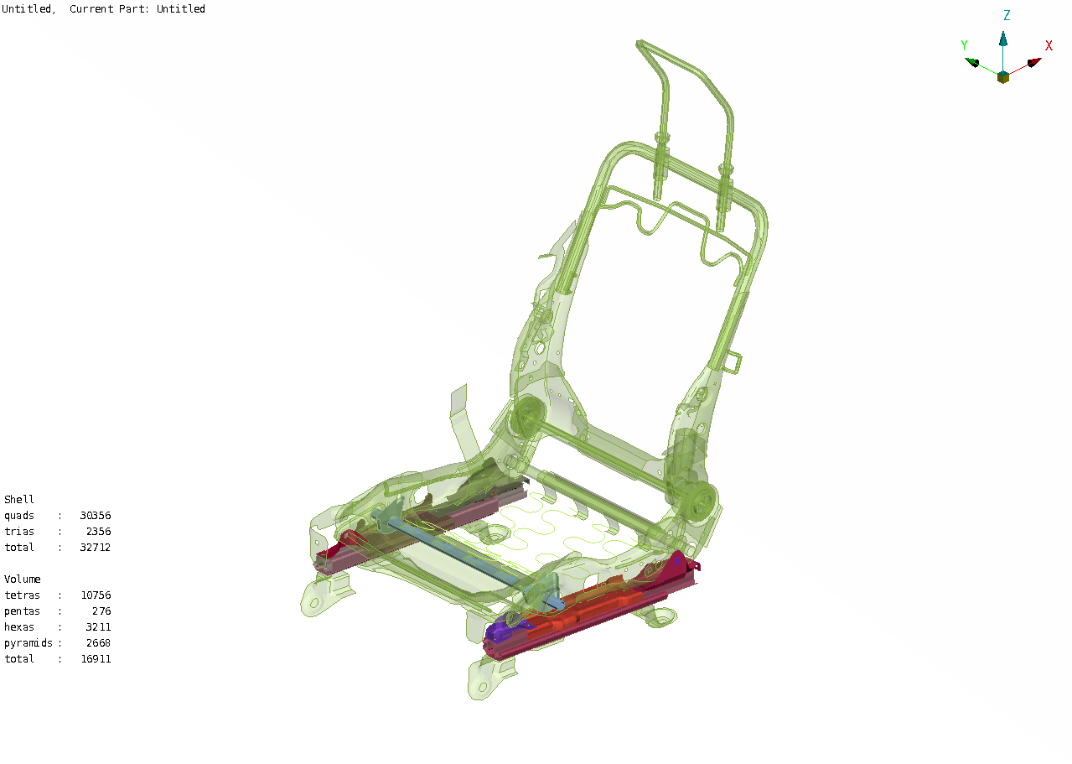
Gauge = 2mm to 3.2mm
Gauge = 1.93mm to 2mm
IF 260-410 to DP500-800
Gauge = 2.7mm to 4mm
IF 260-410 to DP500-800
Gauge = 1.5mm to 3mm
IF 260-410 to DP500-800
Gauge = 1.45mm to 2mm
Figure 45: Seat Bottom Countermeasure (Manual and Power Seats)

It should be noted that, since the countermeasures were on the seat bottom frame parts, it is common for both manual and power seats. This means, the same changes of the parts on the manual seat were implemented on the respective parts of the power seat also.

Updated Manual Seat – FMVSS 301 Simulations with Rear Seat Passenger
The 2G optimized seat model was integrated in to the FMVSS301 FEA model and simulations was carried out. Seat back rotation of simulation was compared to the baseline and post-test seat back rotation curves as shown in Figure 46. Comparison of seat back kinematics and rear seat occupant characteristics between the countermeasures implemented seat model and baseline model is provided in the following Figure 47 – 49.

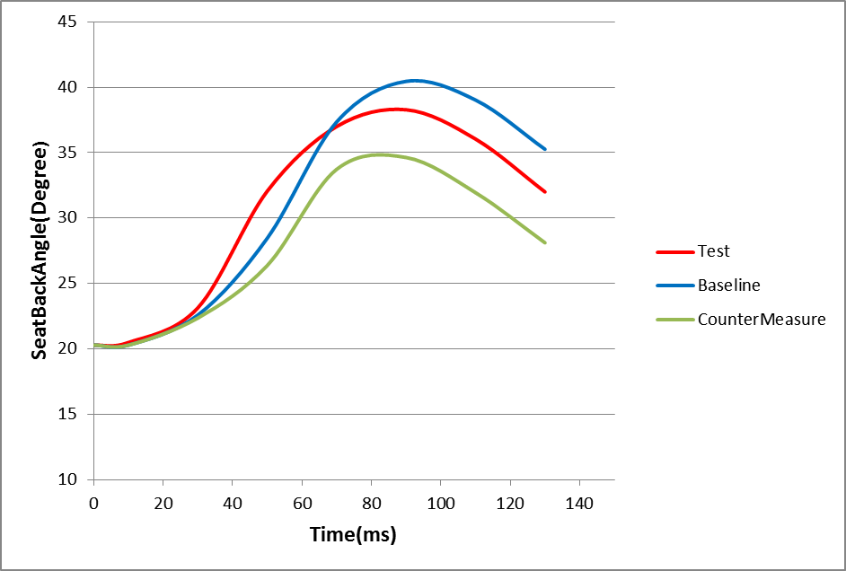
Figure 46: Seat back Rotation Comparison (Manual Seat)

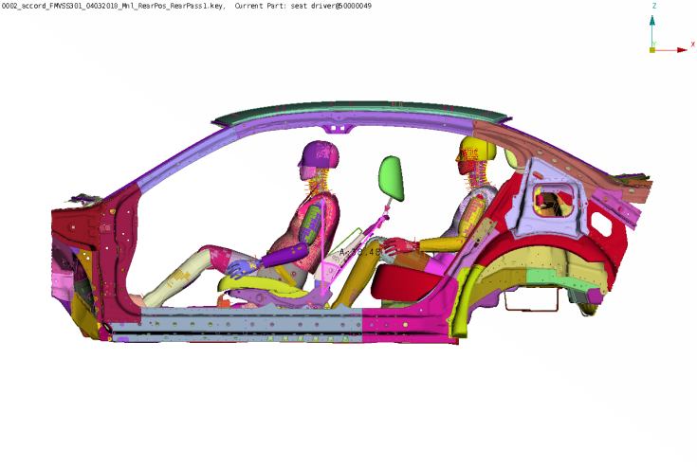
39 Deg.
Figure 47: Seat back Angle (Baseline – Manual Seat)

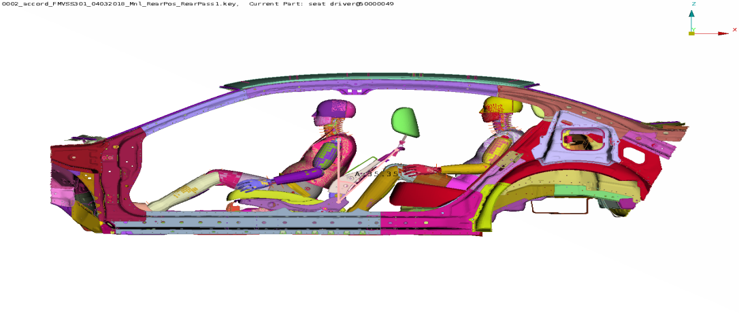
35.2 Deg.
Figure 48: Seat back Angle (Countermeasure – Manual Seat)

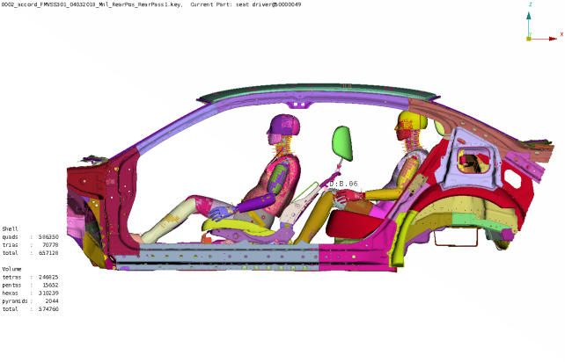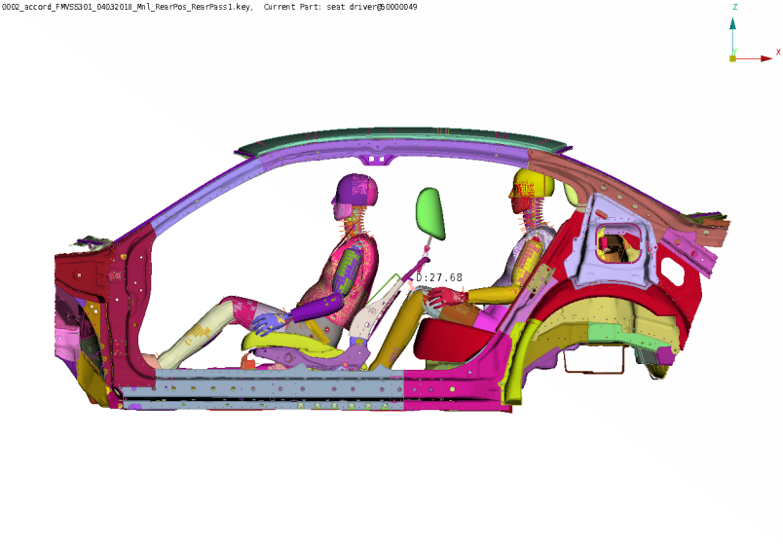
8.06 mm
27.68 mm
Baseline
Countermeasure
Figure 49: Seat back to Knee clearance (Baseline and Countermeasure – Manual Seat)

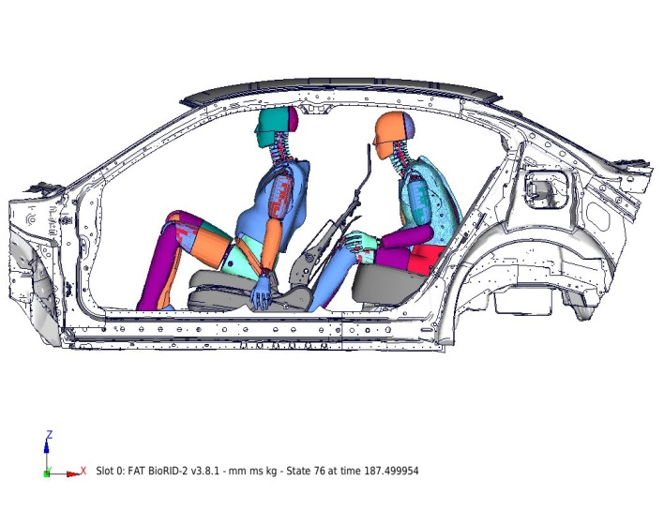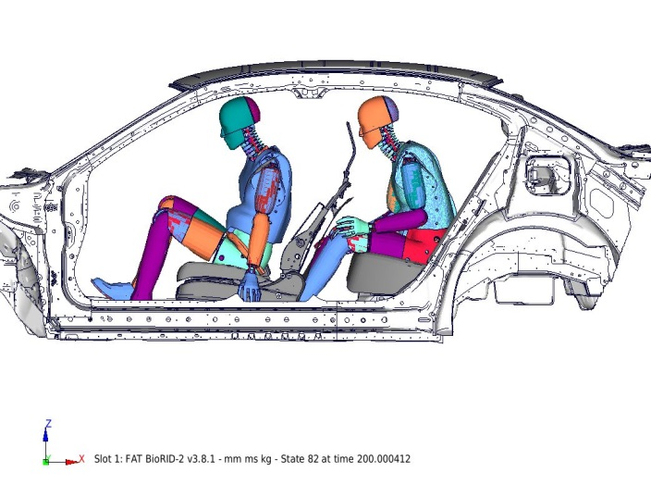
Countermeasure
Baseline
Figure 50: Head rest clearance (Baseline and Countermeasure – Manual Seat)

The knee impact force and HIC value of the rear seat occupant also reduced due to the effectiveness of the countermeasure. Figure 51 and 51 show the rear seat occupant knee force and head acceleration compared to the baseline model.

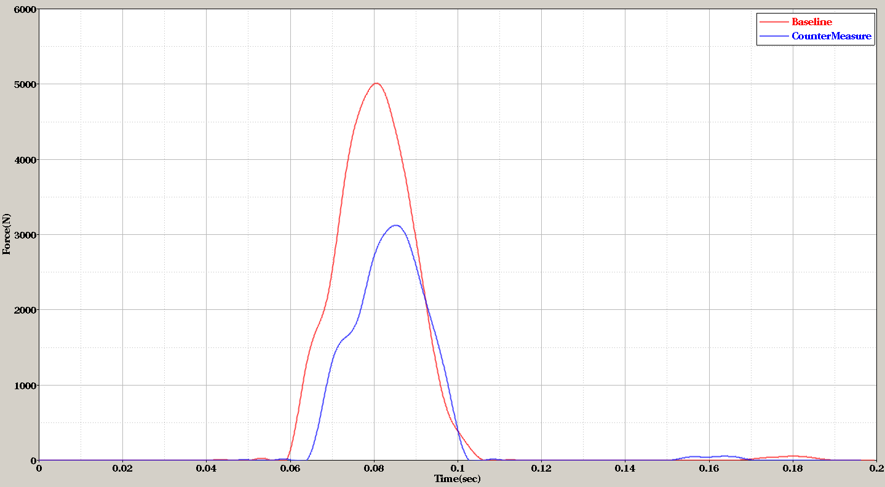
Figure 51: Knee Impact Force Baseline and Countermeasure (Manual Seat)

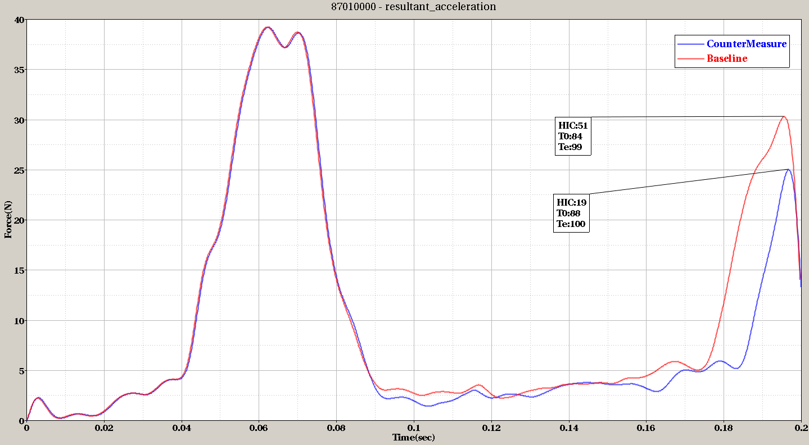
Figure 52: Head Acceleration Baseline and Countermeasure (Manual Seat)

The following Table 7 shows the countermeasure improvements to the target performance measures.

No. | Criteria | Target | Baseline | Countermeasure
1 | Seat back angle | < 35 deg | 39 deg | 35.2 deg
2 | Seat frame to Knee clearance | > 10 mm | 8.06 mm | 27.68 mm
3 | Femur force | < 1.5 kN | 5 kN | 3.1 kN
Table 7: Countermeasure improvement measures (Manual Seat)

Updated Power Seat – FMVSS 301 Simulations with Rear Seat Passenger
Using the similar countermeasures of the manual seat, the power seat bottom members were updated without affecting the seat mechanism. Seat back rotation from simulation was compared to the baseline, and post-test seat back rotation curves as shown in Figure 53. Comparison of seat back kinematics and rear seat occupant characteristics between the countermeasures implemented seat model and baseline model is provided in the following Figure 54-56.

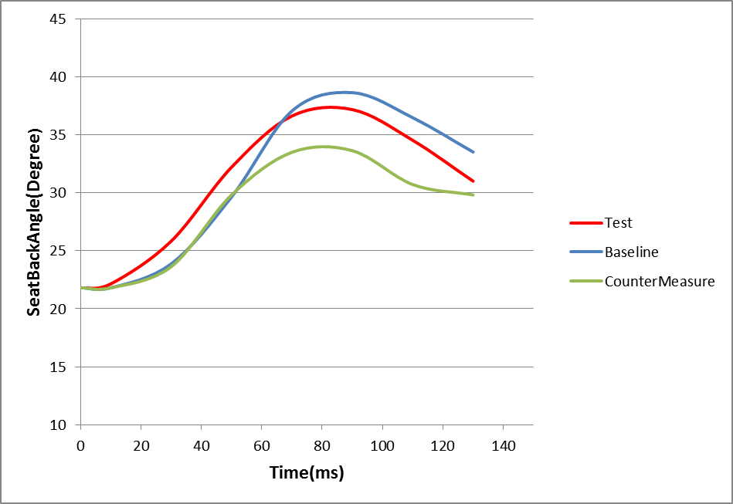
Figure 53: Seat back Rotation Comparison (Power Seat)

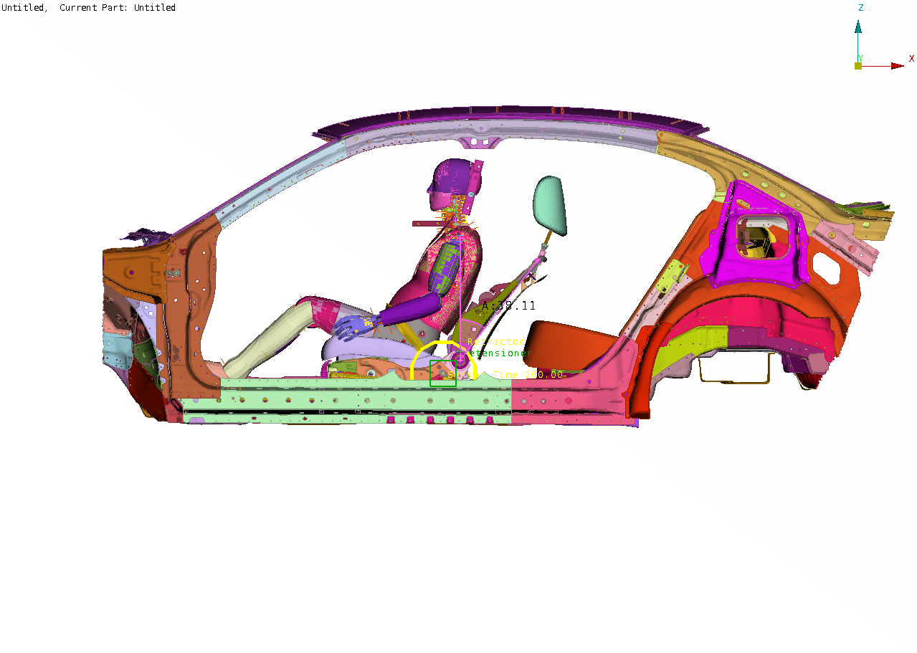
37.7 Deg.
Figure 54: Seat back Angle (Baseline – Power Seat)

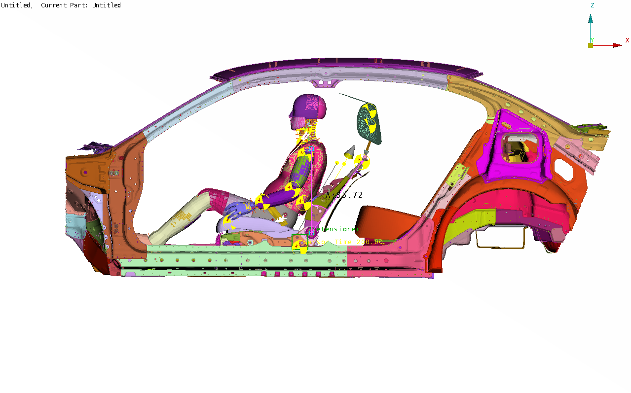
35.1 Deg.
Figure 55: Seat back Angle (Countermeasure – Power Seat)

3.76 mm
17.23 mm
Baseline
Countermeasure
Figure 56: Seat back to Knee clearance (Baseline and Countermeasure – Power Seat)

Baseline
Countermeasure
Figure 57: Head rest clearance (Baseline and Countermeasure – Power Seat)

The knee impact force and HIC value of the rear seat occupant also reduced due to the effectiveness of the countermeasure. Figure 58 and 58 show the rear seat occupant knee force and head acceleration compared to the baseline model.

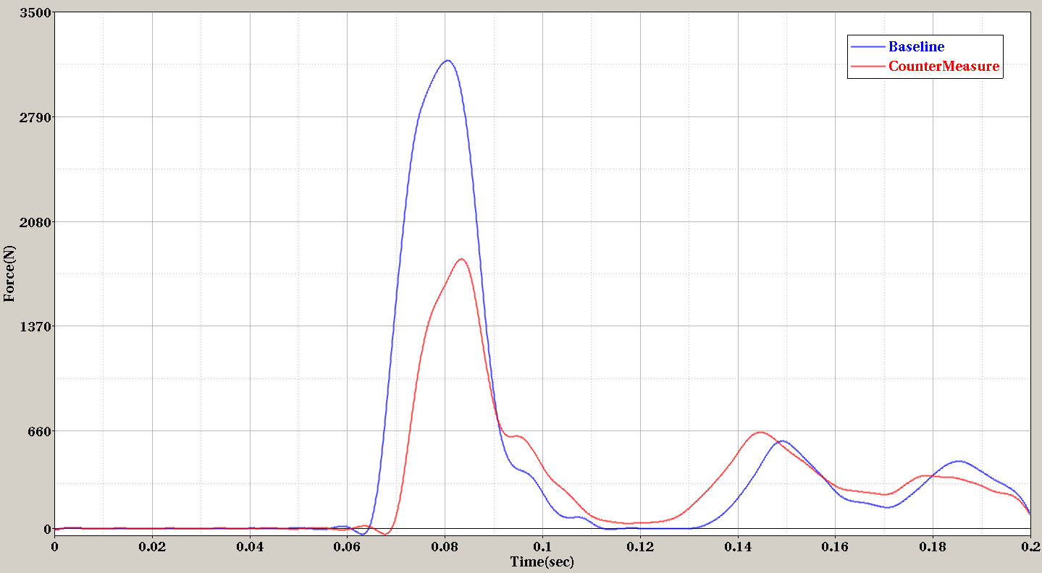
Figure 58: Knee Impact Force Baseline and Countermeasure (Power Seat)

Figure 59: Head Acceleration Baseline and Countermeasure (Power Seat)

The following Table 8 shows the countermeasure improvements to the target performance measures.

No. | Criteria | Target | Baseline | Countermeasure
1 | Seat back angle | < 35 deg | 38 deg | 35 deg
2 | Seat frame to Knee clearance | > 10 mm | 3.76 mm | 17.23 mm
3 | Femur force | < 1.5 kN | 3.5 kN | 1kN
Table 8: Countermeasure improvement measures (Power Seat)

Countermeasure Validation for Low Speed Rear Impact
Once the seat models were updated to achieve the target requirements of reduced dynamic motions of the seat back, it was intended to verify the countermeasures would not affect the regulatory requirements such as low speed rear impact cases. For this purpose existing IIHS vehicle seat head restraint dynamic test results of Honda Accord MY2013 were compared. The test vehicle was a Honda Accord MY2013 had manual seats. Therefore, FEA model for the IIHS vehicle seat head restraint dynamic test setup was developed by using the manual seat FEA model. A baseline model was developed to validate the FEA model was comparable to the test results. The baseline model setup for IIHS vehicle seat head restraint dynamic test for manual seat is shown in Figure 60.

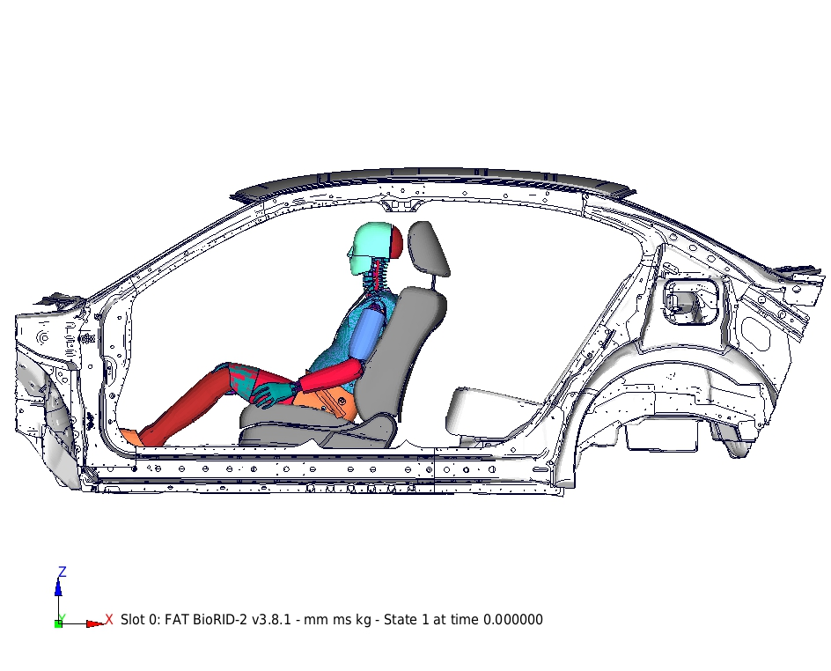
Figure 60: IIHS Vehicle Seat Head Restraint Test – Baseline (Manual Seat)

The FEA simulation of baseline model was carried out for 200 milliseconds duration by using LS-DYNA. The baseline model results were compared to the test results to verify the baseline model was in good correlation. FEA simulation results of the baseline model and the comparison to the test results is provided in Figure 61.

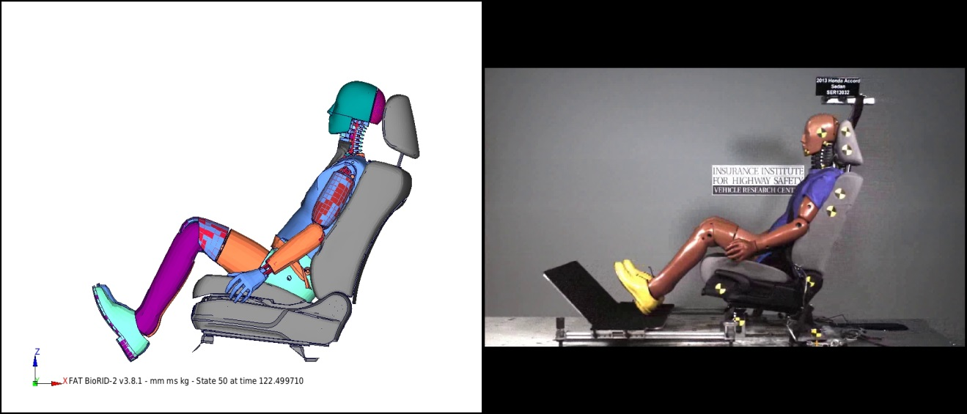
Figure 61: IIHS Vehicle Seat Head Restraint Test – Baseline vs. Test (Manual Seat)

The neck injury criteria for baseline and test were also compared as shown in the IIHS neck injury rating graph Figure 62.

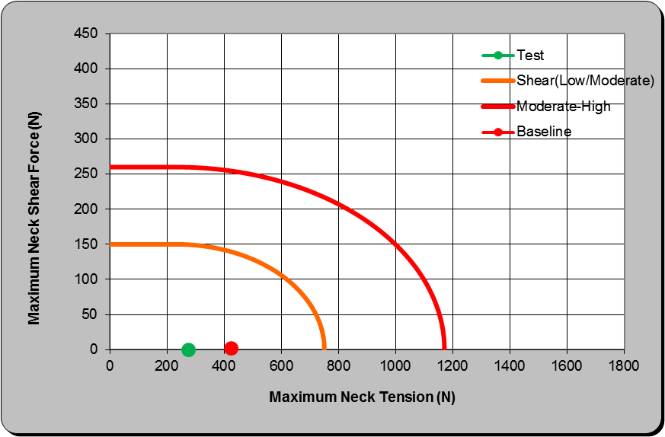
Figure 62: IIHS Vehicle Seat Head Restraint Test – Neck Injury Rating, Baseline vs. Test

From the above results comparison, it can be seen that both test and baseline FEA model ratings are within the Good corridor of IIHS rating chart. Therefore the FEA model is deemed reasonable to use for countermeasure verification. The scope of the project included the power seat, so another baseline model for IIHS vehicle seat head restraint dynamic test also was developed by replacing the manual seat by the power seat. The FEA model setup for baseline IIHS load case with power seat is shown in Figure 63.

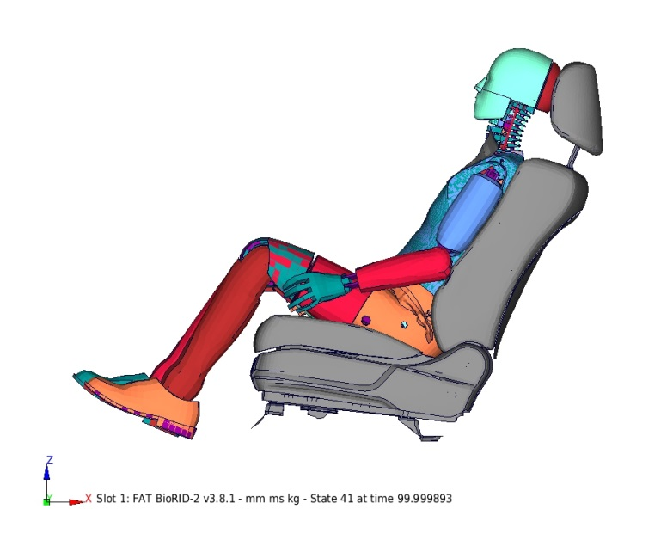
Figure 63: IIHS Vehicle Seat Head Restraint Test – Baseline (Power Seat)

Similarly, FEA simulation of baseline model for power seat was carried out for 200 milliseconds duration using LS-DYNA. The neck injury criteria for the power seat baseline are shown in the IIHS neck injury rating graph Figure 64. The rating was recorded above the Moderate-Higher corridor. It should be noted that, there was no test result available for power seat case. Correlating the FEA model to a better rating of within the Moderate-High corridor is out of the scope, the FEA model was intended for comparison purpose only for validating the countermeasures.

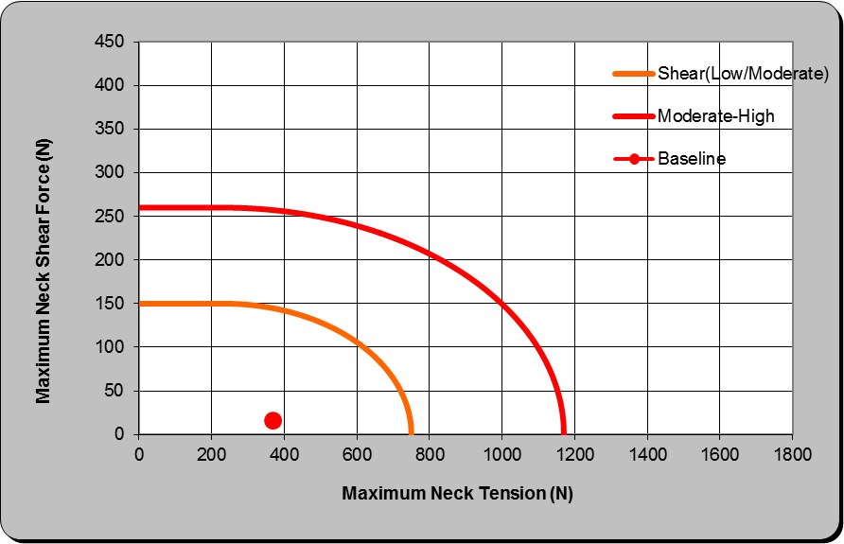
Figure 64: IIHS Vehicle Seat Head Restraint Test – Neck Injury Rating, Baseline (Power Seat)

These two baseline models and results were used for validating the countermeasures using the countermeasure seats respectively. The baseline seat FE modules in the IIHS test baseline models were replaced with corresponding countermeasure seat FE modules. The test conditions and load case setup were maintained as same as the IIHS test baseline models. Once the simulations of the countermeasure models were run, the results were compared to the baseline results, which is the neck injury rating chart. The neck injury rating chart for the countermeasure seats are shown in the following Figure 65 and 66.

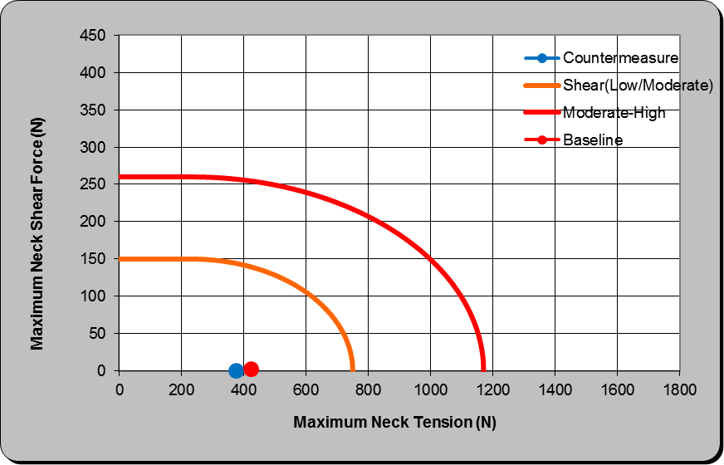
Figure 65: IIHS Neck Injury Rating Chart – Countermeasure vs. Baseline (Manual Seat)

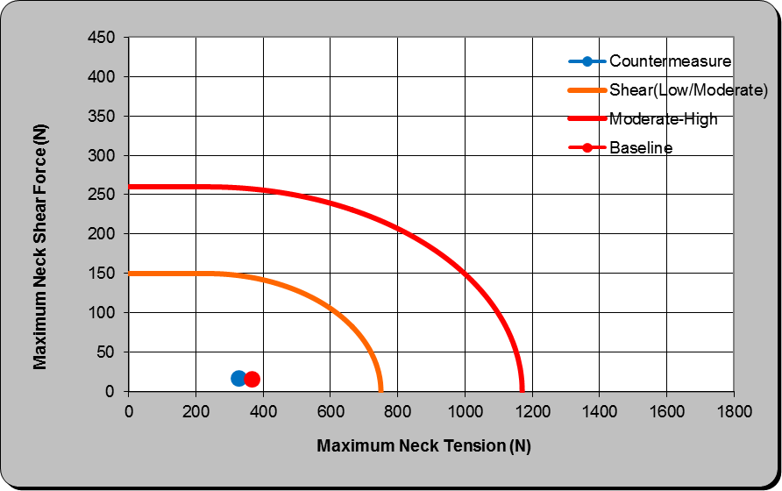
Figure 66: IIHS Neck Injury Rating Chart – Countermeasure vs. Baseline (Power Seat)

Thus, it is noted that, from the above investigation using IIHS vehicle seat head restraint test in low speed rear impact scenario, the countermeasures on the front seats did not affect the IIHS rating with much deviation from baseline or test. Therefore, the proposed countermeasures of the front seats to reduce the dynamic seat back rotation should be acceptable in both high speed and low speed rear crash events.

Cost Estimation
The seat back strength investigation of this project also studied the cost impact of going from baseline seat to improved seat to reduce the dynamic seat back rotation. The proposed countermeasures are within the gauge and grade changes, with no design changes of the part. The countermeasure ideas discussed in this study provides directional inputs about seat strength improvements to be able to protect the rear seat occupant by reducing the injury levels. When it is necessary to implement the countermeasures by the seat manufacturers, the cost impact of the changes also needs to be considered in the product development. EDAG performed the cost estimate for the baseline and countermeasure seats using standard MIT cost model process sheets. Cost difference was estimated for the countermeasure parts obtained from 2G optimization (seat bottom frame and mechanism components). The cost estimation was performed for manual seat and power seat separately due to a small difference found in one of the countermeasure parts geometry of the power seat.

Cost Estimate – Manual Seat
The weight of the baseline manual seat was calculated from baseline FEA seat model as 18.81 kg and the weight of the countermeasure seat was calculated from countermeasure FEA seat model as 20.94 kg. The cost estimation was performed only for the parts changed by the countermeasure with the manufacturing and assembling processes are assumed to be remaining same as existing seat. The parts affected weighed originally 3.87 kg and the countermeasure added 2.13 kg due to gauge and grade changes. The countermeasure parts weighed 6 kg. Using standard material price and grade premium for the upgraded materials and using EDAG cost model worksheet, the baseline parts cost was estimated to be $2.24 and the countermeasure parts cost was found to be $4.17, and the delta cost was estimated as $1.94 for the manual seat.

The seat countermeasures, weight and cost differences due to the countermeasure are shown in Figure 67 for the manual seat.

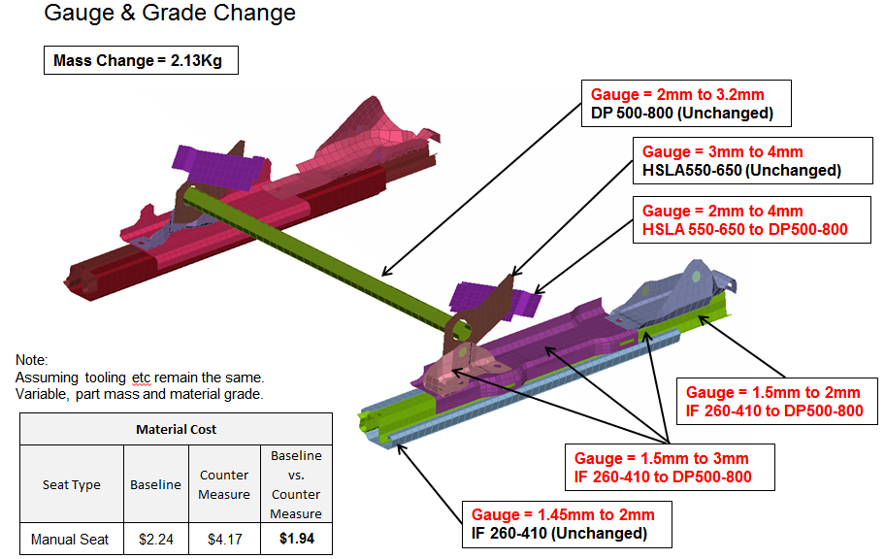

Figure 67: Countermeasure Parts and Cost Estimate (Manual Seat)

Cost Estimate – Power Seat
Similarly, the weight of the baseline power seat was calculated from baseline FEA seat model as 23.41 kg and the weight of the countermeasure seat was calculated from countermeasure FEA seat model as 25.10 kg. The cost estimation was performed only for the parts changed by the countermeasure with the manufacturing and assembling processes are assumed to be remaining same as existing seat. The parts affected weighed originally 3.87 kg and the countermeasure added 1.69 kg due to gauge and grade changes. The countermeasure parts weighed 6 kg. Using standard material price and grade premium for the upgraded materials and using EDAG cost model worksheet, the baseline parts cost was estimated to be $9.69 and the countermeasure parts cost was found to be $14.01, and the delta cost was estimated as $4.62 for the power seat.

The seat countermeasures, weight and cost differences due to the countermeasure are shown in Figure 68 for the power seat.

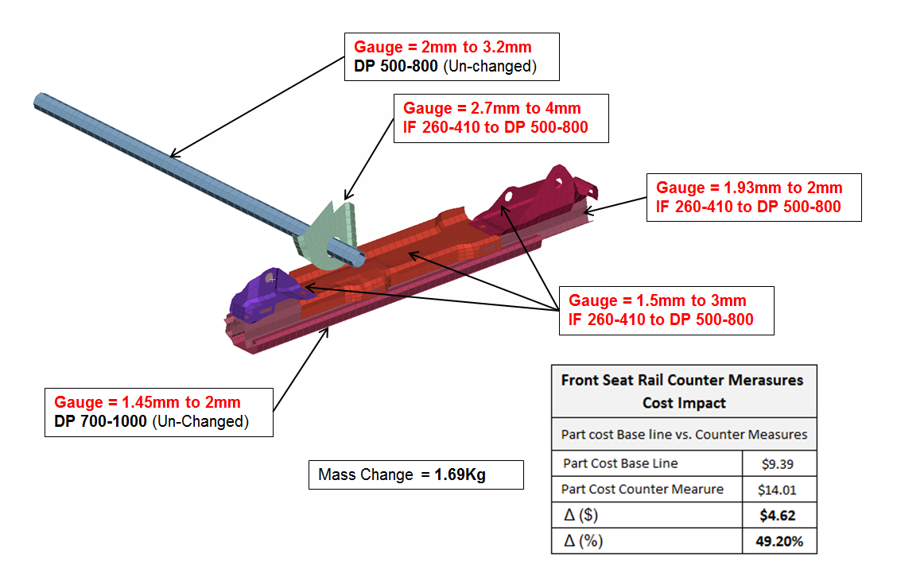
Figure 68: Countermeasure Parts and Cost Estimate (Power Seat)

An overview of the cost impact for the countermeasures is shown in the Table 9.

No. | Description | Manual Seat | Power Seat
1 | Baseline seat weight (kg) | 18.81 | 23.41
2 | Countermeasure seat weight (kg) | 20.94 | 25.10
3 | Baseline weight of parts affected (kg) | 3.87 | 4.13
4 | Countermeasure weight of parts affected (kg) | 6.00 | 5.82
5 | ∆ weight (kg) / seat | 2.13 | 1.69
6 | Baseline cost of parts affected | $2.24 | $ 9.39
7 | Countermeasure cost of parts affected | $4.17 | $ 14.01
8 | ∆ cost / seat | $1.94 | $ 4.62
9 | Cost / kg increase | $0.91 | $ 2.73
Table 9: Cost Impact of Countermeasure Seats

