FMVSS 301 Model Development
After developing and validating the FE seat models by correlating to the physical test, the FE seat models were used in the FMVSS 301 FE modeling.

FMVSS 301 FEM Development
The FMVSS 301 Rear Impact simulation included the Bio-RID II dummy FE model positioned on the fully trimmed front seats. For this purpose, MY2014 Honda Accord Vehicle FE structural model was used as a rigid sled. The study focused on the driver side of the vehicle. Therefore, only the driver side half (left hand side) of the FE model was converted to a rigid sled model. The above validated seat models were integrated by including the standard seat bottom and seat back cushion (or foam) modeling for realistic dummy to seat interaction. The seat structure, seat position mechanism, and cushions are shown in Figure 31.

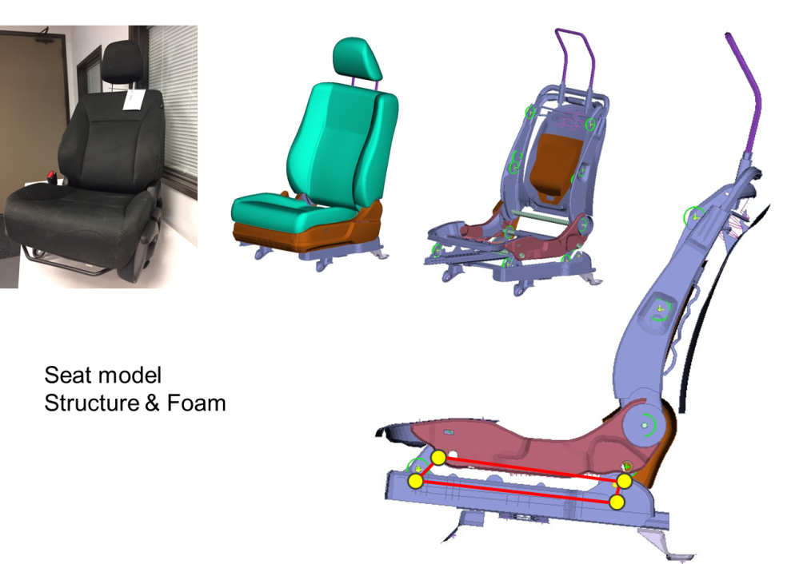
Figure 31: Seat FEM –Mechanism and Cushions (Ex. Manual Seat)

The seat cushions were modeled as solid elements and were assigned foam material properties. Another important requirement to have more realistic occupant kinematics is to have the seat cushions pre-deformed due to weight of the dummy to match the lower torso profile impression on the seat bottom cushion and upper torso impression over the seat back cushion. The model was gravity settled prior to simulation. The seat cushions were deformed to the Bio-RID II dummy shapes by using LS-DYNA pre-simulations. Figure 32 shows the pre-deformed seat cushions attached to the seat structure.

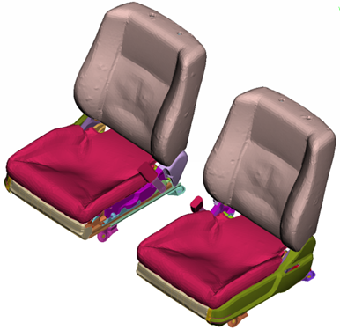
Figure 32: Manual and Power Seat Models with Pre-deformed Cushions

FMVSS 301 Sled Test CAE, Test Comparison
Two different FE models were developed using the manual and power seat FE models. All the FE parts of the sled model were assigned with rigid materials and attached globally to one freely moving master rigid part.

Manual Seat – Sled Test Comparison
The manual seat was integrated with seat position and seat back angle as per the test. Bio-RID II occupant dummy was positioned as per the required H-Point and seat back angle. Shoulder belt and lap belt were modeled and wrapped over the Bio-RID II dummy. Gravity was applied to Bio-RID II dummy. The sled pulse (shown in Figure 25) was applied to the master rigid part. LS-DYNA simulation was run for 200 milliseconds and the characteristics of Bio-RID II dummy and seat structure were computed. In particular, the seat back rotation, occupant head acceleration and neck forces were obtained, plotted, and compared to that of physical test. The kinematics of the seat back rotation and occupant position are shown in Figure 33 for several frames of the simulation and test.

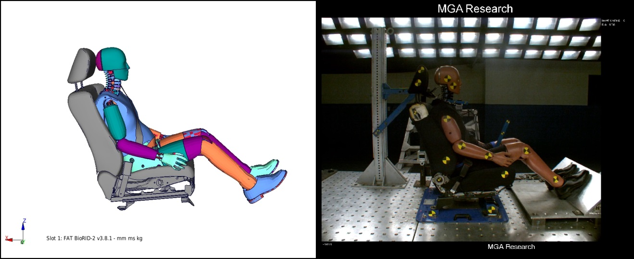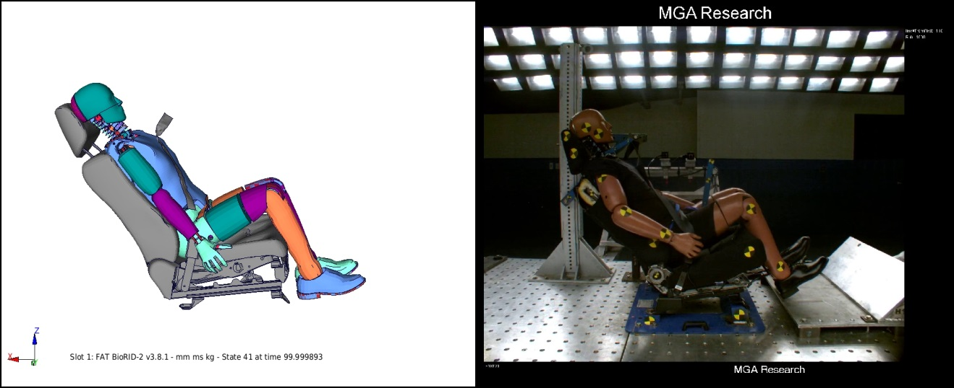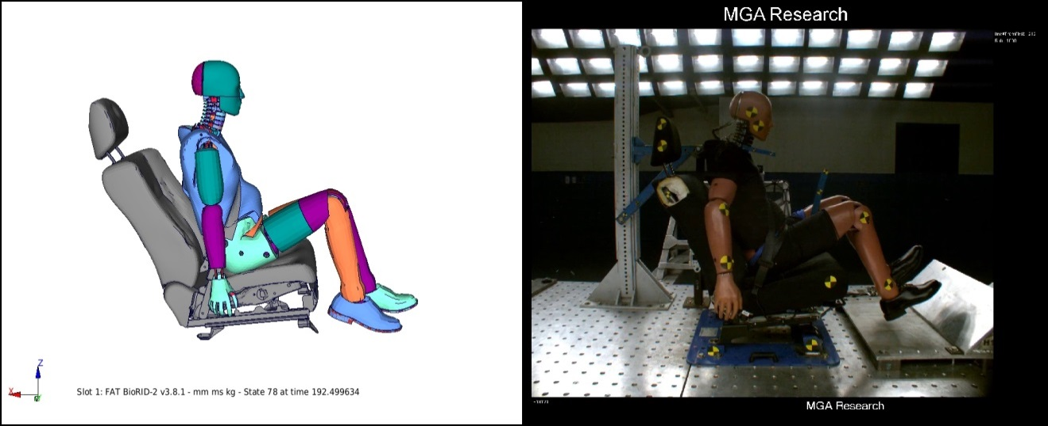
T=100ms, max. deflection
T=192.5ms
T=0ms, Pretest
Figure 33: FMVSS301 Sled Test FEA and Test – Manual Seat

The manual seat FE simulation and sled test results comparison including seat back dynamic deflection, occupant head acceleration plot, Head Injury Criteria (HIC) value and neck forces for Neck Injury Criteria (NIJ) are given in the following Figure 34, 35 and 36.

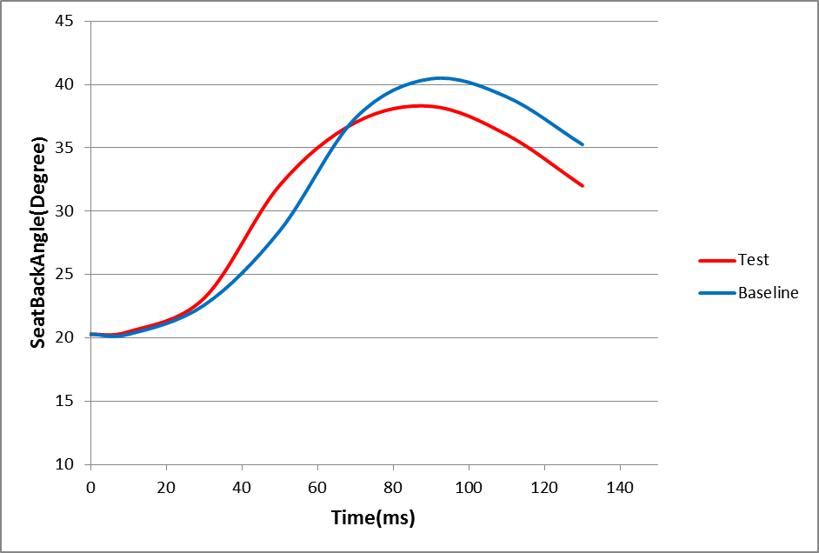
Figure 34: Seat Back Rotation – Manual Seat

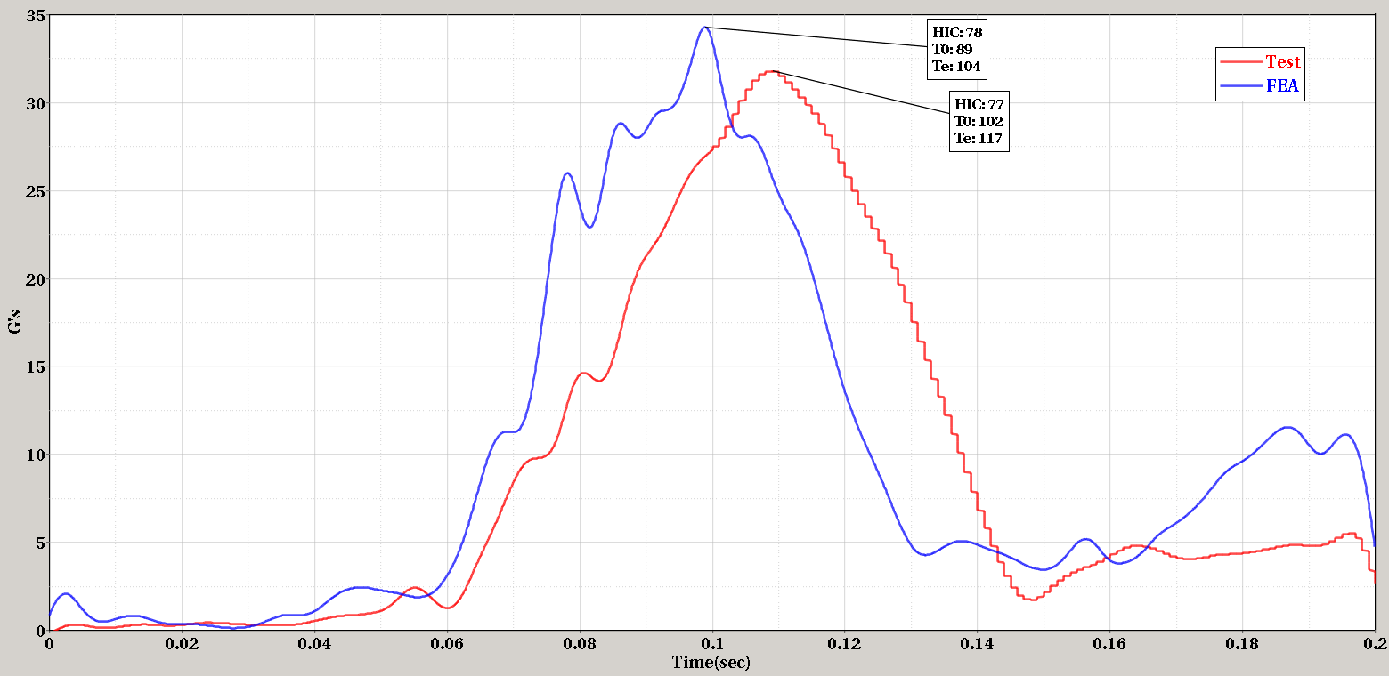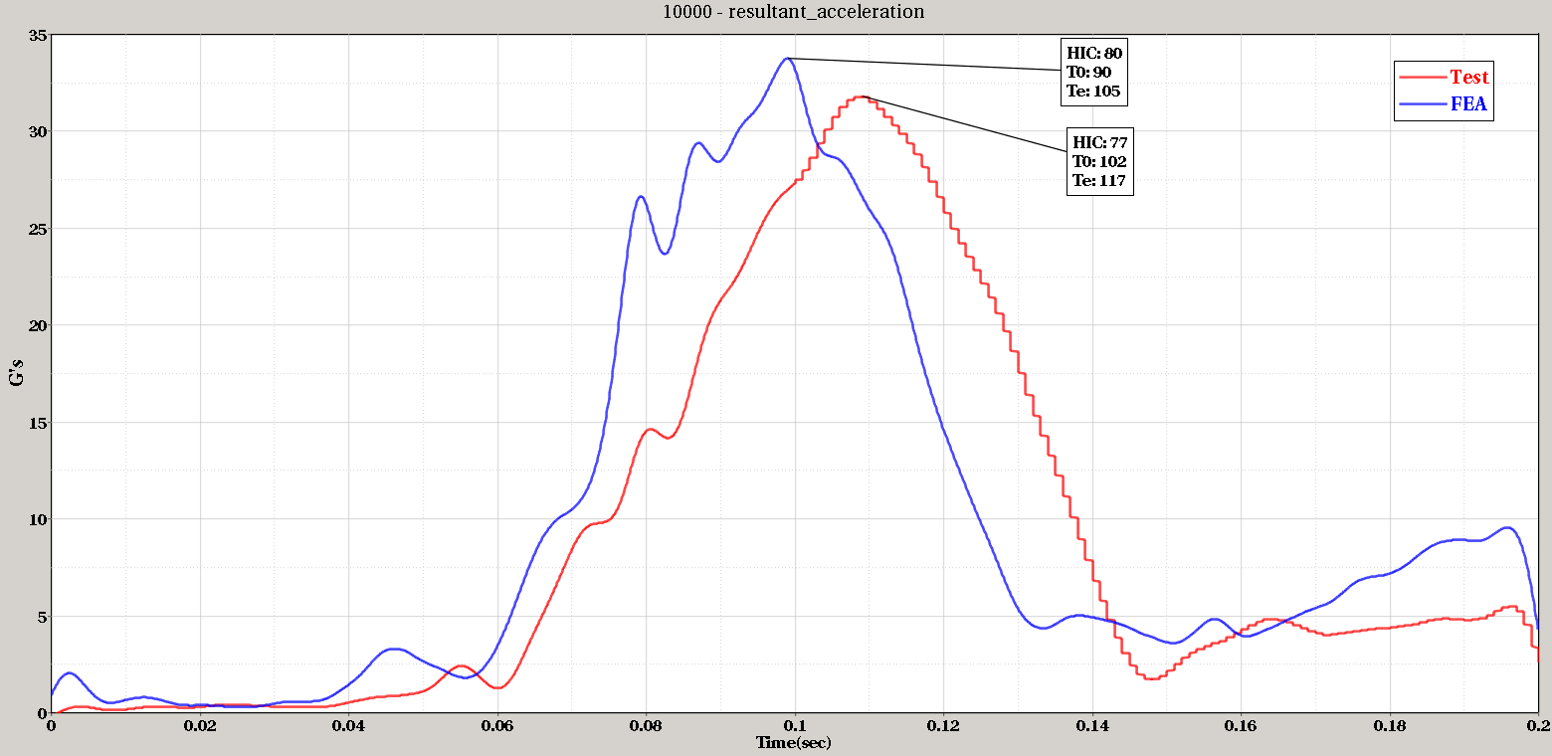
Figure 35: Head Acceleration – Manual Seat

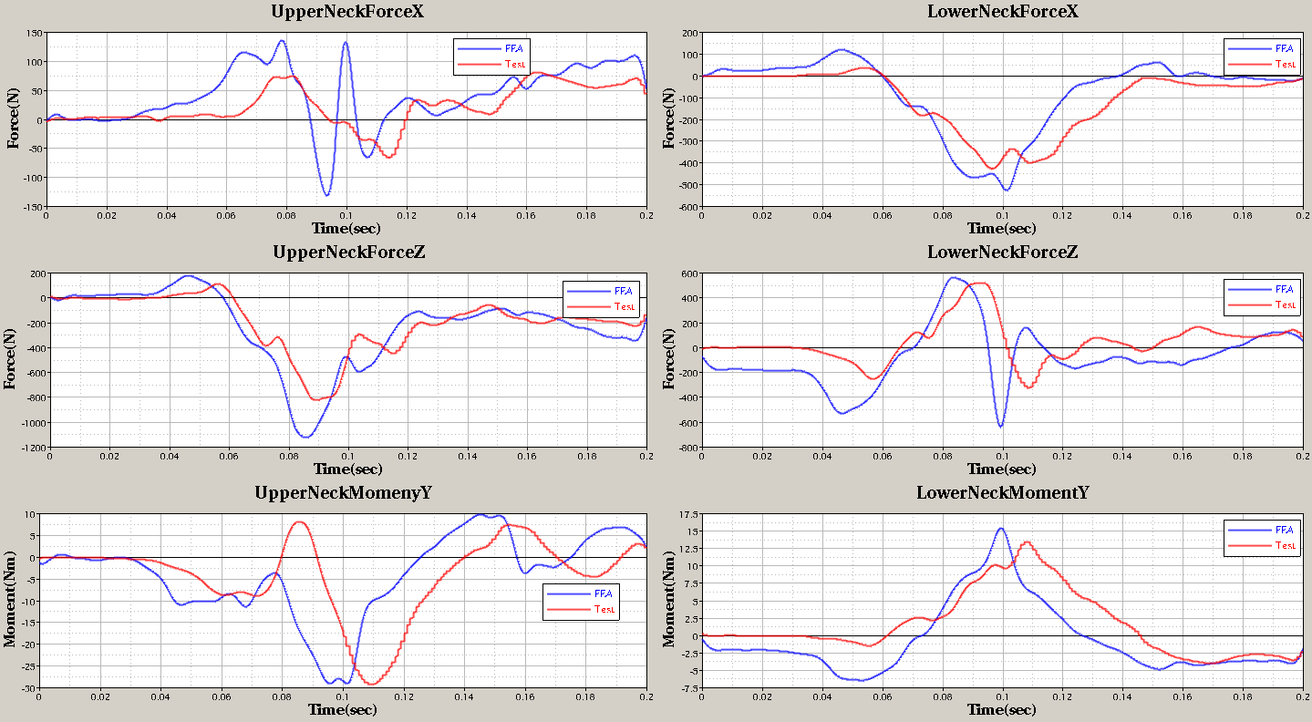
Figure 36: Neck Forces – Manual Seat

In Figure 34, significant offset between test and simulations are observed, the reason being, the test had idle time for the first 10sec that the test curve was offset to match with FEA, and FEA did not represent this test idle time during simulation. Even though the main objective of comparison of FE simulation in this case was for validating the FE model for seat back strength, it was always a general practice to obtain a reasonable seat and occupant kinematics similar to that of the physical test. The FE animation and physical test video showed similar kinematics. The comparisons of HIC, Nij are listed in the Table 4.

No. | Injury measures | FEA | Test
1 | HIC 15 | 80 | 77
2 | NIJ | 0.18 | 0.28

Table 4: FMVSS 301 Sled Test FE Simulations and Test Comparison – Manual Seat

Power Seat – Sled Test Comparison
Similarly, the power seat was integrated with seat position and seat back angle as per the test. The same method was followed from the manual seat sled test modeling to set up and run power seat sled test simulation. The kinematics of the seat back rotation and occupant position of power seat are shown in Figure 37 for several frames of the simulation and test.

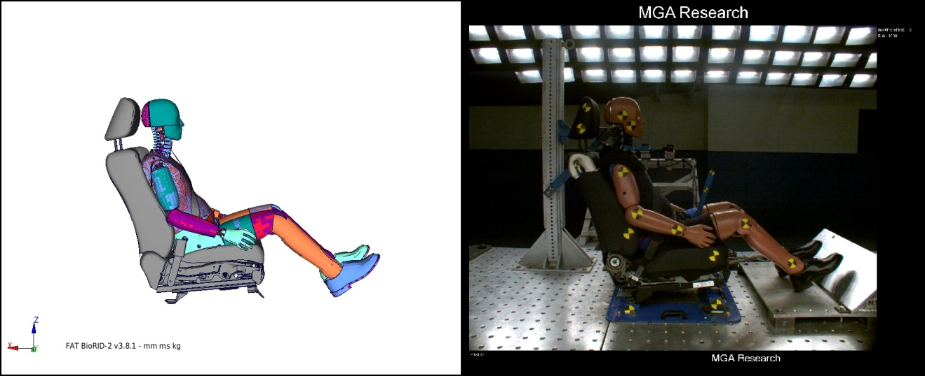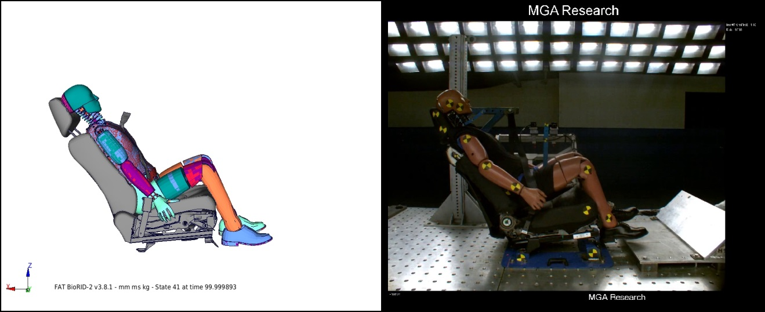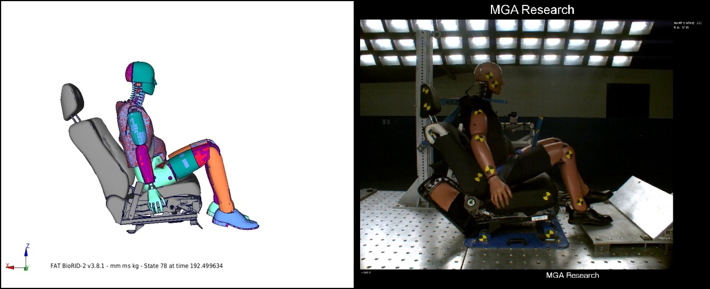
T=192.50ms
T=100ms, Max. deflection
T=0ms, Pretest
Figure 37: FMVSS301 Sled Test FEA and Test – Power Seat

The power seat FE simulation and sled test results comparison including seat back dynamic deflection, occupant head acceleration plot, Head Injury Criteria (HIC) value and neck forces for Neck Injury are given in the following Figure 38, 39 and 40.

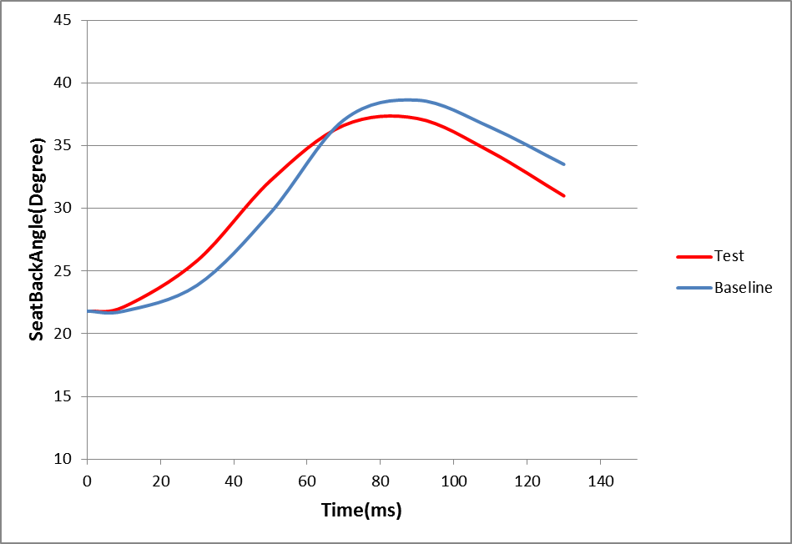
Figure 38: Seat Back Rotation – Power Seat

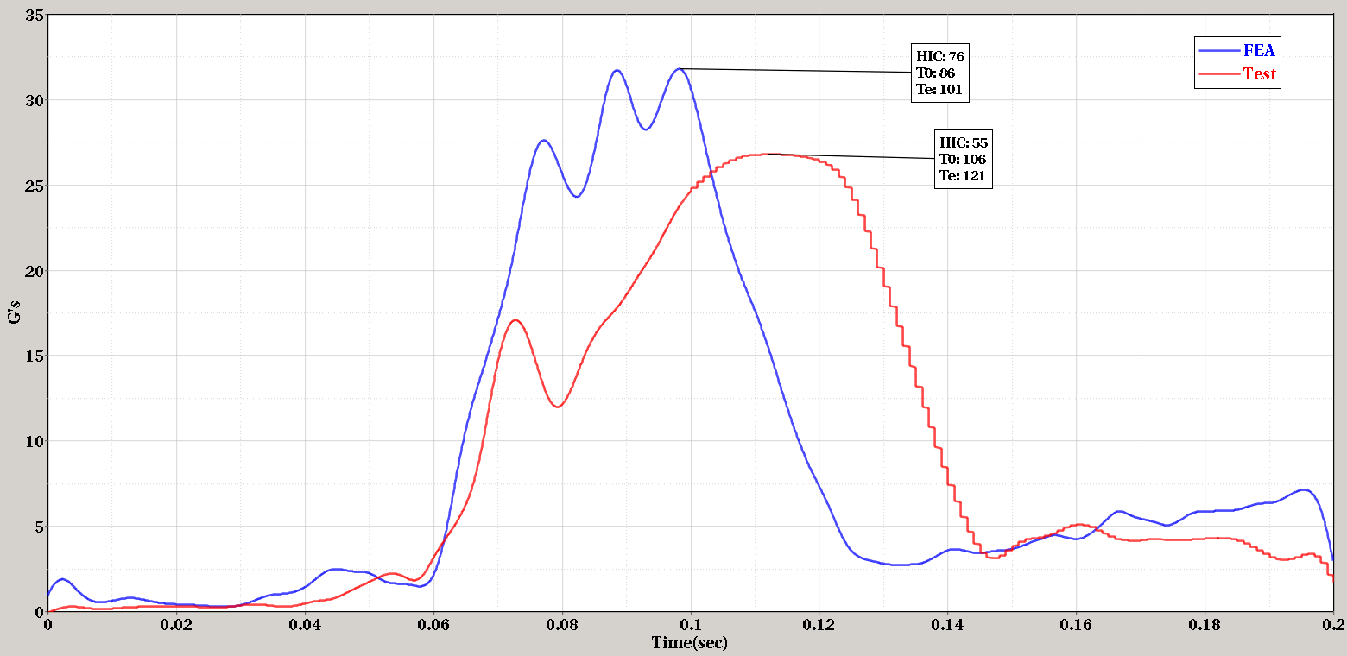
Figure 39: Head Acceleration – Power Seat

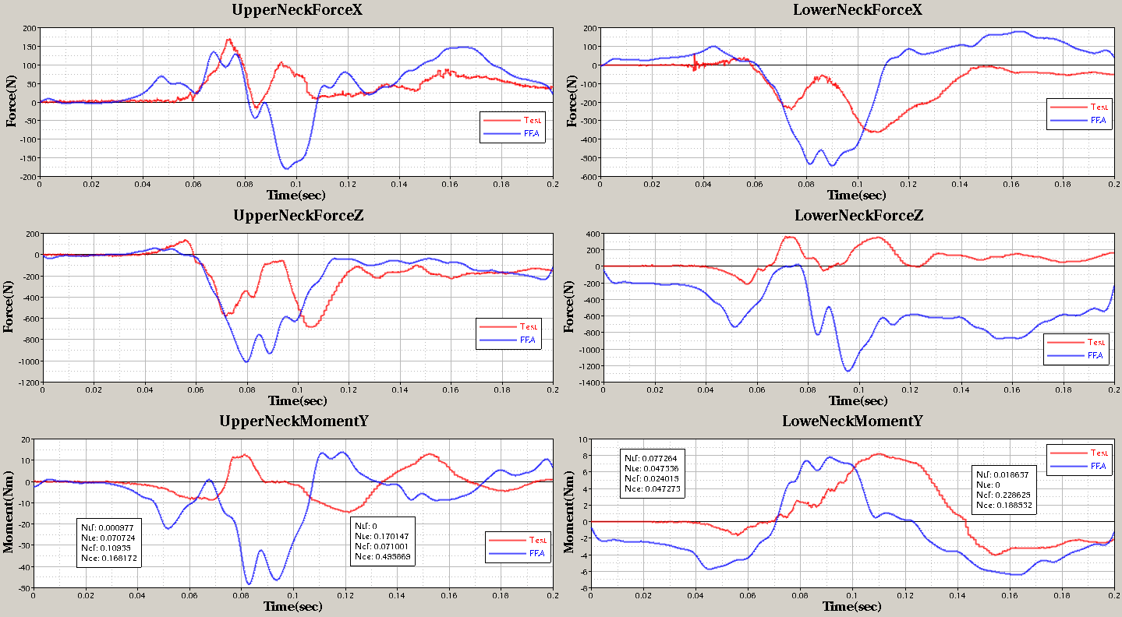
Figure 40: Neck Forces – Power Seat

It should be noted FEA and test curves offset in In Figure 38 is due to a 10secs test idle time. The neck forces and moments shown in Figure 40 were not used directly for seat back strength study. From the project scope point of view, the main purpose of comparison of FE simulation in this case was for validating the seat FE model for seat back strength. It was decided to obtain a reasonable global seat kinematics only similar to that of the physical test. The FE animation and physical test video showed similar kinematics. Therefore, with this level of comparison, the results were deemed sufficient for this project. The comparison of HIC and Nij are listed in the Table 5 for additional references for comparison purpose during seat back countermeasures.

No. | Injury measures | FEA | Test
1 | HIC 15 | 55 | 76
2 | NIJ | 0.42 | 0.08

Table 5: FMVSS 301 Sled Test FE Simulations and Test Comparison – Power Seat

