FMVSS 301 High Speed Rear Impact Sled Test
The objective of this project is to study the front seat back strength in rear crash events. While the low speed rear impact study is limited to the whiplash and neck injury measures of the occupant, this study is aimed at rear seat passenger protection in high speed impact such as FMVSS 301 Rear Impact scenario. The FMVSS 301 Rear Impact subjects the vehicle to rear impact by a moving deformable barrier (MDB) at 55 mph with 70% offset. This test generates an acceleration pulse of the vehicle. In order to study the front seat back strength requirements with occupant seated on it, it was decided to conduct the FMVSS 301 test with a physical sled and Bio-RID II dummy positioned on the front seat using the vehicle acceleration pulse.

EDAG sub-contracted the testing company MGA to conduct the rear impact sled test for the manual and power seat. The necessary vehicle pulse was computed by running the FMVSS 301 Rear Impact simulation using MY2014 Honda Accord Structural Model (Ref. Section 3.1). The rear impact vehicle pulse is shown in Figure 24.

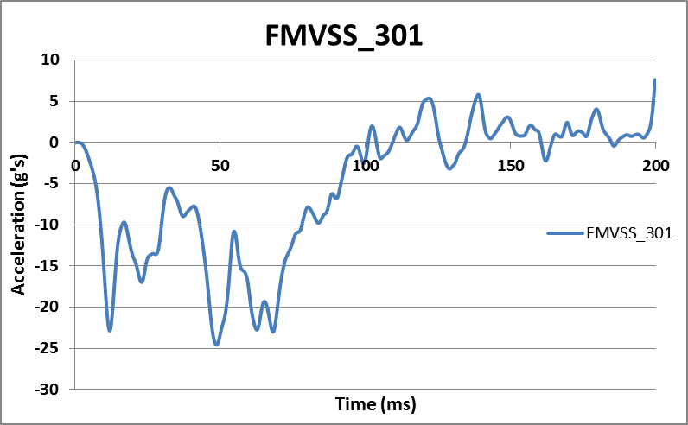
Figure 24: FMVSS 301 Rear Impact Vehicle Pulse (CAE Simulation)

The Bio-RID II rear impact dummy was used in the sled test. The Bio-RID II dummy was supplied by NHTSA. The rear impact dummy was calibrated with 22 necessary channels. Considering the Bio-RID II dummy’s loading capacity limited to a rear impact speed of 17 mph, the vehicle pulse was tuned to approximately 20 G. The vehicle pulse was a generic vehicle pulse calculated based on the FMVSS 301 Rear Impact pulse obtained from the CAE simulation (shown in Figure 24). The generic vehicle pulse used in the sled test is shown in Figure 25.

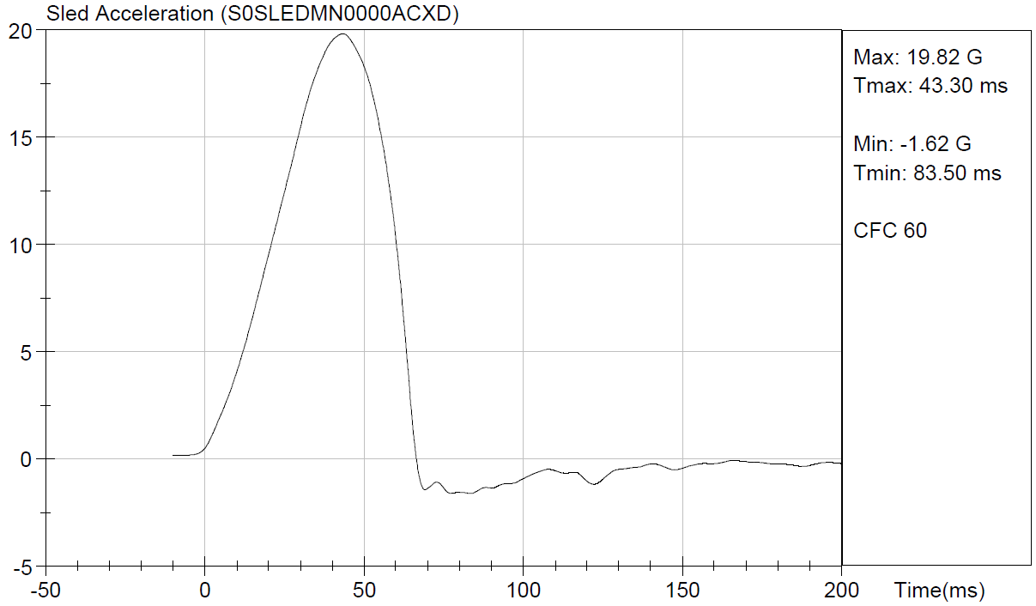
Figure 25: FMVSS 301 Sled Pulse (Generic, 20G Pulse)

The dummy position data such as H-Point location and torso angle were computed based on MY2014 Honda Accord Vehicle structure and seat models. The FMVSS 301 Rear Impact Sled test setups for fully trimmed manual and power seat are shown in Figure 26.

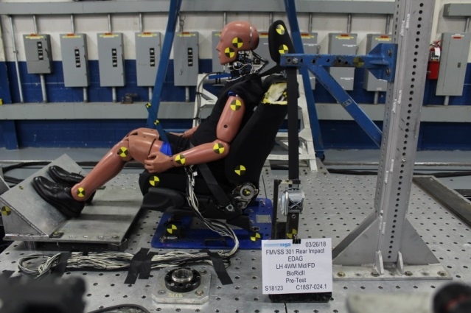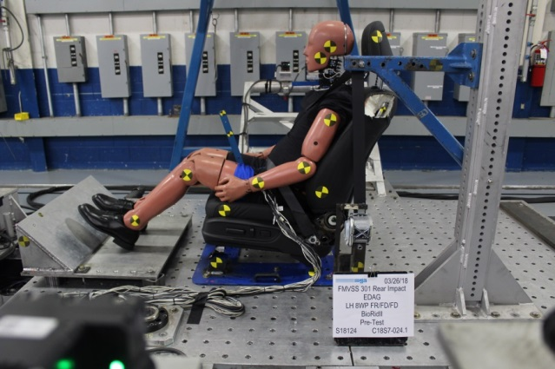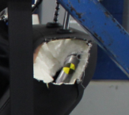
Manual Seat
Power Seat
Figure 26: FMVSS 301 Sled Test Setup

The manual seat was tested in mid track and full down seat position. The power seat was tested in full rear track and full down seat position. The reason for conducting the sled tests for two different seat positions is to understand the seat back strength requirements for nominal and extreme conditions of occupant seating. Occupant characteristics including head acceleration, neck injury parameters and seat back measurements were recorded appropriately. Considering the scope of this project to study the seat back strength, a target point location was marked on the top of the seat back frame to track the seatback angle (shown in Figure 26). Measured from the initial position, the manual seat recorded a dynamic seat back deflection of 38.4° and post-test static permanent deflection of 9.4°. The power seat recorded a dynamic seat back rotation of 38.5° and post-test static permanent deflection of 9°. The following Figure 27 and 28 show the pre and post-test photographs of the FMVSS 301 Sled Test of manual and power seats respectively. In the dynamic seat back test there is no significant deformation is observed on both power and manual seat similar to the quasi-static pull test.

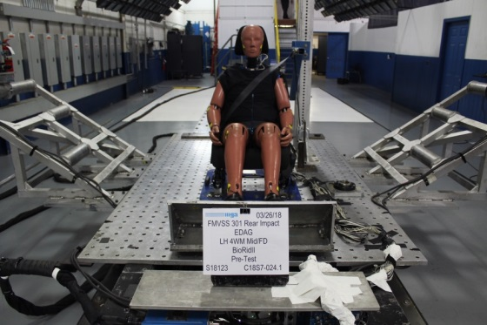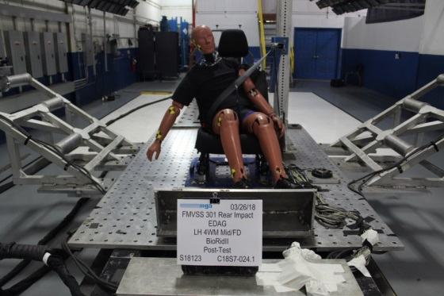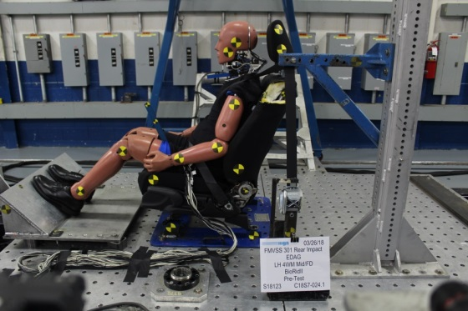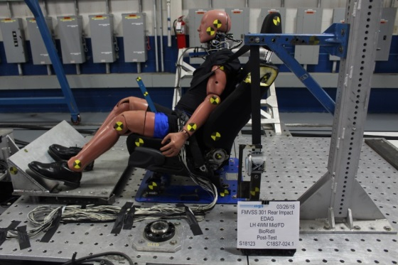
Pre Test
Post Test
Figure 27: FMVSS301 Sled Test – Manual Seat

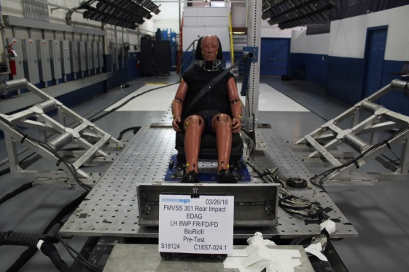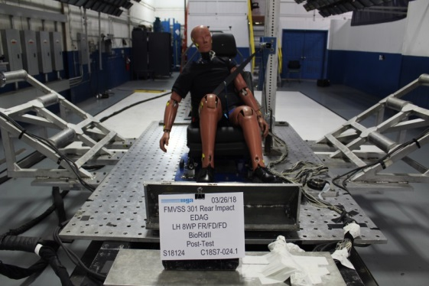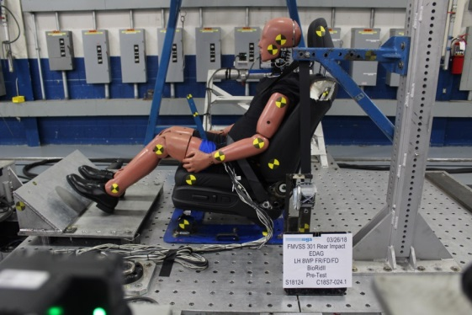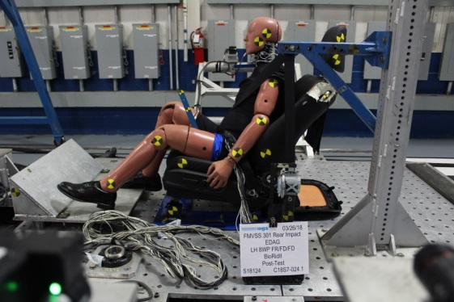
Pre Test
Post Test
Figure 28: FMVSS301 Sled Test – Power Seat

The dynamic seat deflections (in degrees) of manual seat and power seat are shown in Figure 29 and 29 respectively.

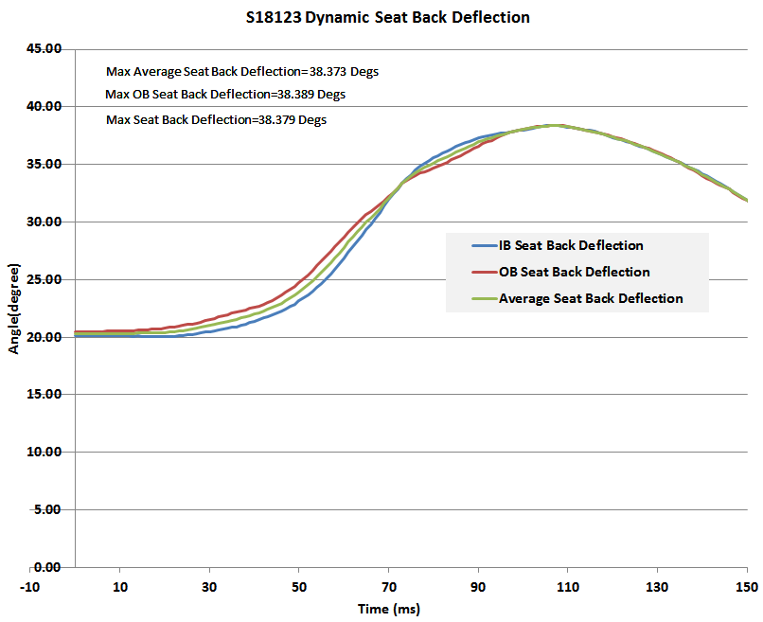
Figure 29: Seat Back Dynamic Deflection - Manual Seat

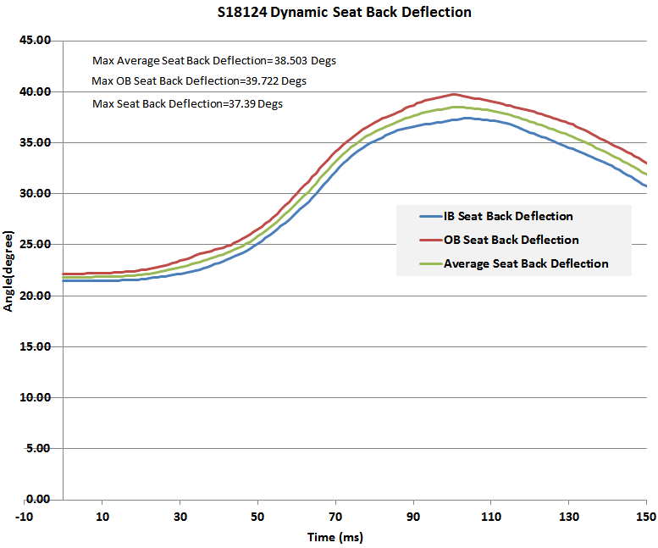
Figure 30: Seat Back Dynamic Deflection - Power Seat

Detailed sled test reports of manual and power seat testing are provided in Appendix A.3a and A.3b where occupant head acceleration and neck injury measures are given accordingly. The occupant characteristics from the sled tests have been referred accordingly in the FEA model development, as described in the following sections.

