Baseline Seat Simulation
This section of report explains the baseline FEA seat model validation and test simulations. The objective of this seat simulation was to compare the FE simulations results to the physical test and determine the FE seat models are equivalent representation of the physical seats.

Baseline Seat Choice
The selected seats for this Task Order was from the MY 2014 Honda Accord mid-size sedan car. This vehicle FE model was used for NHTSA Task Number DOT Contract DTNH22-15-D-00006 Structural Countermeasure/Research Program “Mass and Cost Increase due to Oblique Offset Moving Deformable Barrier Impact Test”. It was also used for NHTSA Task Number DOT Contract DTNH22-15-D-00006/0002 Vehicle Interior and Restraint Modeling/Research Program “Development of Full Vehicle Finite Element Model including Vehicle Interior and Occupant Restraints Systems for Occupant Safety Analysis using THOR Dummies”. The vehicle model included the basic MY2012 seat models of minimum details without any validation for seat back strength.

For this Task Order the seat models were developed based on MY2014 seats available in the market by scanning the parts and modeling the additionally required details. The driver side of the full vehicle was utilized for FMVSS 301 rear impact simulation with Bio-RID II occupant dummy model.

EDAG purchased the following seat assemblies. Figure 1 shows the pictures of the seat assemblies purchased for testing and modeling purpose.
- Front seat without cushions and plastic trims, manual adjustable
- Front seat without cushions and plastic trims, power adjustable
- Front seat fully trimmed, with cushions and standard cloth trim, manual adjustable
- Front seat fully trimmed, with cushions and leather trim, power adjustable

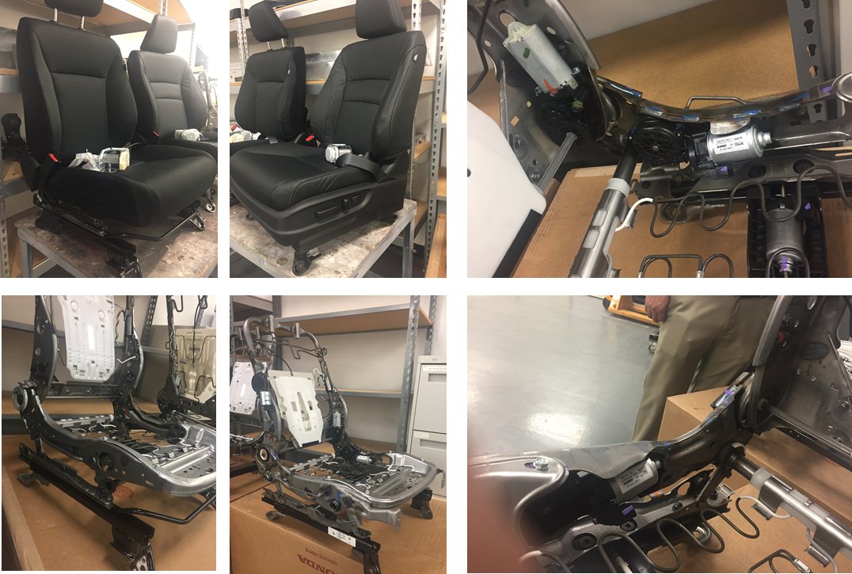
2
1
1
2
3
4
Figure 1: Seat Assemblies

Seat assemblies 1 and 2 were used for seat back pull test. Seat assemblies 3 and 4 were used for FMVSS 301 rear impact sled test.

Baseline Seat Tests
In order to develop a detailed seat model, the seat model was validated with physical test results. The seat back strength was chosen as validation criteria to compare the FE seat model with physical test. The seat back strength was tested using seat back pull test. The test was conducted with a similar loading method to that stated in FMVSS 207 Rearward Moment (49 CFR 571.207 S4.2d, dated 10/1/2016), but the loads were applied until the seats collapsed. The load was applied at the uppermost seatback at -9 degree as shown in Figure 2.
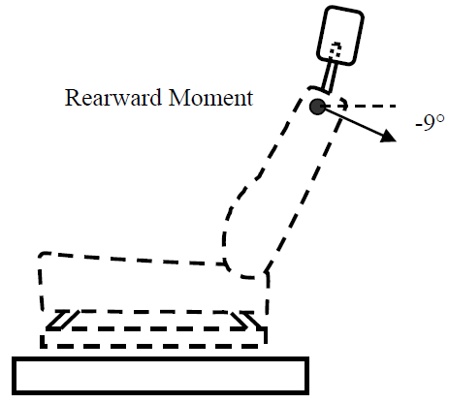
Figure 2: Schematic Diagram of the Seat Back Pull Loading

Seat Back Pull Test – Manual Seat
This test was conducted on the manual seat without cushions and plastic trim in a quasi-static loading condition. The following load profile shown in Table 1 was used to pull the seat back. The necessary seat fixtures were fabricated to mount the seat at four seat bolts at the four corners of the seat base. The load of 875N corresponds to the FMVSS207 moment requirement of 373Nm.
Table 1: Seat Back Pull Test Load Profile – Manual Seat

The seat back pull test setup of the manual seat is shown in Figure 3 and the test position of the seat is given in Table 2.

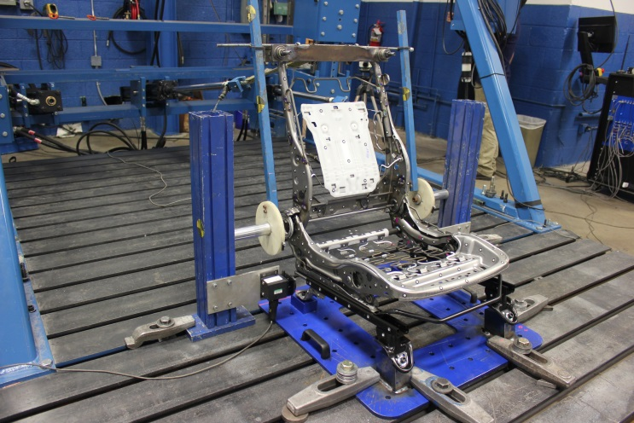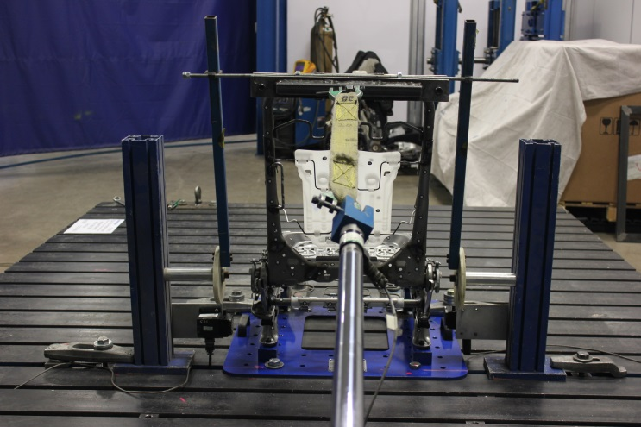
Fixture
Mounting Plate
Loading Piston
Figure 3: Seat Back Pull Test Seat Setup – Manual Seat

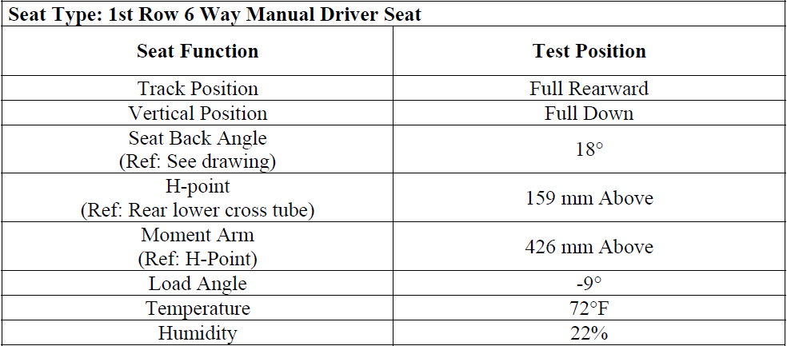
Table 2: Seat Back Pull Test Seat Position – Manual Seat

The load was applied at mounting plate on the top of the seat back frame in the rearward direction. A pull load was applied in the rearward direction from 88 N (at 0 seconds) to 875 N (at 5 seconds), and then the load was maintained for the next 6 seconds (per the FMVSS 207 quasi static seat back strength test). The intent of this study is to observe the seat back strength for the maximum seat back rotation that might cause injury to the rear seat passenger by contact with the seat back. Therefore, after 11 seconds the pull load was increased further, until the seat back collapsed. It was found that the manual seat collapsed at 7,151N. Images of deformed seat frames after the seat back pull test are shown in Figure 4 and Figure 5.
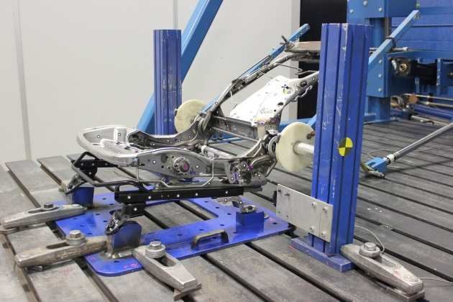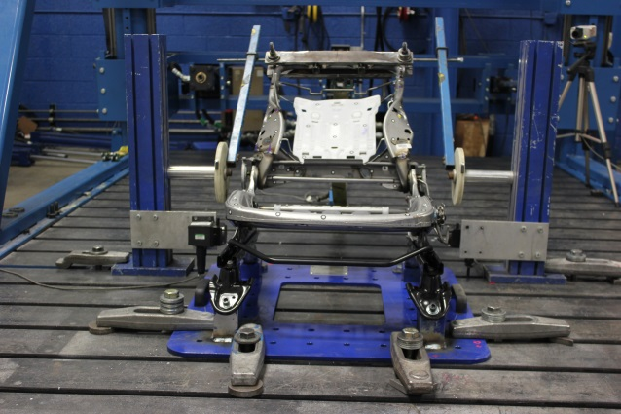
Figure 4: Seat Back Pull Test, Post Test – Manual Seat

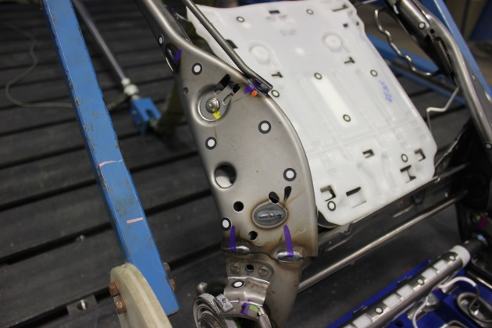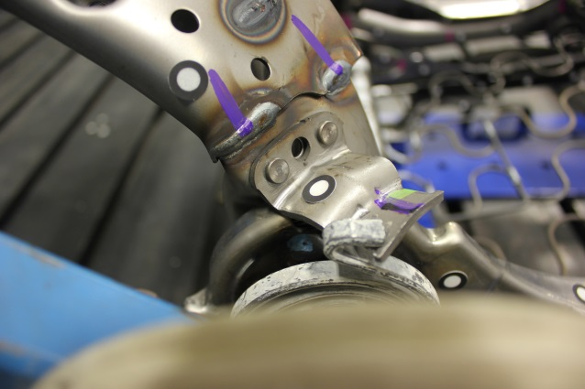
Figure 5: Seat Back Pull Test, Post Test, Seat Back Frame Deformation – Manual Seat

From the test results we can observe that until 11 sec there is no deformation or failure. The deformation is been observed on the seat bottom frame at the connecting flanges also we can see significant deformation occurred symmetrically at the seat back frame at weld joint location. There are no failures or deformation observed on the recliner mechanism. The collapse of the seat started when the seat back angle reached 50.1 degrees from the normal.

Seat Back Pull Test – Power Seat
Similar to the manual seat, the seat back pull test was conducted on the power seat without cushions and plastic trim in quasi-static loading condition. The following load profile shown in Table 3 was used to pull the seat back. The necessary seat fixtures were fabricated to mount the seat at four seat bolts, in the same way as was done for the manual seat.

Table 3: Seat Back Pull Test Load Profile – Power Seat

The power seat, seat back pull test setup is shown in Figure 6.

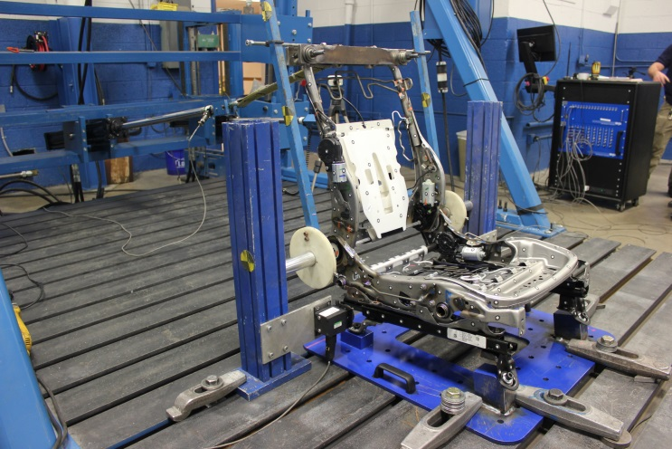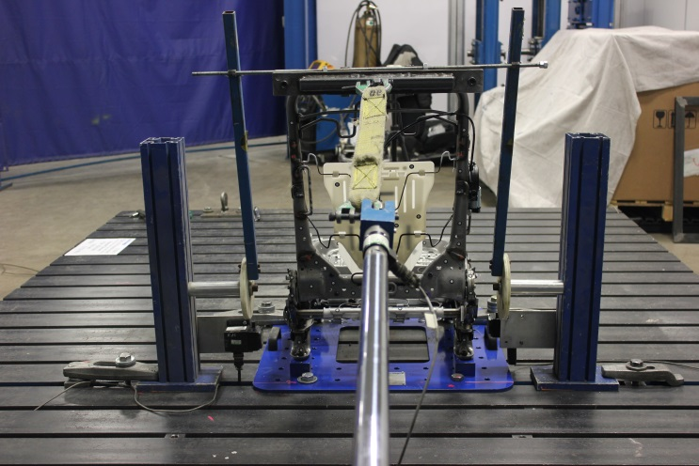
Fixture
Mounting Plate
Loading Piston
Figure 6: Seat Back Pull Test Seat up – Power Seat

The load was applied at mounting plate on the top of the seat back frame in the rearward direction. A pull load was applied in the rearward direction from 86 N (at 0 seconds) to 861 N (at 5 seconds), and then the load was maintained for the next 6 seconds (per the FMVSS 207 quasi static seat back strength test). Similar to the manual seat test, after 11 seconds the pull load was increased further until the seat back collapsed. It was found that the power seat collapsed at 6,246N. Images of deformed seat frames after the seat back pull test are shown in Figure 7 and Figure 8.

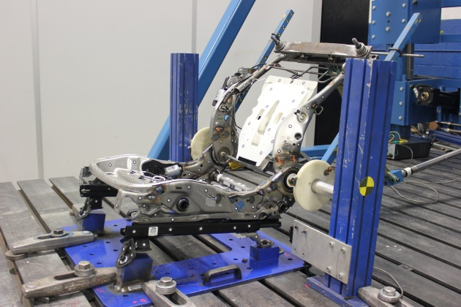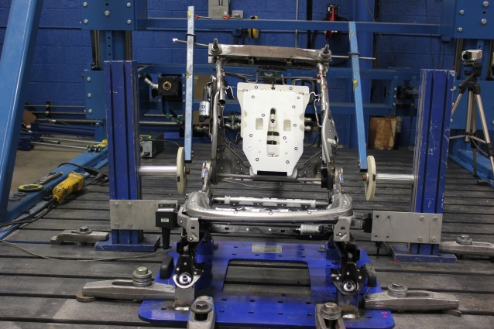
Figure 7: Seat Back Pull Test, Post Test – Power Seat

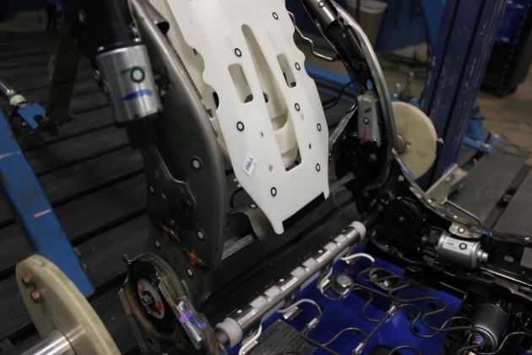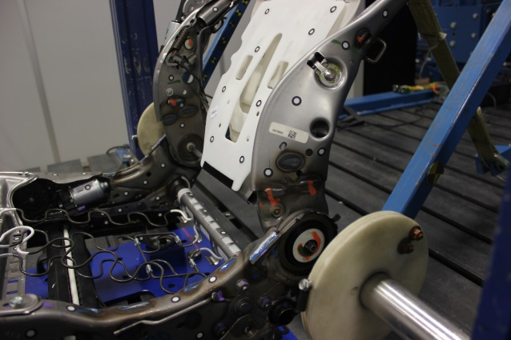
Figure 8: Seat Back Pull Test, Post Test, Seat Back Frame Deformation – Power Seat

Similar to the manual seat there is no deformation or failures seen until 11 sec. There are no failures or deformation observed on the recliner mechanism. Unlike the manual seat, the power seat frame deformation was not symmetry due to the varied motor and mechanisms attachment locations on the seat frames. The left hand side (LHS) seat frame deformed higher than the right hand side (RHS) seat frame. The LHS and RHS seat back frames collapsed at 37.1 degrees and 20 degrees respectively.

The detailed test reports for both manual seat and power seat have been provided in Appendix A.1.

Seat FE Model Development
The Honda Accord MY2014 vehicle FE data in this study included the seat data from MY2012 vehicle. Therefore it was decided to update the seat models with MY2014 seat structural components. The manual and power seat structural parts were compared to the MY2012 FE seat models. The parts which were new and significantly different from MY2012 seat models (in terms of design and assembling) were scanned and exported to stereolithographic (STL) digital format readable in computer aided design (CAD) tools. The thicknesses of the new parts were recorded. The material grades were estimated based on a hardness test. The scanned CAD data of the manual and power seats are shown in Figure 9.

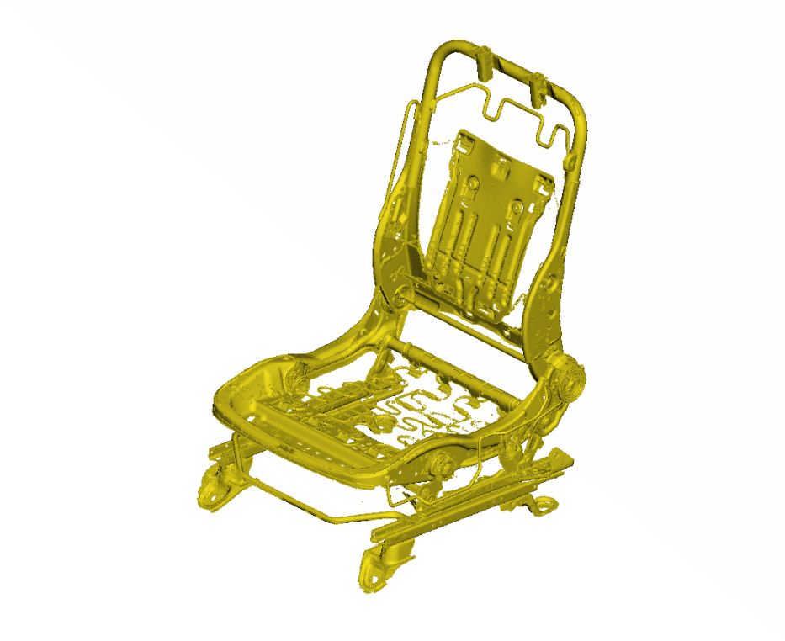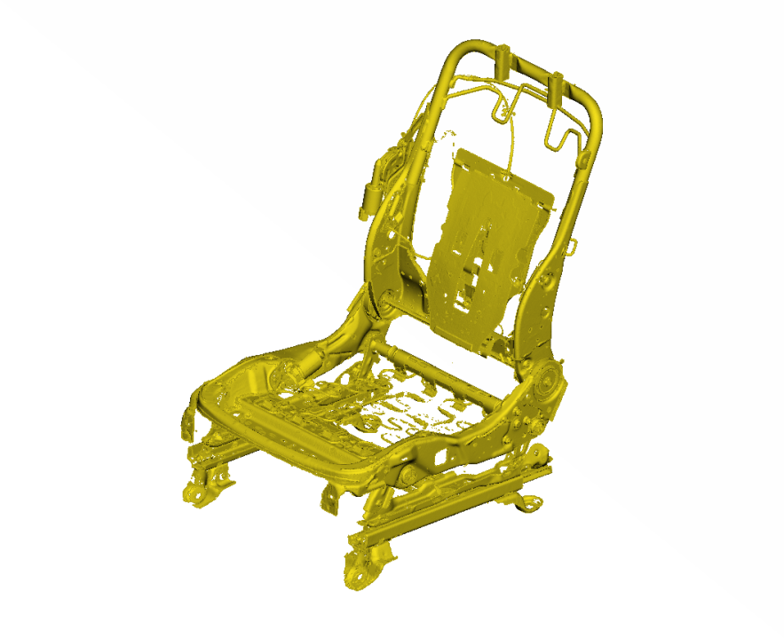
Manual Seat CAD Model
Power Seat CAD Model
Figure 9: Scanned Seat Models

The new and significantly different parts CAD data were then meshed in commercially available FE modeling tools. The FE meshed parts were integrated to the respective manual and power seat FE models. The main differences between the MY2012 and MY2014 seat models are the seat back and seat rest; it has been listed in Appendix A.2. The detailed MY2014 manual and power seat models are shown in Figure 10.

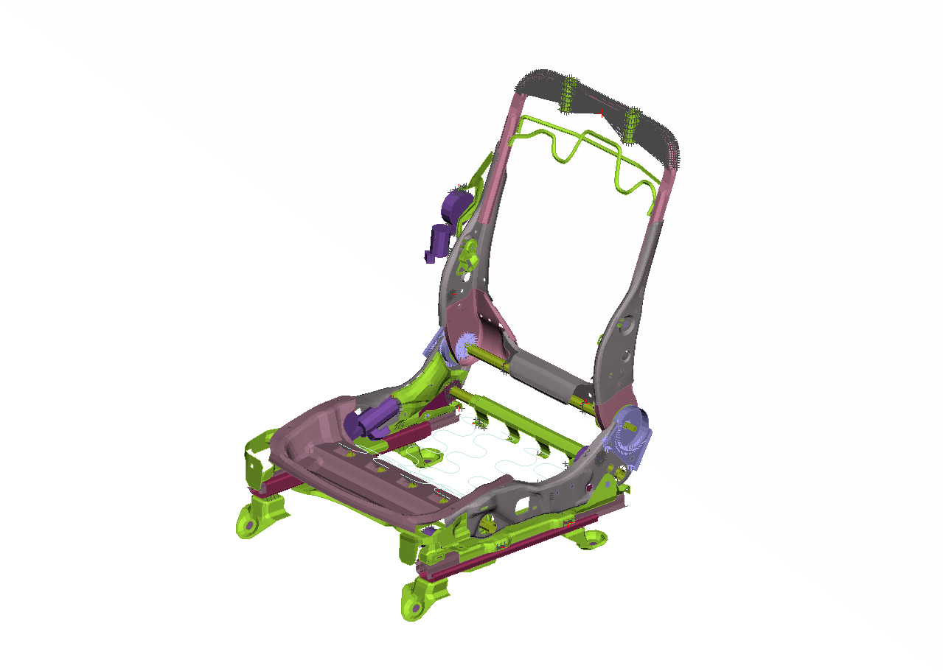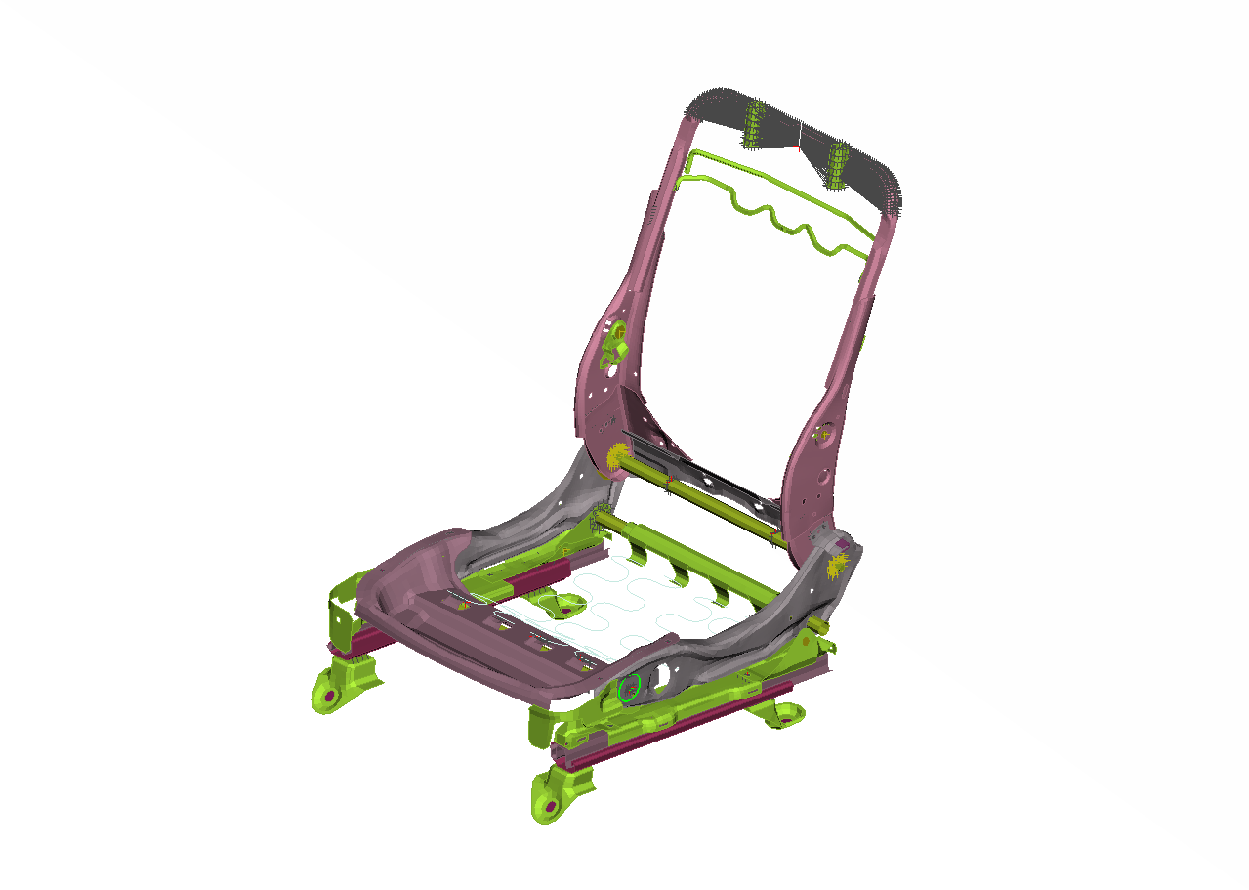
Manual Seat
Power Seat
Figure 10: MY 2014 Detailed FE Models

Manual Seat – Seat Back Pull Test Correlation
The manual seat (MY2014) FE model was set up with positioning the seat to full down, full rear position by adjusting the seat position mechanism. The seat back was rotated to 18 degrees rearward with respect to vertical plane. A nodal rigid body (NRB) was created representing the rigid mounting plate welded on the uppermost member of the seat. The load profile in terms of load curve (force vs. time) was applied at the NRB at -9 degrees with respect to the horizontal plane. It was noted from the test that as the loading piston pulls the seat back rearward, the concentrated force rotates about global Y axis at the point of application of load. Therefore, the FE model was setup to represent this force rotation. The load was applied in the direction matching to the loading piston displacement from the test. A local coordinate system was included in the model, at the centroid of the NRB to measure the seat back displacement along the loading direction. The load application and boundary conditions are shown in Figure 11 and 12.

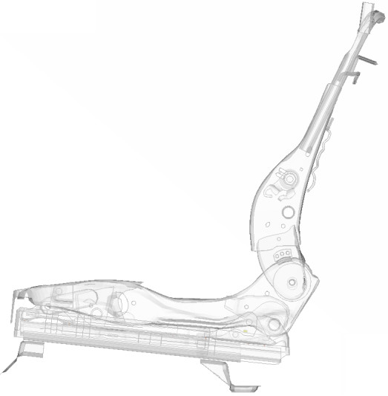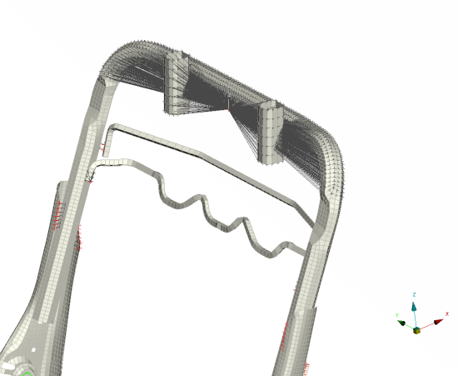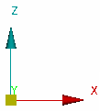
Seat Mount Attachment points are constrained

F
Point of load Application
F
Mounting plate is modeled as constrained Nodal Rigid Body (NRB)
99°
The force angle changes as the seat back is pulled rearward
Figure 11: Manual Seat (MY2014) FE Model Setup, Loading and Boundary Conditions

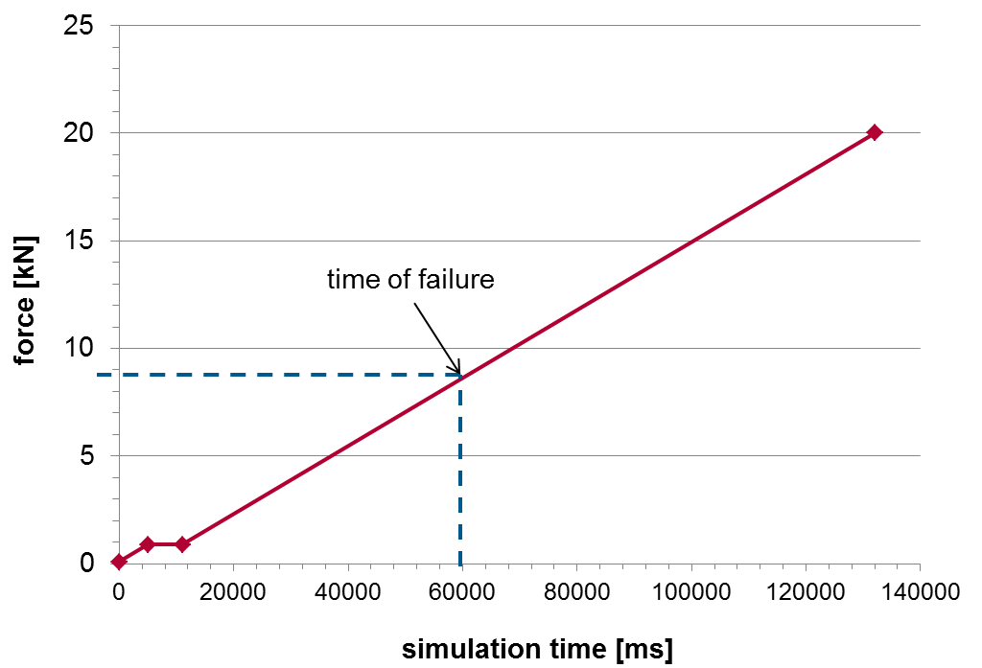
875 N
Figure 12: Loading Curve – Manual Seat

LS-DYNA simulation was run in implicit mode (LS-DYNA solver option to run quasi-static simulations) for 60 seconds. It should be noted that the material properties of FE parts were assumed with 0 strain rate stress-strain curve to run in quasi-static condition. FE simulation results of the manual seat back pull test were compared with the physical test. Figure 13 shows the comparison of the deformed shape of the seat. Figure 14, 15 and 16 show the deformation of the collapsed seat frames at the failed area.

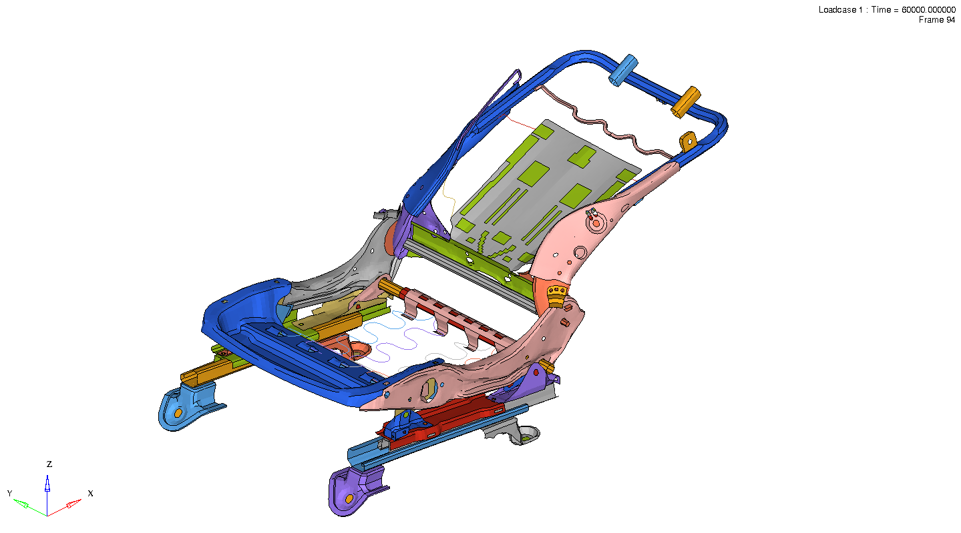
Figure 13: Global deformation of the Seat Frame – Manual Seat

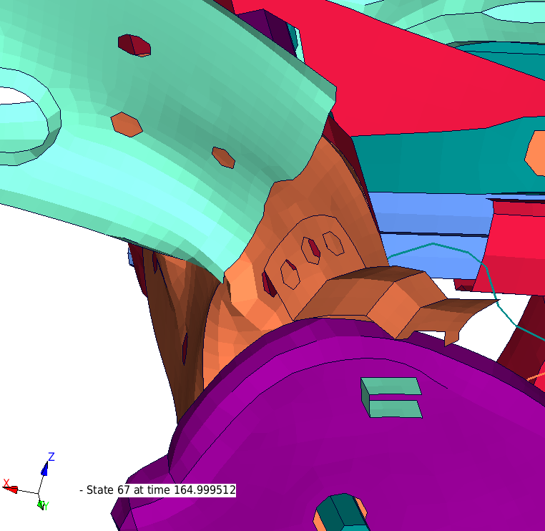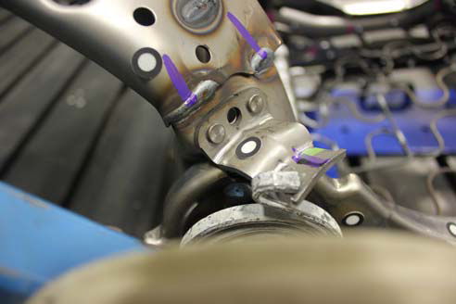
Figure 14: Similar deformation of LHS Seat Frame Test vs FEA – Manual Seat

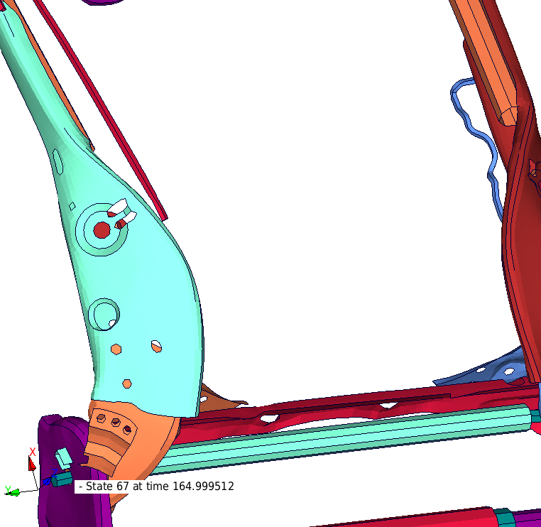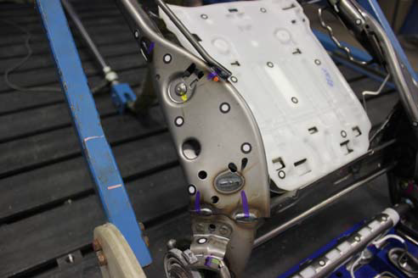
Figure 15: Similar deformation of RHS Seat Frame Test vs FEA – Manual Seat

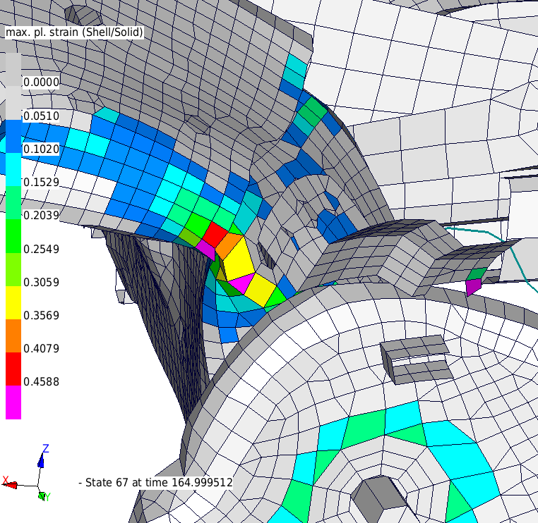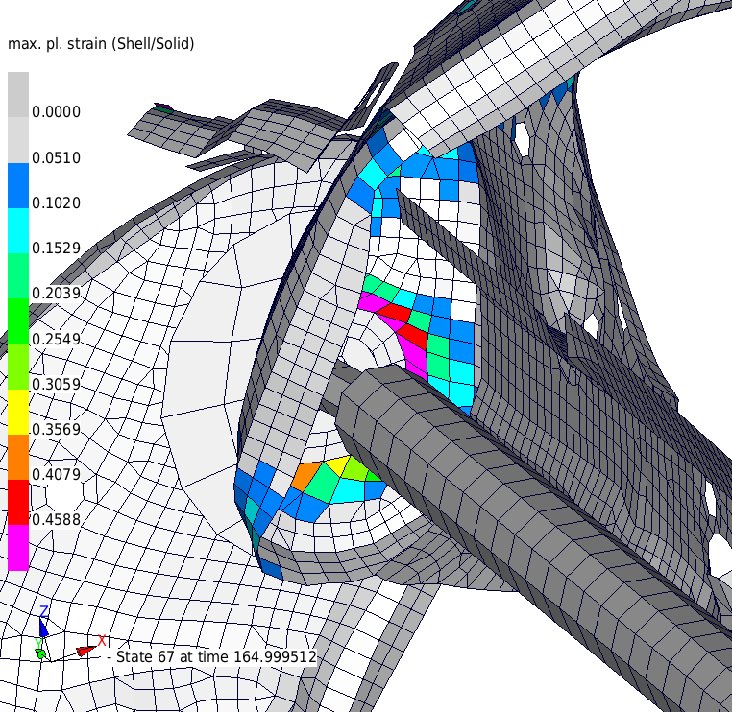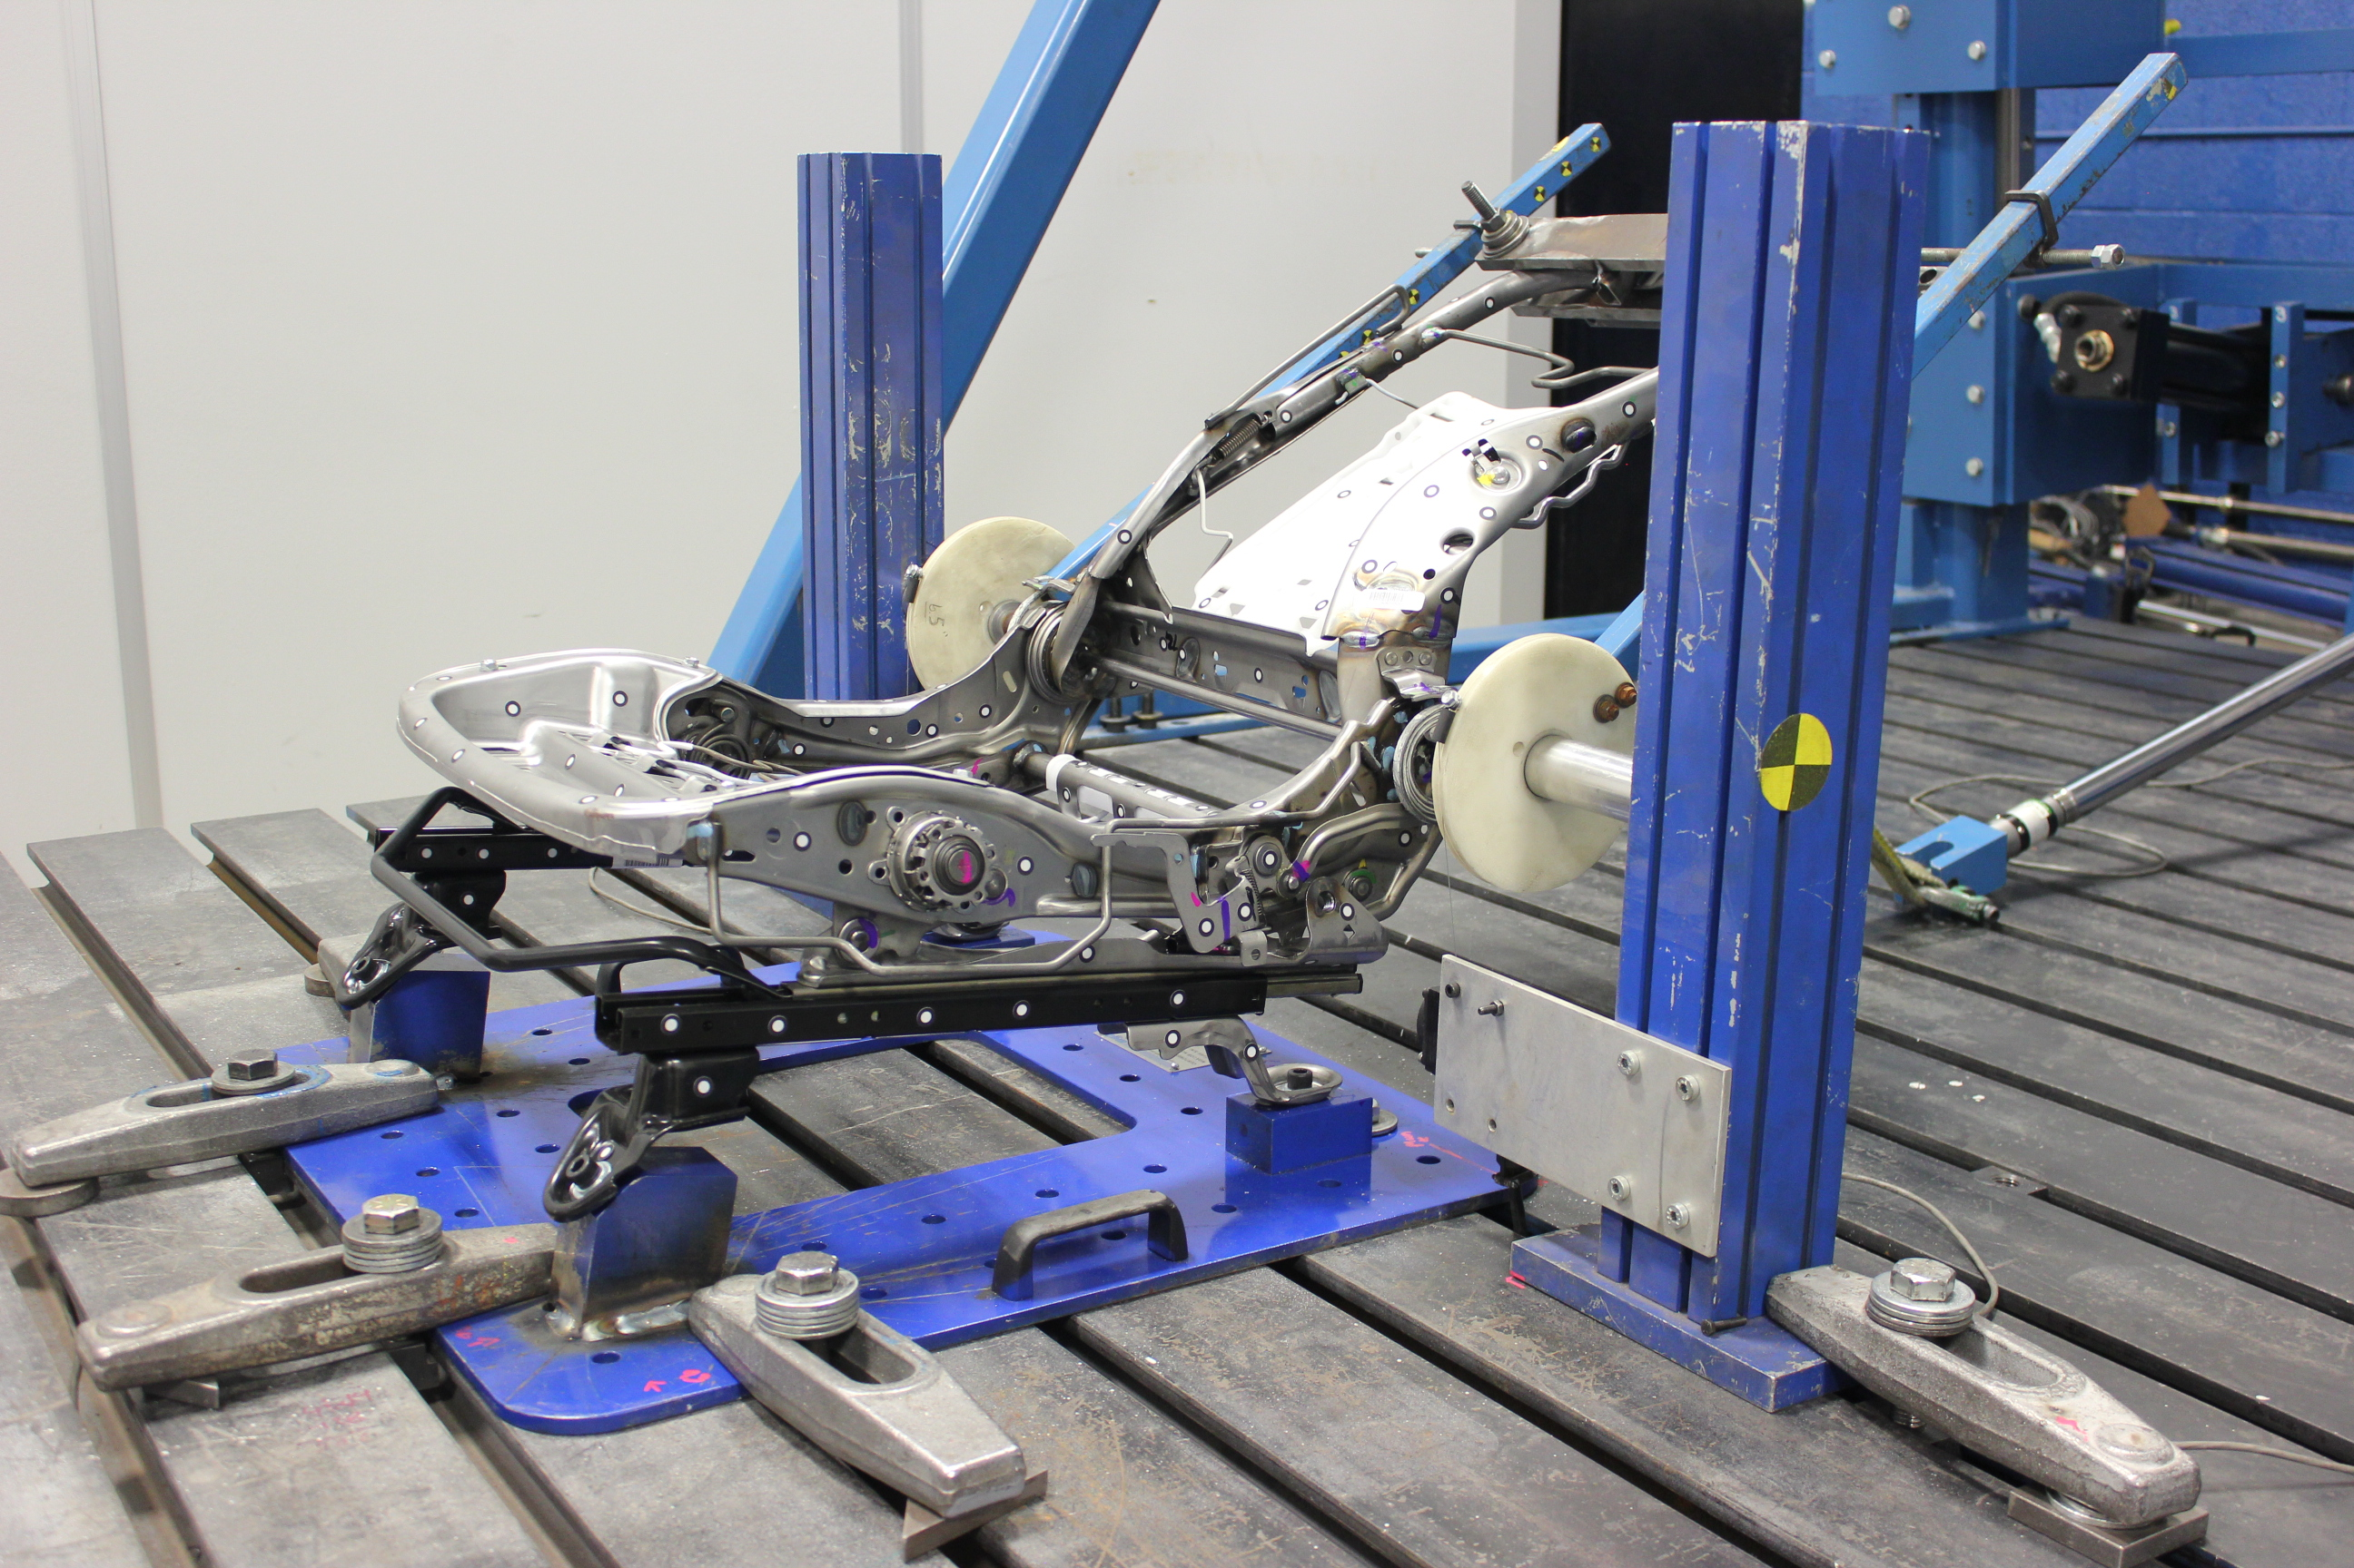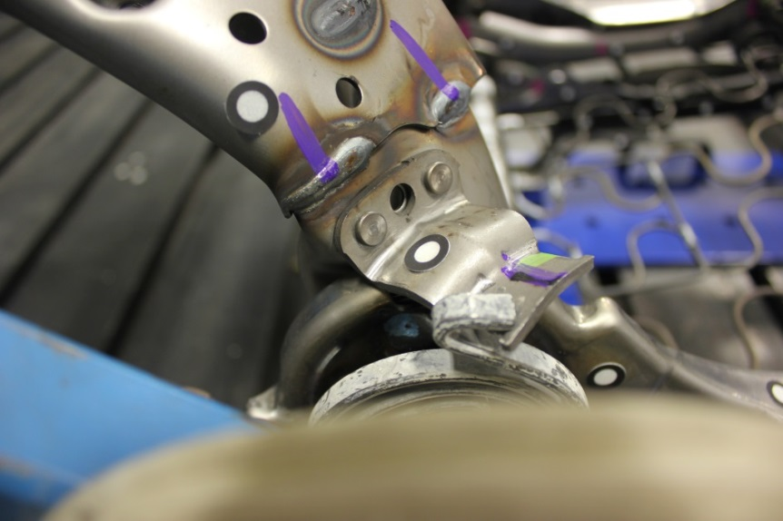
Figure 16: Manual Seat deformation at Failure Area Similar to Test

The gussets folded inward and failed symmetrically in both Test and FEA. In addition to the frame deformation, the seat back strength was compared in terms of stiffness or Force vs. Displacement (FD) plots. The displacement of the seat back along the loading direction, which is the representation of the piston displacement in the physical test, was measured and plotted against the applied load profile. The comparison of FD curves of FE simulation and physical test is shown in Figure 17.

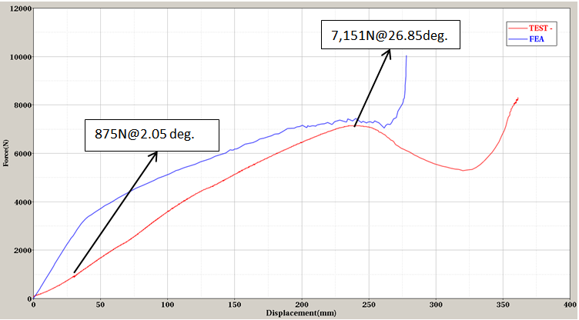
Figure 17: Force vs. Displacement Curves – Manual Seat

A commercially available curve comparison tool called “CORA” was utilized to compare the CAE and test FD curves. The FD curve shows a correlation rating of about 78% which is a generally acceptable rating for such curves as good correlation.

From the above comparisons of frame deformation and stiffness (FD curve), it can be concluded that the manual seat correlated well with the physical test. Thus the manual FE seat was modeled with acceptable detail and accuracy.

Power Seat – Seat Back Pull Test Correlation
Similarly, the power seat FE model was also set up to full down, full rear position by adjusting the seat position mechanism. The same method was followed from the manual seat modeling to set up and run power seat pull test simulation. The load application and boundary conditions setup are similar to the manual seat as shown in Figure 11, but the loading curve is slightly different. The loading curve used for power seat is shown in Figure 18.

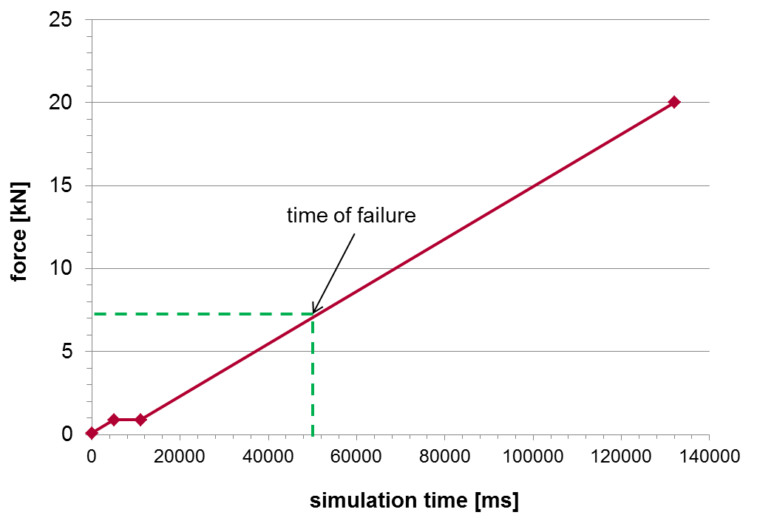
861 N
Figure 18: Loading Curve – Power Seat.

FE simulation results of the power seat back pull test were compared with the physical test. Figure 19 shows the comparison of the deformed shape of the seat. Figure 20, 21 and 22 show the deformation of the collapsed seat frames at the failed area. The gussets folded non-symmetrically due to the motor that is located on the right side gusset, LHS and RHS seat back frames collapsed at 37.1 degrees and 20 degrees respectively.

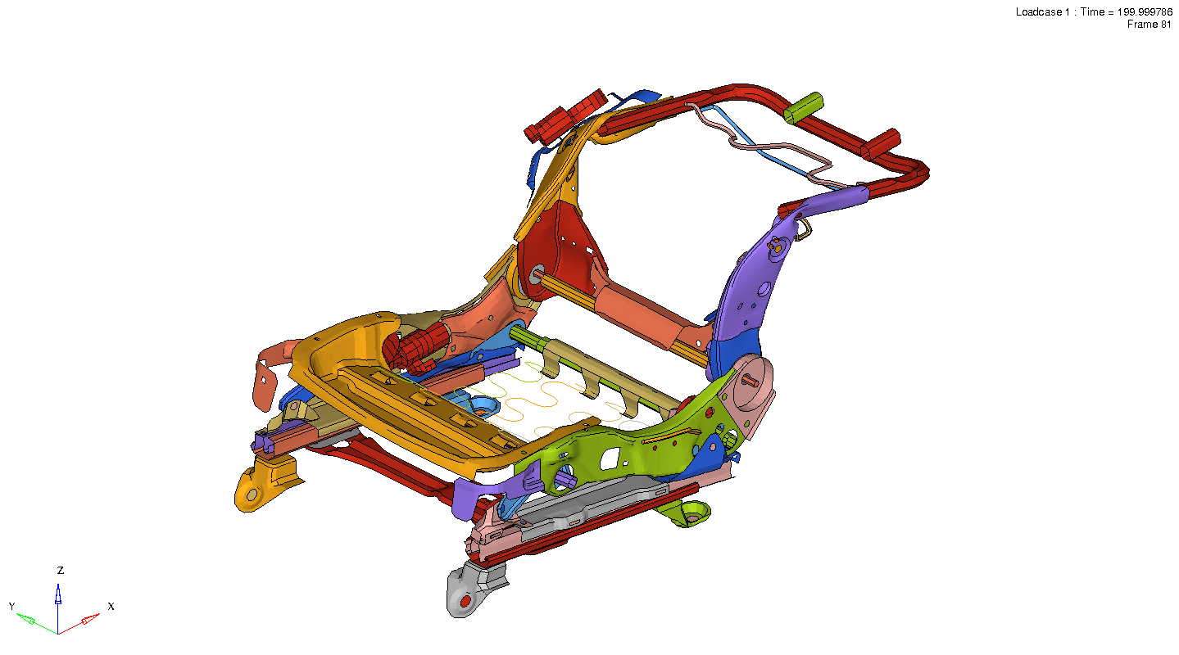
Figure 19: Global deformation the Seat Frame – Power Seat
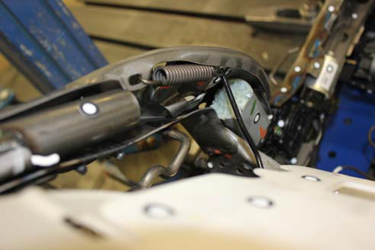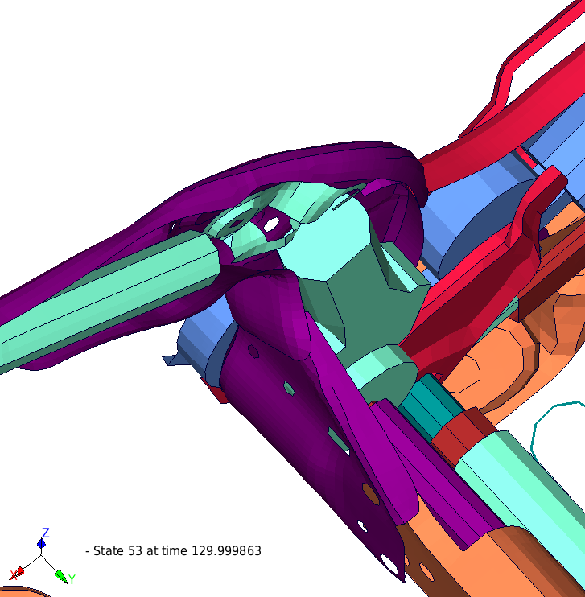
Figure 20: Similar deformation of LHS Seat Frame Test vs FEA – Power Seat

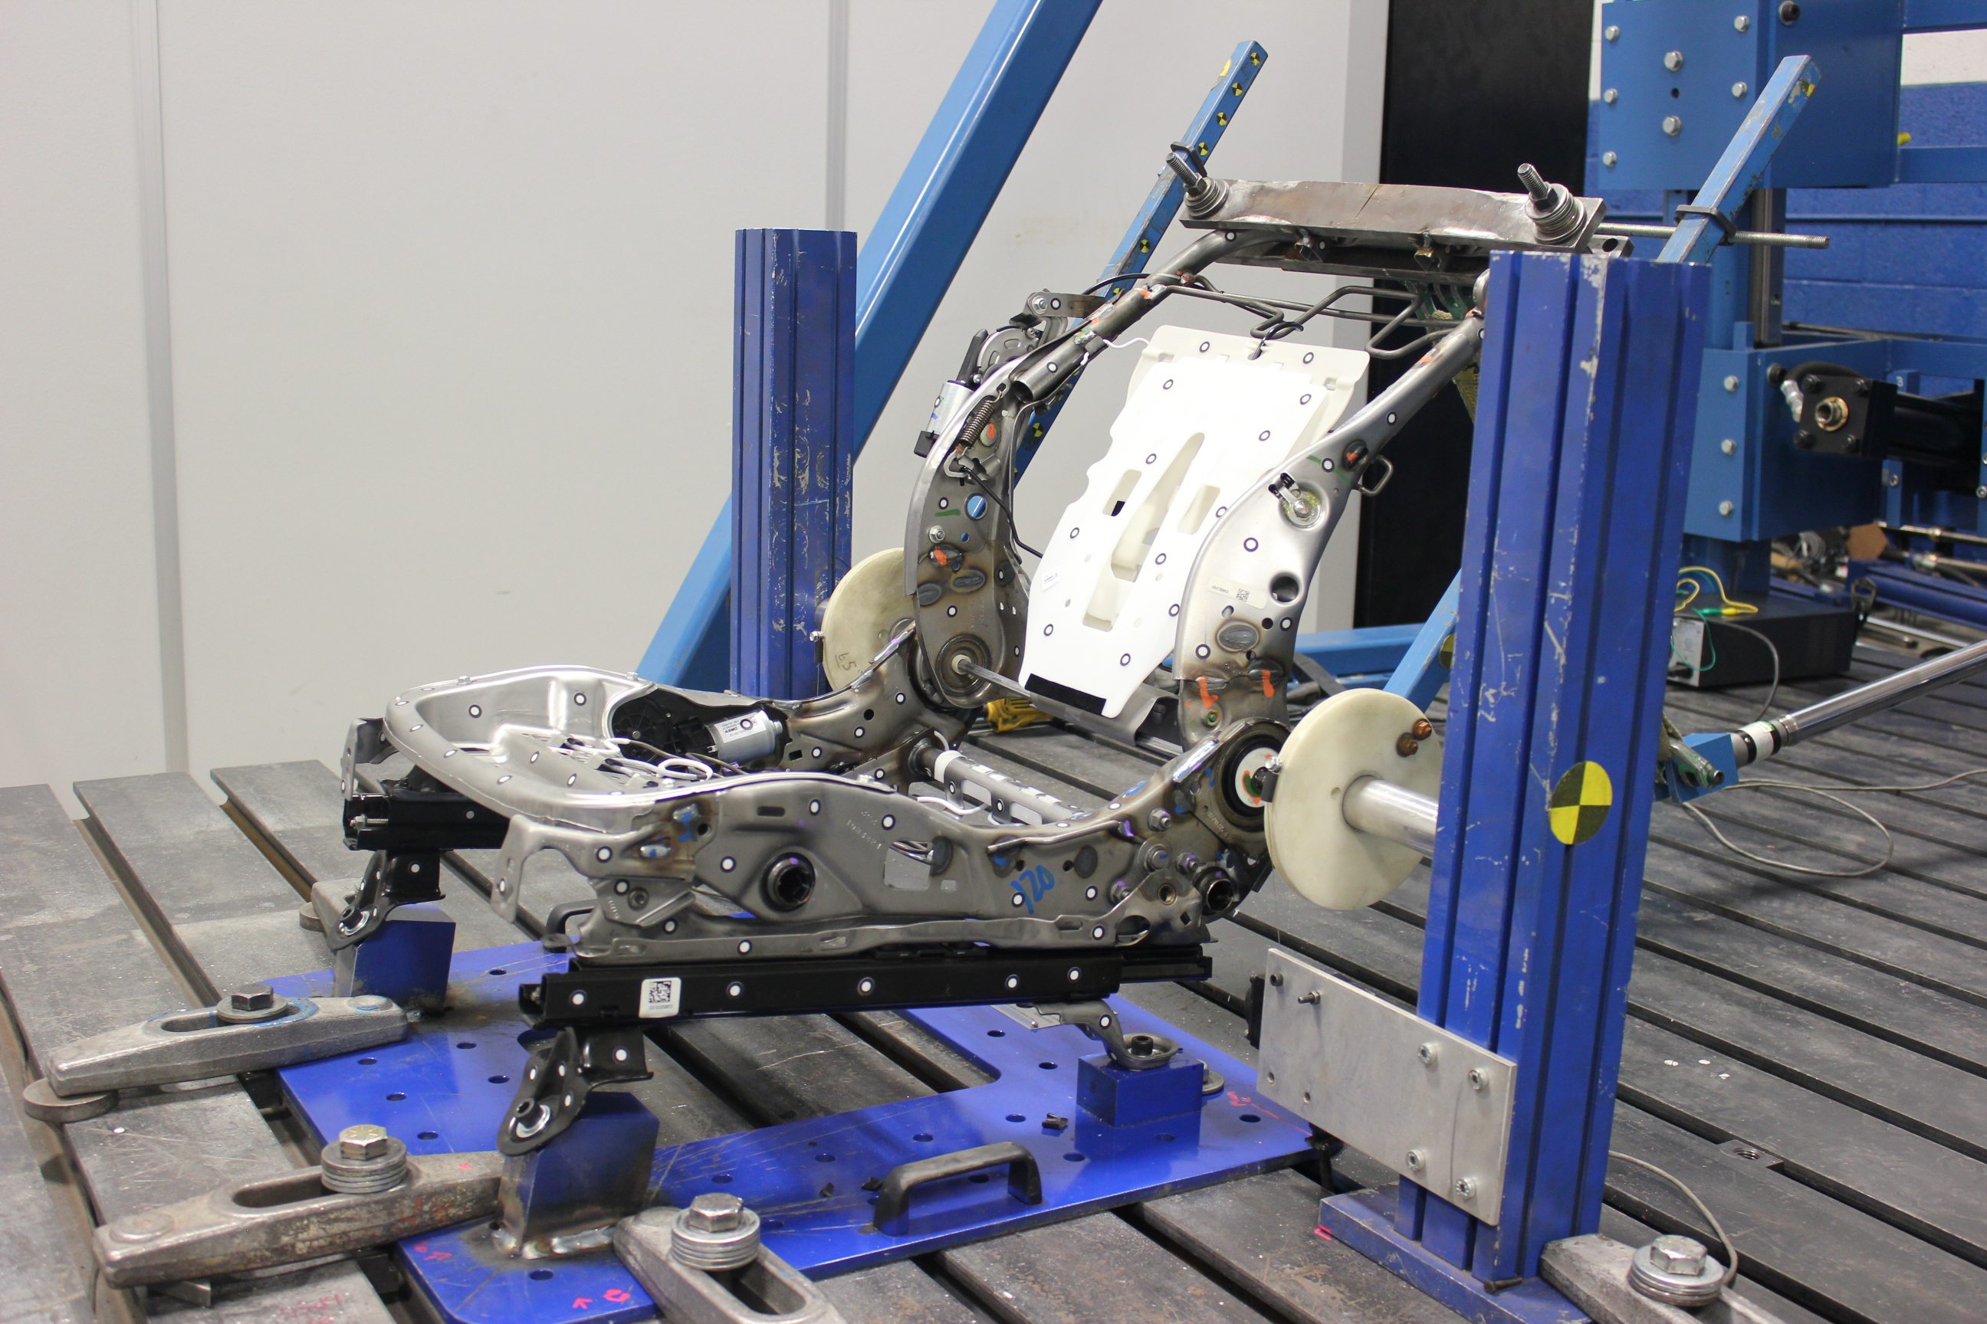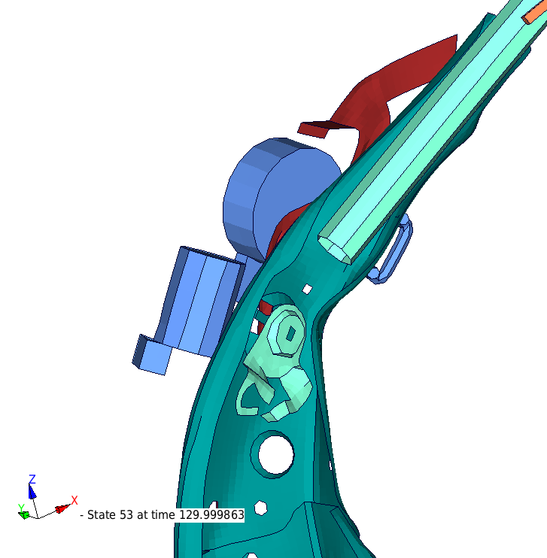
Figure 21: Similar deformation of RHS Seat Frame Test vs FEA – Power Seat

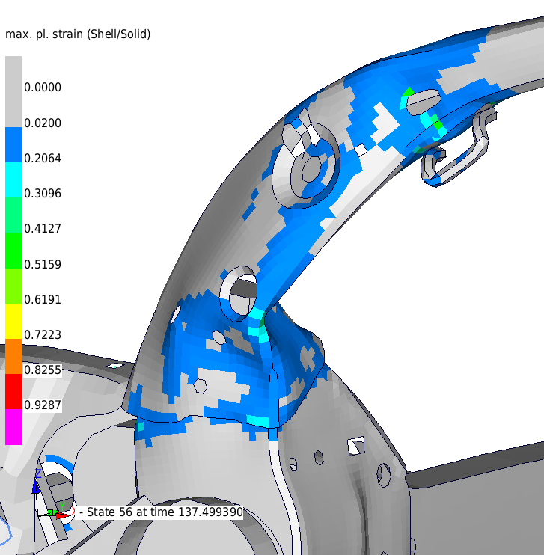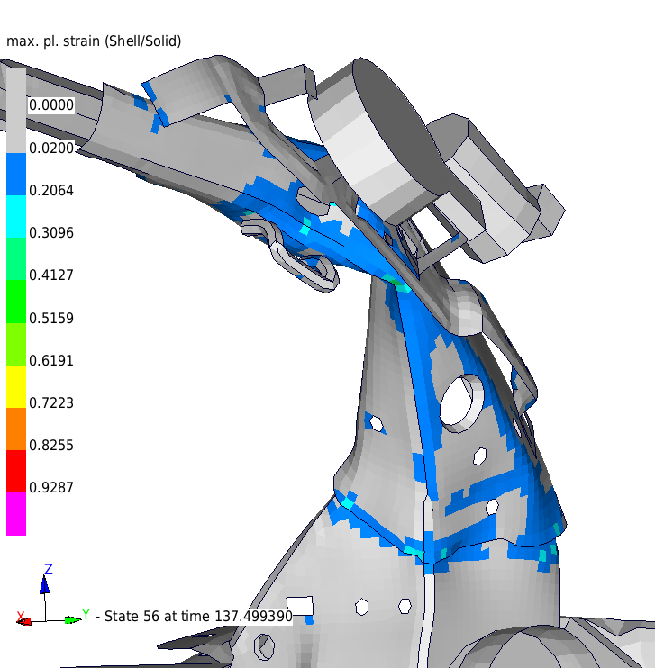
Figure 22: Power Seat Deformation at Failure Area Similar to Test

In addition to the frame deformation, the seat back strength was compared in terms of stiffness or Force vs. Displacement (FD) plots. The displacement of the seat back along the loading direction, which is the representation of the piston displacement in the physical test, was measured and plotted against the applied load profile. The comparison of FD curves of FE simulation and physical test is shown in Figure 23.
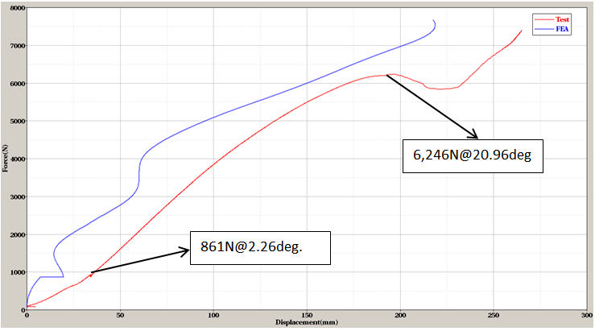
Figure 23: Force vs. Displacement Curves – Power Seat

The commercially available curve comparison tool called “CORA” was utilized to compare the CAE and test FD curves. The FD curve shows a correlation rating of about 76% which is a generally acceptable rating for such curves as good correlation.

From the above comparisons of frame deformation and stiffness (FD curve), it can be concluded that the power seat also correlated well with the physical test. Thus the power FE seat was modeled with acceptable detail and accuracy.

