Vehicle Research and Test Center

Eval of ATD THOR50M Shoulder Evaluation
THOR-50M

Prepared By:

Transportation Research Center Inc.
10820 State Route 347
P. O. Box B-67
East Liberty, OH 43319



Summary Report

October 2020

Prepared For
Vehicle Research and Test Center
P. O. Box 37
East Liberty, OH 43319

SECTION 1
PURPOSE AND SUMMARY FOR THOR-50M

The purpose of the testing is: (1) Evaluate THOR Shoulder design in Frontal Impacts (2) Evaluate THOR Shoulder design in 20°Oblique Impacts

SUMMARY

A THOR-50M (serial number 016) was secured in the left front occupant position (position 1 or P1). The THOR-50M was instrumented with head, spine (upper, middle and lower), and pelvis triaxial accelerometers, upper/lower neck, thoracic spine, ASIS, tibia and Femur force and moment load cells; acetabulum force load cells, knee displacement potentiometers and thorax and abdomen IRTRACC voltages. During this test series the dummy was restrained with a 3-point seatbelt and airbags.

Section 2 contains the driver’s side 20° buck views of the dummy. Section 3 contains the driver’s side 0° buck views of the dummy. Section 4 contains the dummy certification information.

SECTION 2
DRIVER SIDE 20° BUCK TEST SUMMARY

TEST DUMMY INFORMATION

Description | Position # 1
ATD Type/Serial No. | THOR-50M/016
Restraint System | 3-Point Seatbelt
Shoulder | Original (SD3) or Alternate (NHTSA)

CAMERA POSITIONING FARO MEASUREMENTS

Description | Units | X | Y | Z
Origin | mm | 0.00 | 0.00 | 0.00
N3 Driver Shoulder | mm | -681.05 | -452.28 | -533.20
N1 Center | mm | -677.39 | -721.72 | -531.83

DUMMY POSITIONING

THOR50M 016 – Original (SD3) – 20° Degrees

TRC Test Number: S201013-1 VRTC Test Number: FRT_ALTSHLD_01
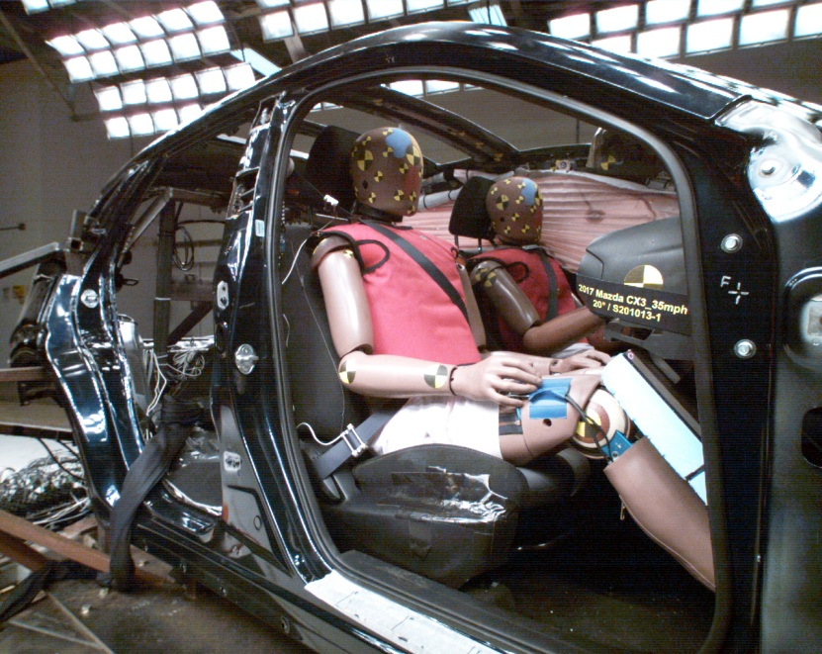
DUMMY POSITIONING FARO MEASUREMENTS
Description | Units | X | Y | Z
Origin-post | mm | -0.005 | 0.063 | -0.082
SO | mm | 447.647 | 404.633 | -177.374
TS | mm | 534.021 | 401.195 | -339.996
BS | mm | 396.944 | 404.091 | -25.314
RHDCG | mm | -40.351 | 482.331 | -483.331
Right EAM | mm | -30.379 | 476.197 | -455.358
LHDCG | mm | -36.226 | 328.274 | -480.572
Left EAM | mm | -29.342 | 333.234 | -456.755
NS | mm | 58.488 | 408.863 | -493.916
Right IOF | mm | 55.514 | 439.373 | -455.930
Left IOF | mm | 55.425 | 376.132 | -456.361
TN | mm | 58.469 | 408.647 | -457.707
TC | mm | 52.662 | 409.299 | -357.513
C1 | mm | 85.657 | 409.720 | -233.054
C2 | mm | 114.890 | 405.687 | -177.721
C3 | mm | 204.471 | 405.501 | -23.652
SHT1 | mm | -62.092 | 212.510 | -258.180
SHT2 | mm | 18.134 | 216.629 | -244.335
E1 | mm | 185.362 | 138.300 | -15.608
P1 | mm | 103.256 | 135.397 | 141.928
H-Point | mm | 178.187 | 175.733 | 169.806
OK | mm | 582.196 | 231.273 | 44.810
IK | mm | 586.719 | 488.903 | 64.698
DUMMY POSITIONING FARO MEASUREMENTS, CONTINUED
OA | mm | 850.130 | 210.987 | 368.138
IA | mm | 867.488 | 541.706 | 370.891
OH | mm | 895.238 | 231.108 | 502.851
IH | mm | 879.763 | 559.772 | 501.143
OP | mm | -236.547 | 312.791 | -337.232
Shoulder Belt Top | mm | 82.736 | 408.703 | -241.649
Shoulder Belt Bottom | mm | 128.308 | 408.827 | -174.185
Lap Belt Top | mm | 232.796 | 408.175 | 18.854
Lap Belt Bottom | mm | 253.859 | 408.136 | 59.713
HW | mm | 760.428 | 409.695 | -493.679
Seat Point | mm | 313.847 | 171.342 | 306.728

DUMMY INJURY
HIC (36 ms) | N/A
HIC (15 ms) | N/A
BrIC | 067
NIJ Max | 0.43
Chest Deflection (mm) | 43.7
Abdomen Deflection (mm) | 45.3
Acetabulum Force (N) | 4421.9
Femur Force (N) | -4796.1

DUMMY POSITIONING

THOR50M 016 – Original (SD3) – 20° Degrees

TRC Test Number: S201022-1 VRTC Test Number: FRT_ALTSHLD_02
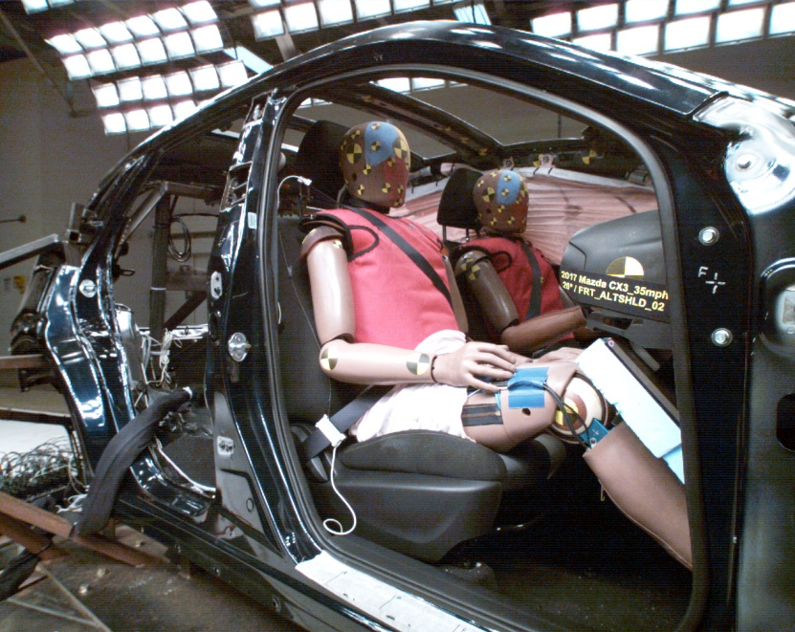
DUMMY POSITIONING FARO MEASUREMENTS
Description | Units | X | Y | Z
Origin-post | mm | -0.023 | 0.164 | 0.195
SO | mm | 448.658 | 408.119 | -179.724
TS | mm | 532.388 | 409.689 | -345.442
BS | mm | 396.847 | 409.216 | -28.553
RHDCG | mm | -32.980 | 486.700 | -483.044
Right EAM | mm | -23.670 | 481.088 | -454.520
LHDCG | mm | -28.382 | 332.438 | -481.275
Left EAM | mm | -20.889 | 338.192 | -457.672
NS | mm | 65.255 | 413.593 | -494.509
Right IOF | mm | 60.933 | 444.935 | -456.188
Left IOF | mm | 60.303 | 381.016 | -456.889
TN | mm | 61.046 | 413.768 | -457.341
TC | mm | 58.525 | 412.803 | -357.212
C1 | mm | 89.200 | 410.442 | -229.595
C2 | mm | 115.741 | 411.580 | -178.235
C3 | mm | 206.483 | 411.858 | -27.121
SHT1 | mm | -52.794 | 213.503 | -258.061
SHT2 | mm | 26.186 | 215.247 | -240.602
E1 | mm | 193.085 | 146.934 | -13.048
P1 | mm | 107.331 | 137.695 | 145.408
H-Point | mm | 182.282 | 177.211 | 172.192
OK | mm | 586.029 | 230.699 | 49.028
IK | mm | 592.668 | 486.924 | 64.166
DUMMY POSITIONING FARO MEASUREMENTS, CONTINUED
OA | mm | 849.360 | 217.043 | 375.816
IA | mm | 867.899 | 540.918 | 373.027
OH | mm | 886.128 | 234.174 | 510.635
IH | mm | 881.345 | 565.081 | 506.520
OP | mm | -225.910 | 316.238 | -339.864
Shoulder Belt Top | mm | 80.589 | 410.303 | -241.007
Shoulder Belt Bottom | mm | 119.727 | 410.852 | -169.781
Lap Belt Top | mm | 233.969 | 411.880 | 18.374
Lap Belt Bottom | mm | 256.440 | 411.202 | 57.112
HW | mm | 758.950 | 412.324 | -493.032
Seat Point | mm | 313.926 | 173.636 | 306.830

DUMMY INJURY
HIC (36 ms) | 371
HIC (15 ms) | 195
BrIC | 0.98
NIJ Max | 0.46
Chest Deflection (mm) | 47.8
Abdomen Deflection (mm) | 49.2
Acetabulum Force (N) | 6614.1
Femur Force (N) | -7174.4

SECTION 3
DRIVER SIDE 0° BUCK TEST SUMMARY

Description | Position # 1
ATD Type/Serial No. | THOR-50M/016
Restraint System | 3-Point Seatbelt
Shoulder | Original (SD3) or Alternate (NHTSA)

CAMERA POSITIONING FARO MEASUREMENTS

Description | Units | X | Y | Z
Origin | mm | 0.00 | 0.00 | 0.00
N3 Driver Shoulder | mm | -681.05 | -452.28 | -533.20
N1 Center | mm | -677.39 | -721.72 | -531.83

DUMMY POSITIONING

THOR50M 016 – Alternate (NHTSA) – 0° Degrees

TRC Test Number: S201123-1 VRTC Test Number: FRT_ALTSHLD_07
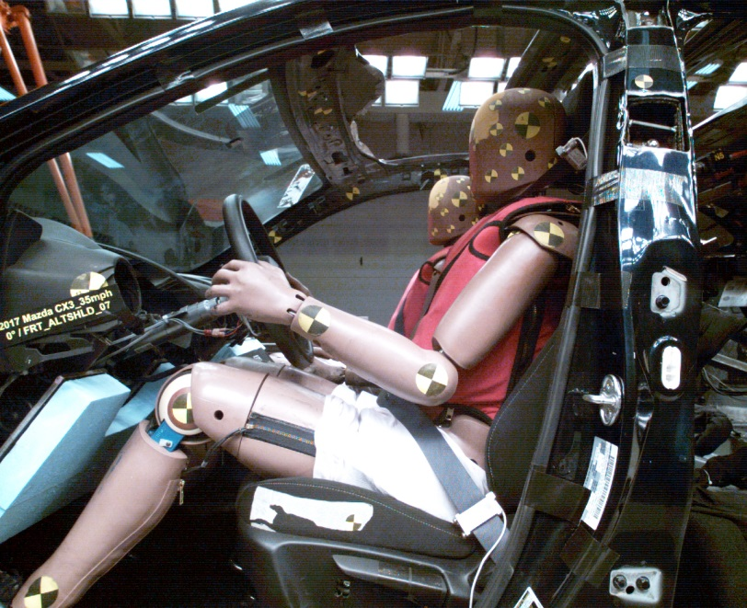
DUMMY POSITIONING FARO MEASUREMENTS
Description | Units | X | Y | Z
Origin-post | mm | 0.429 | 0.110 | -0.033
SO | mm | 447.398 | 410.684 | -181.725
TS | mm | 530.989 | 408.631 | -346.503
BS | mm | 397.101 | 412.057 | -29.849
RHDCG | mm | -34.270 | 485.920 | -480.708
Right EAM | mm | -25.184 | 481.084 | -452.421
LHDCG | mm | -31.815 | 331.419 | -477.124
Left EAM | mm | -23.396 | 336.362 | -453.425
NS | mm | 62.618 | 411.573 | -493.782
Right IOF | mm | 60.623 | 443.090 | -455.497
Left IOF | mm | 60.416 | 377.781 | -455.450
TN | mm | 64.132 | 410.519 | -456.848
TC | mm | 60.750 | 412.649 | -356.960
C1 | mm | 91.566 | 409.690 | -231.661
C2 | mm | 122.057 | 412.299 | -182.633
C3 | mm | 209.098 | 412.335 | -26.379
SHT1 | mm | -45.739 | 207.638 | -253.937
SHT2 | mm | 32.989 | 207.510 | -244.943
E1 | mm | 182.749 | 149.987 | -10.067
P1 | mm | 102.021 | 135.053 | 147.774
H-Point | mm | 177.927 | 171.927 | 175.036
OK | mm | 584.695 | 225.932 | 43.288
IK | mm | 594.431 | 485.456 | 56.698

DUMMY POSITIONING FARO MEASUREMENTS, CONTINUED
OA | mm | 846.711 | 214.234 | 372.143
IA | mm | 859.442 | 544.980 | 377.606
OH | mm | 876.591 | 235.517 | 508.374
IH | mm | 867.046 | 586.138 | 506.415
OP | mm | -233.766 | 323.227 | -333.946
Shoulder Belt Top | mm | 85.212 | 411.559 | -241.728
Shoulder Belt Bottom | mm | 122.193 | 411.242 | -171.894
Lap Belt Top | mm | 237.187 | 411.199 | 19.563
Lap Belt Bottom | mm | 263.264 | 411.312 | 58.350
HW | mm | 768.144 | 410.784 | -490.758
Seat Point | mm | 315.077 | 174.935 | 304.279

DUMMY INJURY
HIC (36 ms) | 502
HIC (15 ms) | 284
BrIC | 0.93
NIJ Max | 0.45
Chest Deflection (mm) | 33.4
Abdomen Deflection (mm) | 44.4
Acetabulum Force (N) | 2434.0
Femur Force (N) | -6993.7

DUMMY POSITIONING

THOR50M 016 – Alternate (NHTSA) – 0° Degrees

TRC Test Number: S201201-1 VRTC Test Number: FRT_ALTSHLD_08
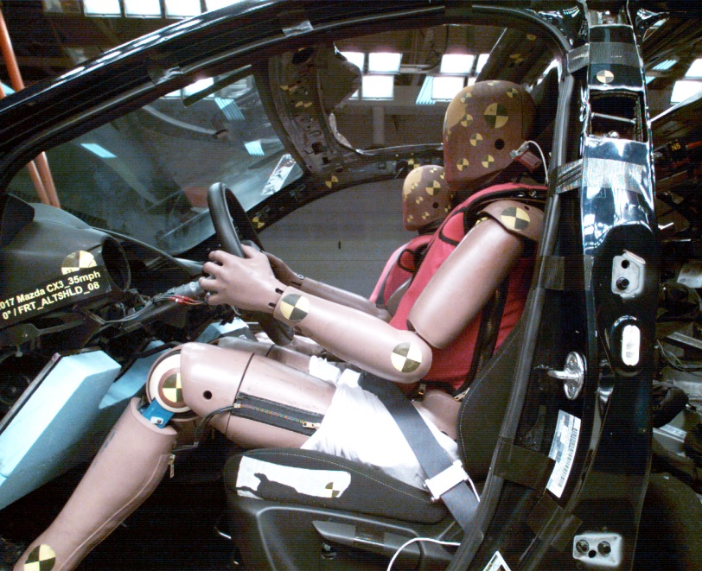
DUMMY POSITIONING FARO MEASUREMENTS
Description | Units | X | Y | Z
Origin-post | mm | 0.591 | 0.335 | -0.047
SO | mm | 450.444 | 411.017 | -181.244
TS | mm | 535.818 | 410.508 | -347.216
BS | mm | 400.280 | 414.206 | -30.851
RHDCG | mm | -42.198 | 479.911 | -479.634
Right EAM | mm | -31.237 | 474.974 | -452.497
LHDCG | mm | -30.376 | 326.632 | -477.373
Left EAM | mm | -22.035 | 331.752 | -454.224
NS | mm | 59.301 | 411.057 | -493.485
Right IOF | mm | 55.745 | 442.119 | -455.712
Left IOF | mm | 59.104 | 378.548 | -455.331
TN | mm | 60.525 | 410.214 | -456.242
TC | mm | 57.087 | 411.595 | -356.442
C1 | mm | 83.282 | 415.033 | -229.667
C2 | mm | 115.186 | 413.968 | -180.388
C3 | mm | 200.772 | 413.561 | -31.830
SHT1 | mm | -42.774 | 201.397 | -255.185
SHT2 | mm | 37.135 | 207.461 | -244.645
E1 | mm | 185.797 | 146.787 | -11.658
P1 | mm | 110.041 | 136.024 | 147.668
H-Point | mm | 184.006 | 177.580 | 175.927
OK | mm | 579.965 | 216.270 | 49.519
IK | mm | 587.825 | 487.601 | 57.225
DUMMY POSITIONING FARO MEASUREMENTS, CONTINUED
OA | mm | 842.372 | 211.718 | 378.734
IA | mm | 851.626 | 539.844 | 376.872
OH | mm | 867.718 | 243.839 | 510.971
IH | mm | 863.612 | 579.030 | 502.754
OP | mm | -234.544 | 324.792 | -330.157
Shoulder Belt Top | mm | 77.236 | 412.743 | -237.493
Shoulder Belt Bottom | mm | 116.566 | 412.756 | -167.537
Lap Belt Top | mm | 231.422 | 410.030 | 26.162
Lap Belt Bottom | mm | 254.403 | 411.234 | 66.402
HW | mm | 764.963 | 411.182 | -491.290
Seat Point | mm | 314.459 | 175.818 | 306.078

DUMMY INJURY
HIC (36 ms) | 437
HIC (15 ms) | 230
BrIC | 0.84
NIJ Max | 0.39
Chest Deflection (mm) | 44.1
Abdomen Deflection (mm) | 45.5
Acetabulum Force (N) | 2819.6
Femur Force (N) | -6647.5

DUMMY POSITIONING

THOR50M 016 – Alternate (NHTSA) – 0° Degrees

TRC Test Number: S201203-1 VRTC Test Number: FRT_ALTSHLD_09
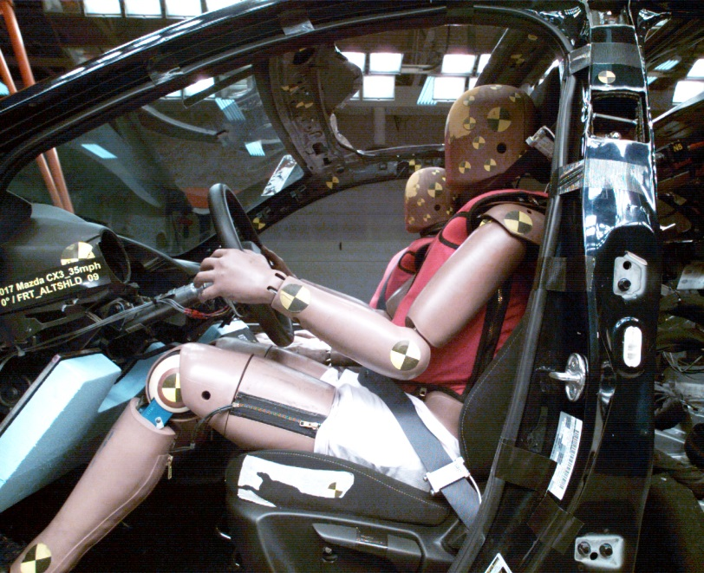
DUMMY POSITIONING FARO MEASUREMENTS
Description | Units | X | Y | Z
Origin-post | mm | 0.491 | 0.323 | -0.089
SO | mm | 451.620 | 412.970 | -182.379
TS | mm | 535.283 | 410.486 | -344.860
BS | mm | 400.474 | 413.566 | -31.718
RHDCG | mm | -41.357 | 485.101 | -477.944
Right EAM | mm | -31.508 | 481.701 | -451.733
LHDCG | mm | -37.671 | 330.736 | -474.127
Left EAM | mm | -28.674 | 335.558 | -450.721
NS | mm | 55.748 | 412.131 | -491.495
Right IOF | mm | 54.175 | 441.924 | -452.800
Left IOF | mm | 54.329 | 378.290 | -452.915
TN | mm | 57.458 | 411.099 | -454.334
TC | mm | 55.448 | 412.443 | -354.602
C1 | mm | 82.092 | 411.015 | -231.982
C2 | mm | 112.687 | 416.122 | -185.442
C3 | mm | 201.531 | 413.611 | -33.166
SHT1 | mm | -48.961 | 210.409 | -251.996
SHT2 | mm | 28.534 | 207.859 | -239.490
E1 | mm | 184.725 | 146.272 | -14.800
P1 | mm | 108.069 | 133.725 | 147.763
H-Point | mm | 182.740 | 173.893 | 175.059
OK | mm | 582.806 | 219.136 | 47.235
IK | mm | 590.000 | 485.593 | 57.480

DUMMY POSITIONING FARO MEASUREMENTS, CONTINUED
OA | mm | 849.740 | 214.364 | 371.399
IA | mm | 854.160 | 539.806 | 376.203
OH | mm | 869.112 | 228.483 | 507.553
IH | mm | 858.155 | 580.533 | 507.550
OP | mm | -234.738 | 323.055 | -330.777
Shoulder Belt Top | mm | 71.330 | 413.327 | -242.102
Shoulder Belt Bottom | mm | 113.781 | 414.047 | -175.279
Lap Belt Top | mm | 233.233 | 411.985 | 22.158
Lap Belt Bottom | mm | 255.889 | 410.536 | 61.908
HW | mm | 770.028 | 414.407 | -489.969
Seat Point | mm | 313.863 | 174.749 | 305.811

DUMMY INJURY
HIC (36 ms) | 477
HIC (15 ms) | 248
BrIC | 0.85
NIJ Max | 0.46
Chest Deflection (mm) | 46.4
Abdomen Deflection (mm) | 45.2
Acetabulum Force (N) | 2844.6
Femur Force (N) | -6777.2

DUMMY POSITIONING

THOR50M 016 – Original (SD3) – 0° Degrees

TRC Test Number: S201208-1 VRTC Test Number: FRT_ALTSHLD_10
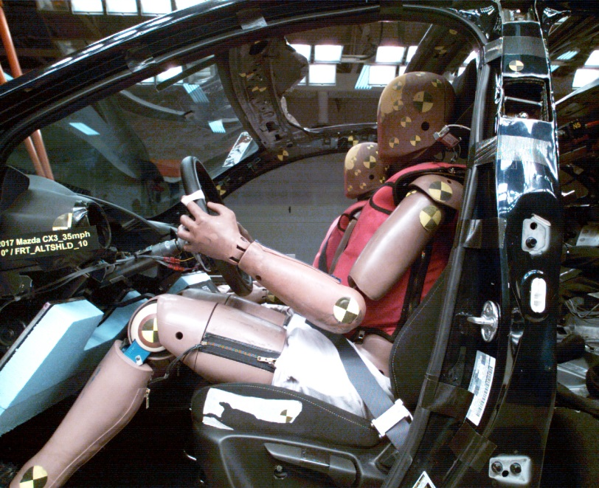
DUMMY POSITIONING FARO MEASUREMENTS
Description | Units | X | Y | Z
Origin-post | mm | 0.451 | 0.302 | -0.093
SO | mm | 443.128 | 410.035 | -180.143
TS | mm | 524.575 | 412.220 | -344.297
BS | mm | 394.525 | 415.463 | -29.811
RHDCG | mm | -38.032 | 490.274 | -481.070
Right EAM | mm | -27.828 | 486.970 | -453.532
LHDCG | mm | -33.241 | 336.027 | -474.583
Left EAM | mm | -25.166 | 340.606 | -450.890
NS | mm | 59.226 | 418.355 | -491.974
Right IOF | mm | 57.178 | 449.729 | -453.980
Left IOF | mm | 58.370 | 385.518 | -453.192
TN | mm | 60.859 | 417.455 | -455.008
TC | mm | 57.607 | 419.015 | -355.161
C1 | mm | 85.686 | 415.512 | -228.115
C2 | mm | 118.050 | 414.018 | -182.558
C3 | mm | 200.316 | 416.775 | -27.995
SHT1 | mm | -45.447 | 215.157 | -250.638
SHT2 | mm | 32.295 | 215.599 | -234.654
E1 | mm | 182.934 | 152.349 | -1.754
P1 | mm | 102.387 | 143.835 | 153.983
H-Point | mm | 177.316 | 174.404 | 181.239
OK | mm | 580.018 | 233.458 | 48.590
IK | mm | 591.660 | 486.762 | 62.436
DUMMY POSITIONING FARO MEASUREMENTS, CONTINUED
OA | mm | 844.830 | 210.420 | 376.060
IA | mm | 865.243 | 537.111 | 373.847
OH | mm | 867.680 | 237.695 | 511.168
IH | mm | 872.939 | 586.620 | 507.007
OP | mm | -236.629 | 327.138 | -330.234
Shoulder Belt Top | mm | 75.168 | 413.193 | -244.963
Shoulder Belt Bottom | mm | 114.839 | 414.702 | -173.044
Lap Belt Top | mm | 229.068 | 415.447 | 23.020
Lap Belt Bottom | mm | 255.788 | 414.796 | 62.258
HW | mm | 765.512 | 420.982 | -492.753
Seat Point | mm | 313.948 | 175.535 | 306.242

DUMMY INJURY
HIC (36 ms) | 509
HIC (15 ms) | 374
BrIC | 0.73
NIJ Max | 0.47
Chest Deflection (mm) | 48.7
Abdomen Deflection (mm) | 46.9
Acetabulum Force (N) | 2152.8
Femur Force (N) | -5394.6

DUMMY POSITIONING

THOR50M 016 – Original (SD3) – 0° Degrees

TRC Test Number: S201209-1 VRTC Test Number: FRT_ALTSHLD_11
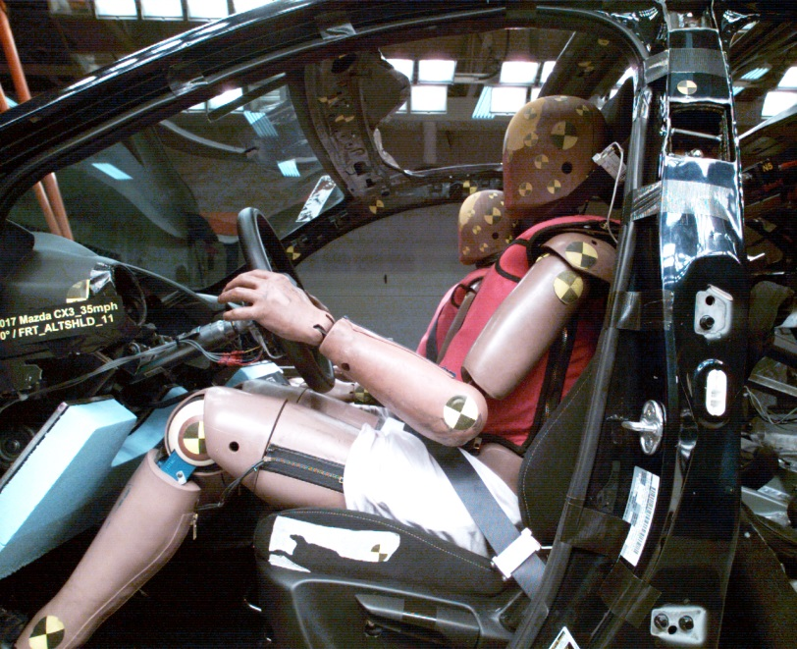
DUMMY POSITIONING FARO MEASUREMENTS
Description | Units | X | Y | Z
Origin-post | mm | 0.639 | 0.357 | -0.115
SO | mm | 447.341 | 409.691 | -181.846
TS | mm | 531.926 | 412.113 | -344.603
BS | mm | 395.688 | 412.023 | -29.360
RHDCG | mm | -39.634 | 488.008 | -479.044
Right EAM | mm | -30.074 | 482.912 | -450.631
LHDCG | mm | -35.706 | 334.592 | -475.028
Left EAM | mm | -27.376 | 340.130 | -451.782
NS | mm | 57.820 | 415.992 | -492.405
Right IOF | mm | 55.310 | 447.638 | -454.203
Left IOF | mm | 56.698 | 383.366 | -454.120
TN | mm | 59.750 | 415.499 | -455.409
TC | mm | 56.842 | 416.446 | -355.109
C1 | mm | 82.675 | 412.280 | -233.830
C2 | mm | 112.041 | 408.747 | -185.620
C3 | mm | 205.824 | 412.102 | -27.794
SHT1 | mm | -41.244 | 213.450 | -250.176
SHT2 | mm | 38.201 | 219.077 | -233.219
E1 | mm | 183.401 | 142.879 | -0.686
P1 | mm | 106.944 | 142.703 | 149.309
H-Point | mm | 182.799 | 172.309 | 176.464
OK | mm | 583.618 | 220.466 | 44.764
IK | mm | 594.622 | 490.911 | 52.774
DUMMY POSITIONING FARO MEASUREMENTS, CONTINUED
OA | mm | 845.000 | 220.248 | 374.309
IA | mm | 852.809 | 545.279 | 374.842
OH | mm | 869.682 | 227.964 | 510.389
IH | mm | 859.427 | 593.505 | 504.501
OP | mm | -235.433 | 324.673 | -329.917
Shoulder Belt Top | mm | 71.905 | 413.676 | -244.845
Shoulder Belt Bottom | mm | 114.611 | 416.125 | -176.930
Lap Belt Top | mm | 238.478 | 414.915 | 21.665
Lap Belt Bottom | mm | 259.525 | 415.703 | 63.401
HW | mm | 764.771 | 414.217 | -492.918
Seat Point | mm | 314.078 | 175.525 | 305.200

DUMMY INJURY
HIC (36 ms) | 444
HIC (15 ms) | 204
BrIC | 0.88
NIJ Max | 0.43
Chest Deflection (mm) | 49.0
Abdomen Deflection (mm) | 47.6
Acetabulum Force (N) | 2680.8
Femur Force (N) | -6475.8

DUMMY POSITIONING

THOR50M 016 – Original (SD3) – 0° Degrees

TRC Test Number: S201210-1 VRTC Test Number: FRT_ALTSHLD_12
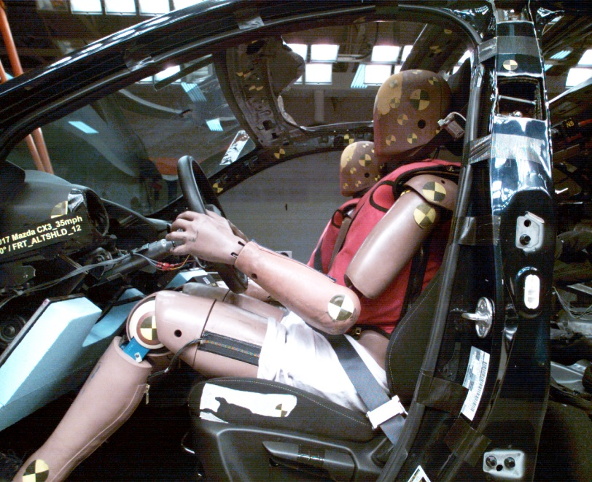
DUMMY POSITIONING FARO MEASUREMENTS
Description | Units | X | Y | Z
Origin-post | mm | 0.550 | 0.364 | -0.109
SO | mm | 447.775 | 413.496 | -177.903
TS | mm | 530.782 | 415.435 | -342.907
BS | mm | 399.812 | 412.713 | -28.977
RHDCG | mm | -37.339 | 482.758 | -478.683
Right EAM | mm | -27.972 | 477.984 | -452.051
LHDCG | mm | -35.718 | 329.433 | -474.523
Left EAM | mm | -27.713 | 335.073 | -451.319
NS | mm | 58.425 | 409.549 | -492.441
Right IOF | mm | 56.465 | 440.357 | -453.517
Left IOF | mm | 56.444 | 376.532 | -453.562
TN | mm | 59.728 | 408.403 | -454.667
TC | mm | 56.917 | 410.760 | -355.260
C1 | mm | 83.768 | 408.489 | -231.706
C2 | mm | 118.977 | 413.781 | -179.651
C3 | mm | 197.873 | 412.168 | -26.480
SHT1 | mm | -43.952 | 209.394 | -245.741
SHT2 | mm | 33.461 | 214.360 | -231.697
E1 | mm | 184.605 | 142.081 | -0.335
P1 | mm | 98.756 | 144.987 | 151.920
H-Point | mm | 174.273 | 177.338 | 179.160
OK | mm | 576.181 | 225.997 | 51.020
IK | mm | 585.624 | 492.396 | 53.032

DUMMY POSITIONING FARO MEASUREMENTS, CONTINUED
OA | mm | 840.389 | 215.826 | 379.141
IA | mm | 854.251 | 539.601 | 370.446
OH | mm | 868.534 | 239.451 | 510.138
IH | mm | 875.911 | 583.883 | 505.393
OP | mm | -238.613 | 324.615 | -329.155
Shoulder Belt Top | mm | 71.479 | 411.388 | -245.535
Shoulder Belt Bottom | mm | 112.998 | 411.474 | -171.991
Lap Belt Top | mm | 229.068 | 411.452 | 21.829
Lap Belt Bottom | mm | 248.856 | 411.515 | 60.016
HW | mm | 766.008 | 408.026 | -491.483
Seat Point | mm | 312.890 | 175.605 | 305.305

DUMMY INJURY
HIC (36 ms) | 432
HIC (15 ms) | 216
BrIC | 0.79
NIJ Max | 0.52
Chest Deflection (mm) | 47.9
Abdomen Deflection (mm) | 48.9
Acetabulum Force (N) | 3367.6
Femur Force (N) | -13056.2

SECTION 4

DUMMY CALIBRATION DATA

